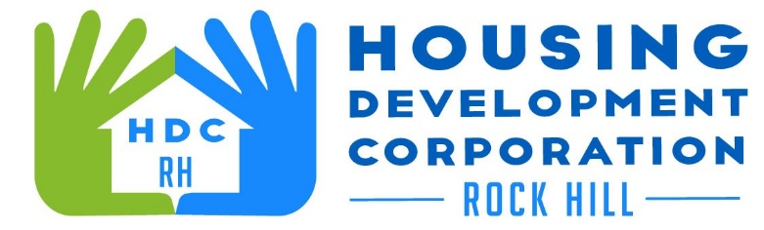

HDCRH MEETING

**January 13, 2022**

8:30 a.m.

Microsoft Teams Meeting

1. Call to Order
2. Approval of December 9, 2021 meeting minutes.

3) Staff Reports

1. Financials and Development Division Reports

1. Special Report
   1. Staff Updates
   2. Client Stories
2. New Business
   1. Housing Needs Assessment 2021 State Overview
   2. Strategic Plan
3. Miscellaneous Business
4. Adjourn

Next Meeting: 8:30 a.m., January 13, 2022

***Mission Statement:*** *The mission of the Housing Development Corporation of Rock Hill is to provide and improve housing opportunities for low-to moderate-income residents.*

***Vision:*** *Inform. Educate. Empower. By providing homeownership education and assistance; rehabilitation assistance to owner-occupied homes; increasing affordable housing options; and offering foreclosure prevention counseling.*