Housing Development Corporation of Rock Hill Board Meeting

Thursday, September 12, 2024

A Board Meeting was held Thursday, September 12, at 8:30 a.m. at City Hall, Room 373.

Members present: Walter Hardin, Naomi Carpenter, Will Jordan, David LeGrande, Anne Lambert, Sandra Oborokumo, Warren Baxter, Phyllis Fickling, Perry Sutton

Members absent: Brent Faulkenberry, Sharon Hines, Tom Roper, Mary Reid

Staff Present: Corinne Sferrazza, Beverly Buchanan, Ryan Powell, David Martin, Hakim Diaz, Sarah Bechtold, Danielle Sanders

Call to Order: Walter Hardin called the meeting to order at 8:32 a.m. and thanked everyone for attending.

Minutes of the July 11, meeting was reviewed. Walter asked for a motion that the minutes be approved as presented. Sandra Oborokumo made a motion to approve. The motion was seconded by Will Jordan. Unanimous approval.

Minutes of the August 8, meeting was reviewed. Walter asked for a motion that the minutes be approved as presented. Phyllis Fickling made a motion to approve. The motion was seconded by Will Jordan. Unanimous approval.

Corinne advised that Jordan Hamrick is not with HDC anymore. He has found another job with Clayton Homes as a Project Manager. At this time, his position is being revamped and more information will follow.

**Staff Reports**

**A. Financials**

Financial information was shared with Board members. Financial information can be e-mailed, or a hard copy can be mailed to Board Members if requested. Account balance information for the South State Community Checking Account (Sunset Park Houses) is $47,371.34. The Wells Fargo Account (HDC rentals) balance is $35,153.44. The TD Bank (Cottages) balance is $55,000.89. The NSP Rental Properties balance is $11,382.92. The TD General account is the main account with the most activity that includes utility and rental assistance transactions, deposits for assistance and proceeds for home sales, the balance is $142,101.00. Total Unrestricted Funding as of 8.31.2024: $117,066.43.

|  |  |
| --- | --- |
| **Finances** | |
| **Total Funds as of 8.31.2024** | **$624,339.77** |
| Restricted for Rental Properties | $260,258.22 |
| Restricted Grant Funds | $1,625 |
| Restricted/Held Funds for Projects | $245,390.12 |
| **Total unrestricted funds as of 8.31.2024** | **$117.066.43** |

**Funding Sources Remaining**

**KEEP - Homeless Prevention Assistance**

Rental

* 2 households assisted
* $4,144.09 spent

Mortgage

* 0 household assisted
* $0 spent

Utilities

* 0 households assisted
* $0 spent

**Emergency Food and Shelter Program**

Provides rent, utility, and mortgage assistance

Total funding: $56,496.59

Remaining: $0

**Rapid Rehousing Update**

Funding available: $31,697.39

RRH Counseling sessions: 12

**Individual Development Account Program**

Number of Accounts opened: 9 (5 homeownership, 4 Transportation)

Funding remaining: $46,600 ($39,600 UWYC + $7000 Family Trust)

Sarah advised that the Rapid Rehousing Program funding for the new year started in August, and currently working on onboarding new individuals. Clients are participating in their monthly meetings as well as working through the IDA. The IDA program is approaching its six months, whereas clients will be exiting the program.

**Housing Navigation**

Number of New Landlord Connections – 5

Hakim advised that there has been some success getting landlords that are willing to partner with HDC. We now have 5 connections and hope to start moving clients in soon.

If anyone knows of landlords that may be willing to partner with us, let him know.

Corrinne advised that funding covers the entire York County area.

**Rental Properties**

Danielle advised on the following rental properties during the month of August

|  |  |  |  |
| --- | --- | --- | --- |
| Gross income: $27,931 | Net income: $18,994.89 | Total properties: 31 | Total persons served: 70 (0 vacancies) |

**BUY**

New Construction

Ryan advised on the following projects

* + 115 Allen
  + 225 Baker
  + Out for bid – bids due October 20th
  + For sale properties

**115 Allen St. 225 Baker St.**

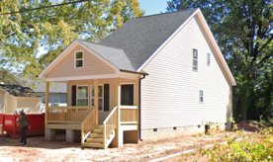  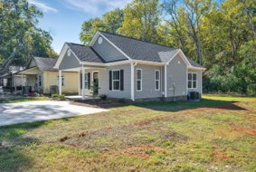

**647 E. Black Street**

David advised that the house is coming along.

* House wrap completed
* Railing installed
* Vinyl siding scheduled
* For sale property

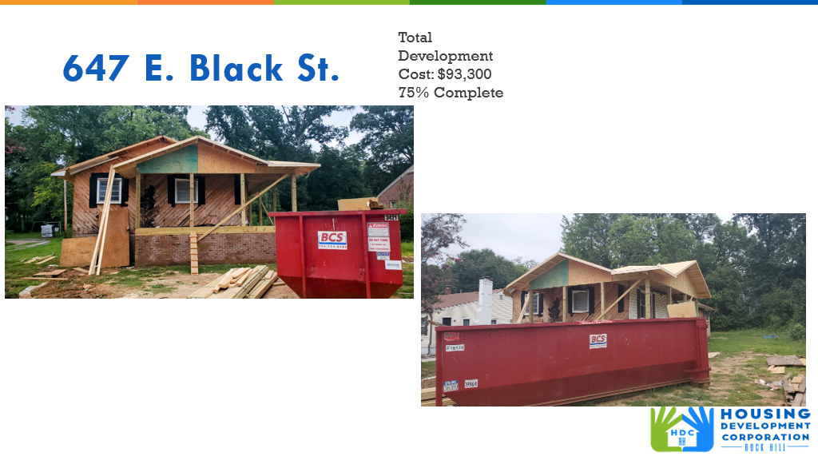

**First Time Homebuyers** – Ryan advised on August FTHB

Client Intake - 29

Students who received certificates – 16

Closings with assistance – 1

Counseling sessions –

# enrolled in next in-person class - 3

Next class: October 12, 2024

CDBG 24/25 Funding - $40,070

**FIX**

**Rehab Projects- CDBG – Southside Home Improvement Program (SHIP)**

|  |  |  |
| --- | --- | --- |
| **Stage** | **Amount of Units** | **SHIP** |
| **Pre-Work** | **2** | * Maximum $5000 |
| **Bidding** | **0** | * Exterior only |
| **In Construction** | **0** | * Roofs, HVACs, Porch, Decks, Handicap accessible ramps |
| **Completed** | **0** | * Ward 1 & 5 |

**Rehab Projects- – CDBG – Owner Occupied Rehab**

|  |  |
| --- | --- |
| **Stage** | **Amount of Units** |
| **Pre-Work** | **4** |
| **Bidding** | **0** |
| **In Construction** | **0** |
| **Completed** | **0** |

**Rehab Projects – HTF- Critical Home Repair & Home Repair**

|  |  |
| --- | --- |
| **Stage** | **Amount of Units** |
| **Pre-Work** | **2** |
| **Bidding** | **0** |
| **In Construction** | **0** |
| **Completed** | **0** |

**Rehab Projects**

CDBG 23/24 CDBG 24/25

OOR - $2,306.30 OOR - $101,930

Volunteer Projects - $0 Volunteer Projects-$35,945.15

SHIP - $164.44 SHIP - $50,000

|  |  |
| --- | --- |
| **Starting amount** | **71** |
| **Inactive *did not respond to mailer\*** | **22** |
| **Over Income** | **3** |
| **Homeowner completed work** | **2** |
| **House Sold** | **1** |
| **Requested Removal** | **2** |
| **In Progress** | **5** |
| **Completed** | **16** |
| **ELIGIBLE HOUSEHOLDS ON WAITLIST** | **21** |

**Grants Update**

* Applied
  + - Sisters of Charity - $5,000 - ‘gap filler’ funding

**Old Business**

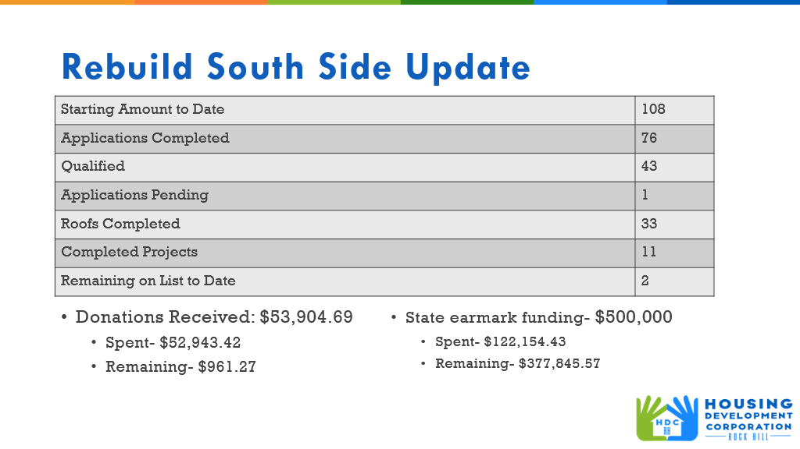

**Homeowners Insurance**

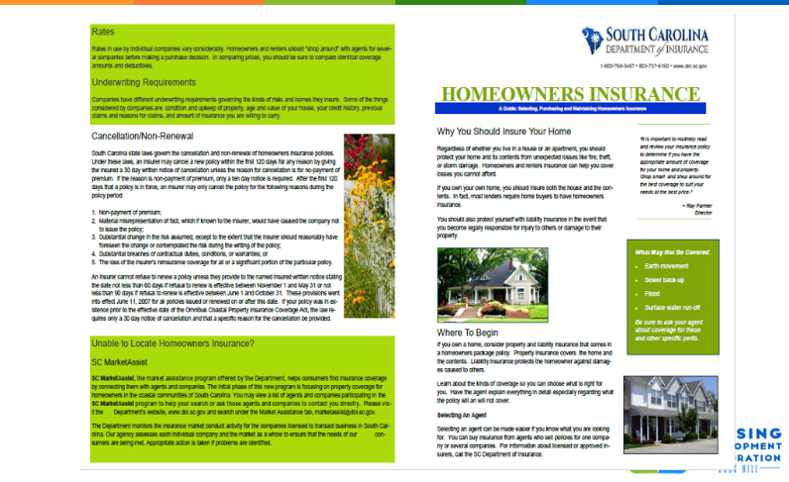

Corinne advised that the importance of having homeowners’ insurance was mentioned during last month’s meeting. In order to provide information to the community regarding the importance of having insurance, Ryan and David found a homeowners insurance brochure and plan to give each Rebuild Southside client a copy.

Perry Sutton asked that the brochure be passed on to Neighbor Services.

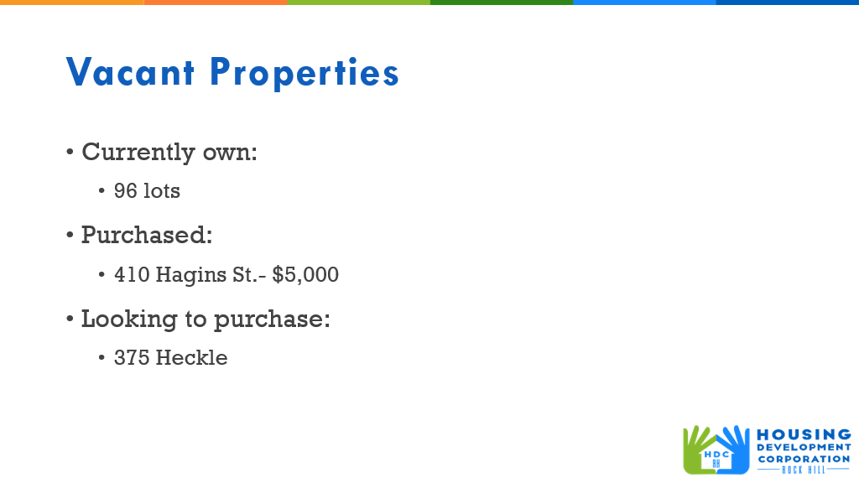

Corinne gave an overview of the HDC vacant properties

**New Business**

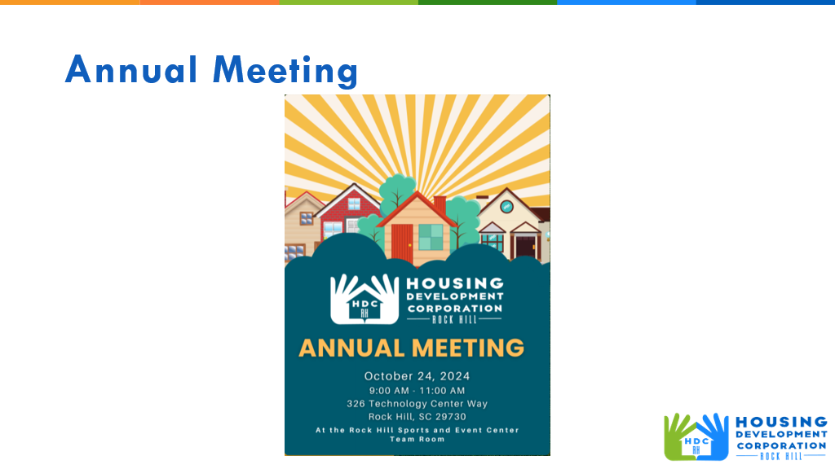

**Adjourn**

With no further business, a motion was made, seconded, and unanimously approved to adjourn.

The meeting was adjourned at 9:11 a.m.

Upcoming Events/Meetings: Annual Meeting – October 24, 2024, 9:00 – 11:00 AM – Sports and Event Center

Submitted by: _____________________  
 Beverly Buchanan, Secretary  
 Date: September 12, 2024

______________________  
Chairman/Vice Chairman  
Date: