Housing Development Corporation of Rock Hill Board Meeting

Thursday, June 13, 2024

A Board Meeting was held Thursday, June 13, at 8:30 a.m. at City Hall, Room 373.

Members present: David LeGrande, Phyllis Fickling, Naomi Carpenter, Tom Roper, Sandra Oborokumo, Mary Reid, Perry Sutton,

Members absent: Walter Hardin, Will Jordan, Sharon Hines, Warren Baxter, Brent Faulkenberry, Anne Lambert

Staff Present: Corinne Sferrazza, Ryan Powell, Beverly Buchanan, Sarah Bechtold, Danielle Sanders, Miguel Rullan, Jordan Hamrick, David Martin

Call to Order: Phyllis Fickling called the meeting to order at 8:35 a.m.

Minutes of the May 9, meeting was reviewed. Corinne Sferrazza asked for a motion that the minutes be approved as presented. Sandra Oborokumo made a motion to approve. The motion was seconded by David LeGrande. Unanimous approval.

**Staff Reports**

**A. Financials**

Financial information was shared with Board members. Financial information can be e-mailed, or a hard copy can be mailed to Board Members if requested. Account balance information for the South State Community Checking Account (Sunset Park Houses) is $45,364.13. The Wells Fargo Account (HDC rentals) balance is $30,723.51. The TD Bank (Cottages) balance is $50,554.00. The NSP Rental Properties balance is $13,319.42. The TD General account is the main account with the most activity that includes utility and rental assistance transactions, deposits for assistance and proceeds for home sales, the balance is $262,998.95. Total Unrestricted Funding as of 5.31.2024: $279,139.98.

|  |  |
| --- | --- |
| **Finances** | |
| **Total Funds as of 5.31.2024** | **$770,920.59** |
| Restricted for Rental Properties | $291,310.69 |
| Restricted Grant Funds | $1,625 |
| Restricted/Held Funds for Projects | $198,844.92 |
| **Total unrestricted funds as of 5.31.2024** | **$279,139.98** |

Received $150,000.00 insurance payment for storm damage to rental properties, which is included in the “Restricted for Rental Properties” total

**KEEP - Homeless Prevention Assistance**

Rental

* 5 households assisted
* $13,395.98 spent

Mortgage

* 0 household assisted
* $0 spent

Utilities

* 24 households assisted
* $6,062.46 spent

**Funding Sources Remaining**

**Emergency Food and Shelter Program–EFSP – 80% AMI**

Provides rent, utility, and mortgage assistance

Total funding: $52,352.50

Remaining: $4,144.09

**Rapid Rehousing Update**

Funding available: $8,792

RRH Counseling sessions: 12

Benefits counseling sessions: 0

Miguel advised that the Rapid Rehousing Program is going well, and clients are participating in their counseling sessions, monthly meetings as well as the IDA program.

**Individual Development Account Program**

Number of Accounts opened: 9 (5 homeownership, 4 Transportation)

Funding remaining: $46,600 ($39,600 UWYC + $7000 Family Trust)

**Rental Properties**

Danielle advised on the following rental properties during the month of May

|  |  |  |  |
| --- | --- | --- | --- |
| Gross income: $22,806.67 | Net income: $150.35 | Total properties: 31 | Total persons served: 70 (0 vacancies) |

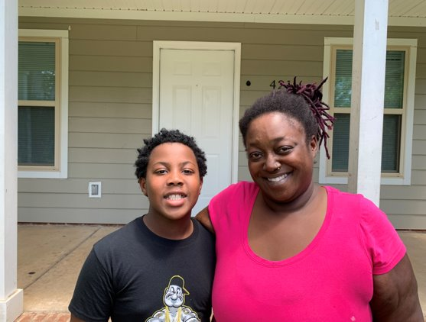

New tenant: 420 Gettys Family

**BUY**

New Construction

Ryan advised on the following projects

* + 115 Allen - two story – 3BR, 2 BT
  + 225 Baker – 2BR, 1 BT
  + Will go out for bid around mid-June
  + For sale

115 Allen St. 225 Baker St.

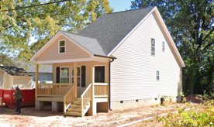  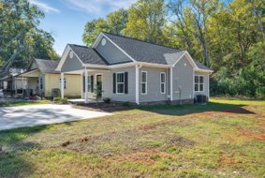

**647 E. Black Street**

David advised that the house has been set on the foundation.

* Projected finish date is mid-July
* For sale property

Total Development cost: $93,300

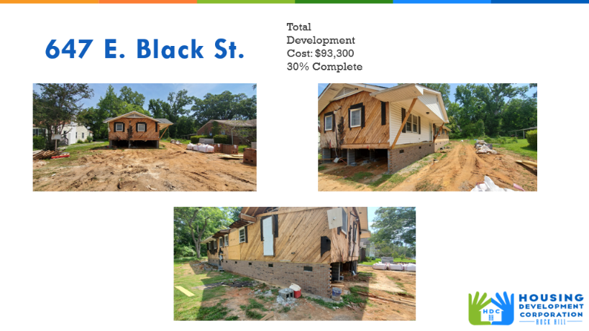

**First Time Homebuyers** –Jordan Hamrick advised on May FTHB

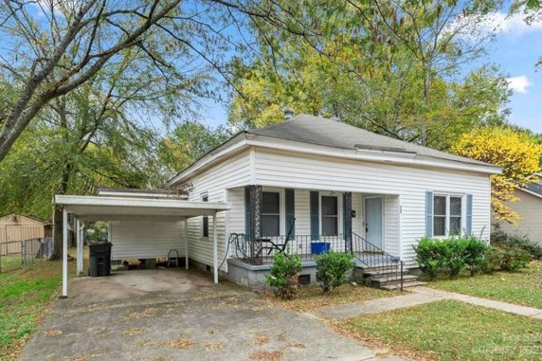

Community Street

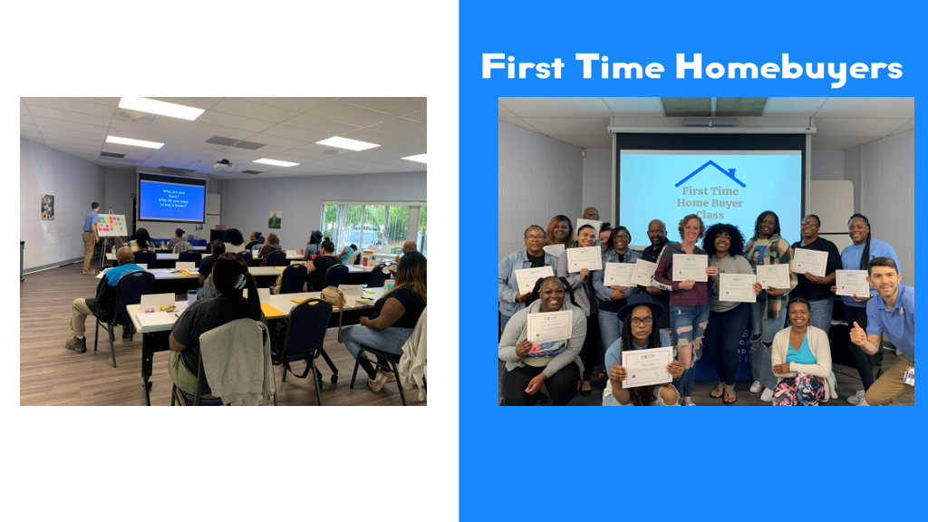

Client Intake - Students - 22

Students who received certificates – 5

Closings with assistance – 3

Counseling sessions – 10

# enrolled in next in-person class - 22

Next Class – August 3, 2024

CDBG 23/24 Funding - $13,070

**FIX**

**Rehab Projects- CDBG – Southside Home Improvement Program (SHIP)**

|  |  |  |
| --- | --- | --- |
| **Stage** | **Amount of Units** | **SHIP** |
| **Pre-Work** | **1** | * Maximum $5000 |
| **Bidding** | **0** | * Exterior only |
| **In Construction** | **0** | * Roofs, HVACs, Porch, Decks, Handicap accessible ramps |
| **Completed** | **7** | * Ward 1 & 5 |

**Rehab Projects- – CDBG – Owner Occupied Rehab - Rehab-World Changers**

|  |  |
| --- | --- |
| **Stage** | **Amount of Units** |
| **Pre-Work** | **10** |
| **Bidding** | **0** |
| **In Construction** | **0** |
| **Completed** | **0** |

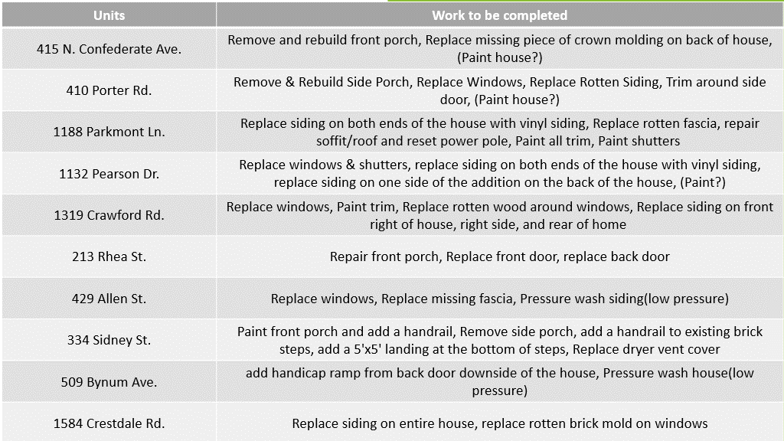

**Rehab Projects – HTF- Critical Home Repair & Home Repair**

|  |  |
| --- | --- |
| **Stage** | **Amount of Units** |
| **Pre-Work** | **2** |
| **Bidding** | **0** |
| **In Construction** | **0** |
| **Completed** | **0** |

**Rehab Projects**

CDBG 23/24

OOR - $4,236.30

Volunteer Projects - $40,000

SHIP - $5,164

|  |  |
| --- | --- |
| **Starting amount** | **71** |
| **Inactive *did not respond to mailer\*** | **22** |
| **Over Income** | **3** |
| **Homeowner completed work** | **2** |
| **House Sold** | **1** |
| **Requested Removal** | **2** |
| **In Progress** | **13** |
| **Completed** | **3** |
| **ELIGIBLE HOUSEHOLDS ON WAITLIST** | **26** |

**Summer Missions Volunteer Project**

**World Changers** – Approximately 250 Volunteers consisting of students from all over the country: Paint, porch repair, siding (no roofs) -June 17-21, 2024.

**Salkehatchie-** State levelthrough United Methodist group – June 22-28, 2024

**Grants Update**

* Applied awaiting notice
  + Family Trust Federal Credit Union
    - Community Partnership Foundation Applied for $5000 for furniture for 405 W. Main St.
  + Received
    - ESG - $35,000 for Rapid Rehousing

**Old Business**

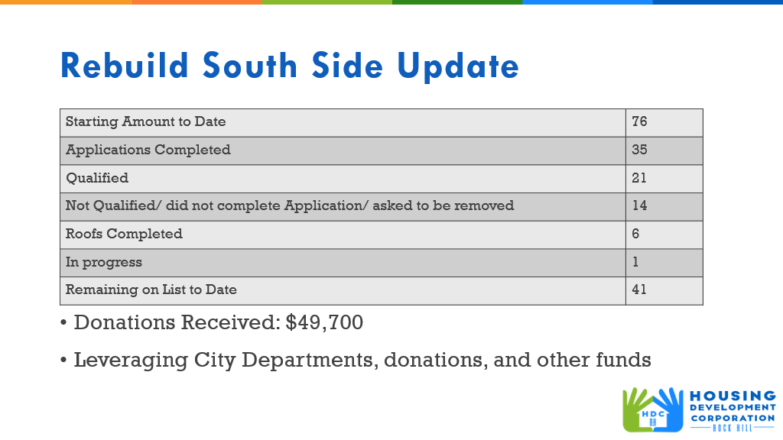

**Client Stories**

Ryan shared a client story regarding a Rebuild Southside project

**Heir’s Property**

Jordan gave an update on the Center for Heir’s property, and that any events moving forward should be coordinated with Habitat.

**New Business**

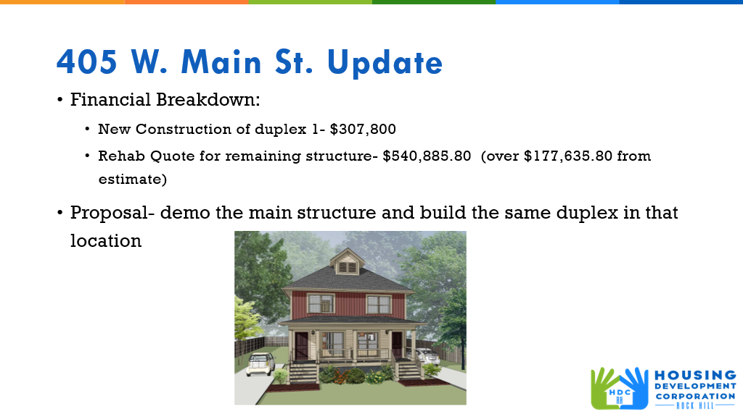

Corinne gave a financial breakdown on 405 W. Main Street regarding new construction vs. rehab. A structural engineer was hired for the rehab and found that the structure is not good. The rehab quote came back at $540,885.80 which is an excessive amount. After speaking with grant financial consultant, it is more feasible to do new construction quoted $307.800. Corinne further advised that it has been proposed to the Mayor and City Council to demo the main structure and build the same duplex in that location.

After discussion, Tom Roper made a motion to demo the main structure and build the same duplex in that location, David LeGrand seconded the motion. The motion passed unanimously.

Jordan advised that he will be representing the HDC at Festival in the Park at Sunset Park, 11:00am -3:30pm, Saturday 15, 2024.

Corinne advised that today is Miguel’s last meeting. He is leaving the City effective June 28th. Miguel advised that he is excited, and has planned four months of travels to Florida, Vietnam, Mexico, etc., with his final destination to Spain. Miguel stated that out of his thirteen years of with the city, HDC has been his most fulfilling role, working with HDC staff who are passionate about what they do. Miguel thanked everyone for the last two years.

Sandra Oborokumo advised that Juneteenth-Rock Hill Festival will be held June 21-23, 2024.

**Adjourn**

With no further business, a motion was made, seconded, and unanimously approved to adjourn.

The meeting was adjourned at 9:37 a.m.

Upcoming Events/Meetings: HDCRH Board Meeting, 8:30 a.m., July 11, 2024.

Submitted by: _____________________  
 Beverly Buchanan, Secretary  
 Date: June 21, 2024

______________________  
Chairman/Vice Chairman  
Date: