Housing Development Corporation of Rock Hill Board Meeting

Thursday, December 12, 2024

A Board Meeting was held Thursday, December 12, at 8:30 a.m. at Operations Center, Room 136.

**Members present**: Anne Lambert, Sandra Oborokumo, Naomi Carpenter, Tom Roper, Brent Faulkenberry, Perry Sutton

**Members absent**: Walter Hardin, Will Jordan, David LeGrande, Sharon Hines, Warren Baxter, Phyllis Fickling, Mary Reid

**Staff present**: Corinne Sferrazza, Beverly Buchanan, Danielle Sanders, Ryan Powell, David Martin, Pam Westmoreland, Sarah Bechtold

**Guest present**: Atalie Zimmerman

Call to Order: Anne Lambert called the meeting to order at 8:31 a.m. and thanked everyone for attending.

Minutes of the November 14, meeting could not be approved due to lack of a quorum.

Corinne welcomed HDC’s Housing Development Specialist Pam Westmoreland to the meeting. Pam will be working with the First Time Home Buyer Program, as well as the rehabilitation program. Pam introduced herself to the board.

**Staff Reports**

**A. Financials**

Financial information was shared with Board members. Financial information can be e-mailed, or a hard copy can be mailed to Board Members if requested. Account balance information for the South State Community Checking Account (Sunset Park Houses) is $52,712.47. The Wells Fargo Account (HDC rentals) balance is $41,788.52. The TD Bank (Cottages) balance is $57,177.69. The NSP Rental Properties balance is $31,964.14. The TD General account is the main account with the most activity that includes utility and rental assistance transactions, deposits for assistance and proceeds for home sales, the balance is $67,715.68. Total Unrestricted Funding as of 11.30.2024: $184,631.33.

|  |  |
| --- | --- |
| **Finances** | |
| **Total Funds as of 11.30.2024** | **$490,220.98** |
| Restricted for Rental Properties | $183,642.82 |
| Restricted Grant Funds | $32,006.83 |
| Restricted/Held Funds for Projects | $89,940 |
| **Total unrestricted funds as of 11.30.2024** | **$184,631.33** |

**Funding Sources Remaining**

**KEEP**

**Homeless Prevention Assistance**

**Rapid Rehousing Update (CoC and ESG)**

Funding Available: $79,820

Funding Remaining: $72,000

RRH Counseling sessions: 12 (3 clients housed)

**Individual Development Account Program**

Number of Accounts opened: 9 (5 homeownership, 4 Transportation)

Funding remaining: $31,600

Participants Graduated: 2 this month

1 participant purchased a home

1 participant has saved $30,000

Sarah Bechtold reported on Rapid Rehousing and IDA Account.

Sarah gave a client story on the IDA participant who saved $30,000, who was a former rapid rehousing client, but is doing very well now.

**Housing Navigation**

Number of New Landlord Connections – 3

Households Moved-In – 1

Total Persons Served - 15

Sarah reported that Hakim is still making landlord connections and the program is going well.

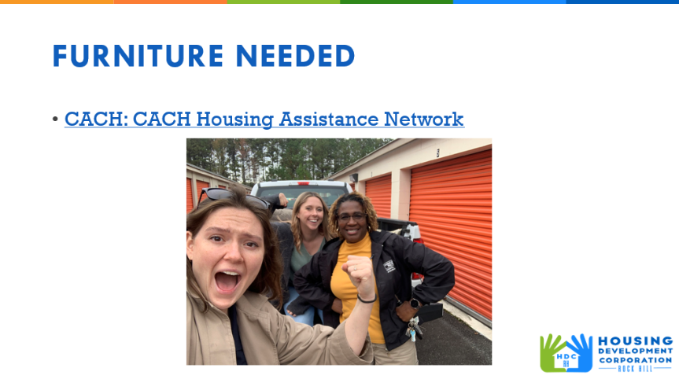

Danielle advised that furniture is needed for families moving into permanent housing. HDC and Catawba Area Coalition for the Homeless are teaming up with local shelters to move families and individuals into permanent housing.

**Rental Properties**

Danielle advised on the following rental properties during the month of November.

|  |  |  |  |
| --- | --- | --- | --- |
| Gross income: $14,508 | Net income: $-36,682.26 | Total properties: 31 | Total persons served: 71 |

 Danielle reported on the rental properties roof replacement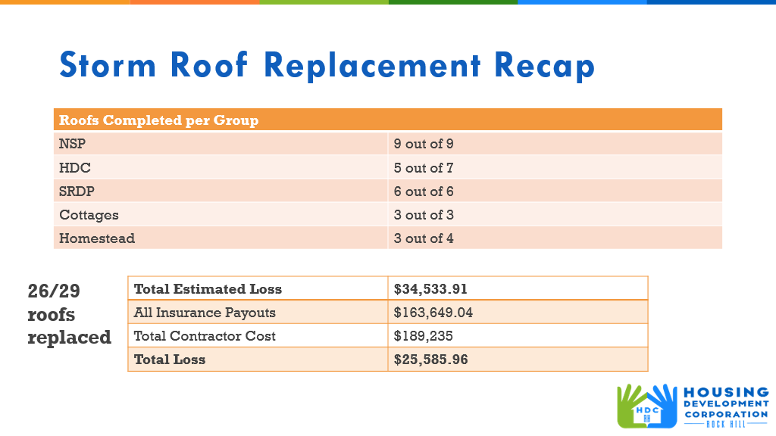

  Ryan reported on 405 W. Main St.

* Two duplexes with four units
* Permanent supportive housing for individuals experiencing homelessness– rapid rehousing 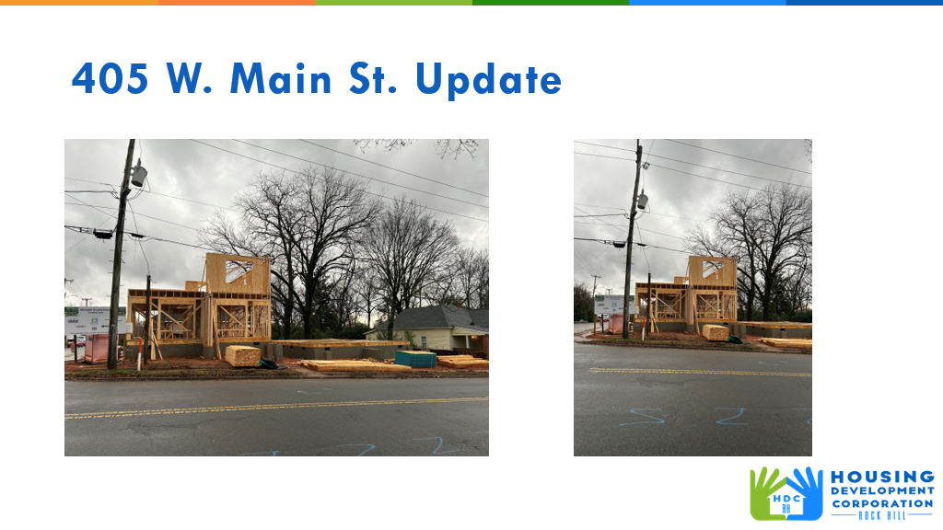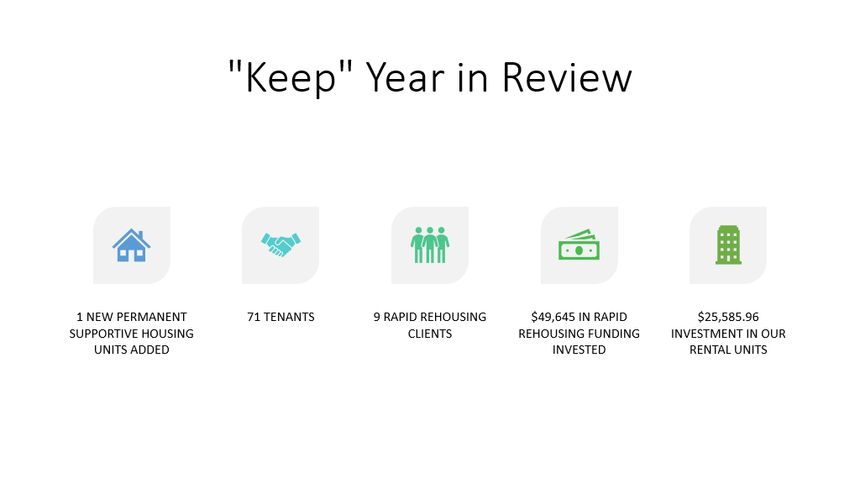

**BUY**

* New Construction - For sale properties

David reported on the following:

* **115 Allen St. -final stages of planning**
* **225 Baker St. foundation laid - rough in plumbing – ready to pour slab**

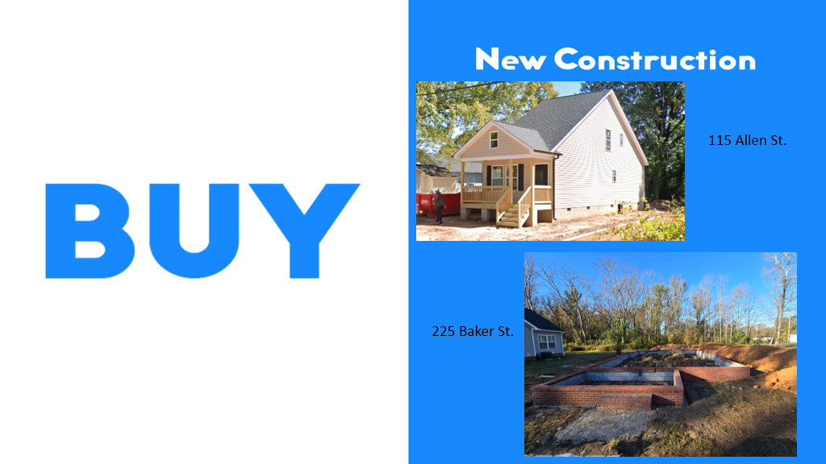

**647 E. Black Street**

* For sale property
* Passed final inspection, passed final landscaping, getting punch list done

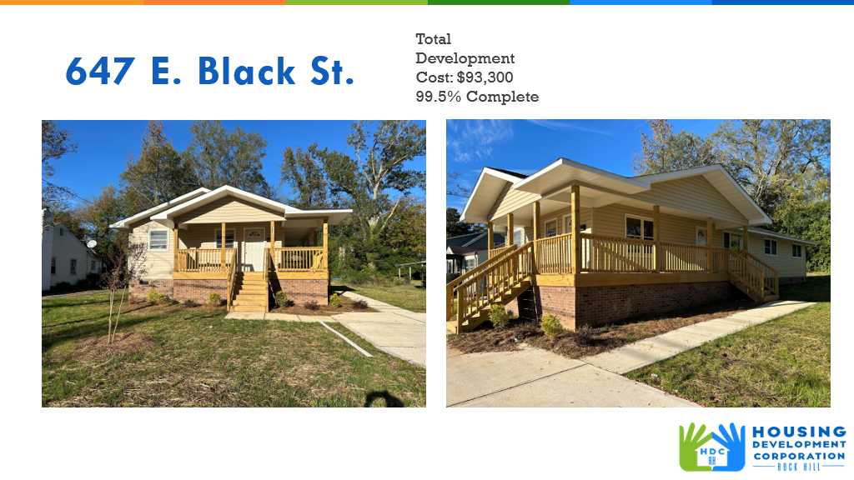

**First Time Homebuyers** – Ryan reported for November

Client Intake September/October: 56

Students who received certificates: 2

Closings with assistance:0

Counseling sessions:0

# enrolled in next in-person class - 15

Next class: December 14, 2024

CDBG 24/25 Funding - $45,070

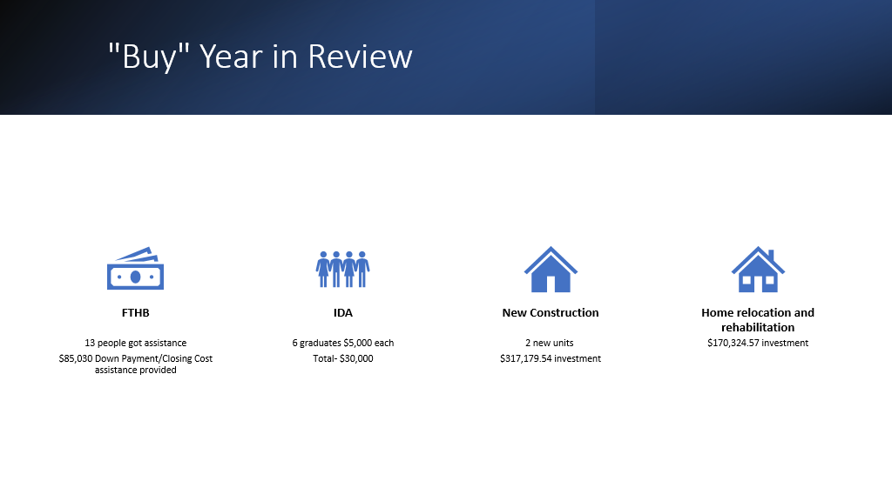

**FIX**

**Rehab Projects- CDBG – Southside Home Improvement Program (SHIP)**

|  |  |  |
| --- | --- | --- |
| **Stage** | **Amount of Units** | **SHIP** |
| **Pre-Work** | **5** | * Maximum $5000 |
| **Bidding** | **0** | * External |
| **In Construction** | **0** |  |
| **Completed** | **0** | * Ward 1 & 5 |

**Rehab Projects- – CDBG – Owner Occupied Rehab**

|  |  |
| --- | --- |
| **Stage** | **Amount of Units** |
| **Pre-Work** | **4** |
| **Bidding** | **0** |
| **In Construction** | **1** |
| **Completed** | **0** |

**Rehab Projects – HTF- Critical Home Repair & Home Repair**

|  |  |
| --- | --- |
| **Stage** | **Amount of Units** |
| **Pre-Work** | **1** |
| **Bidding** | **0** |
| **In Construction** | **0** |
| **Completed** | **0** |

**Rehab Projects**

CDBG 23/24 CDBG 24/25

OOR - $2,306.30 OOR - $101,930

Volunteer Projects - $0 Volunteer Projects-$35,945.15

SHIP - $164.44 SHIP - $50,000

|  |  |
| --- | --- |
| **Starting amount** | **189** |
| **Inactive *did not respond to mailer\*** | **25** |
| **Over Income** | **6** |
| **Homeowner completed work** | **30** |
| **House Sold** | **10** |
| **Requested Removal** | **10** |
| **Deceased** | **18** |
| **Volunteer Waitlist** | **22** |
| **Habitat will complete** | **1** |
| **In Progress** | **6** |
| **Completed** | **36** |
| **ELIGIBLE HOUSEHOLDS ON WAITLIST** | **25** |

Corinne advised that the pre-application for the Summer Missions volunteer program has been posted on the HDC website. Information can also be found on HDC’s Facebook page and asked that the board get the word out.

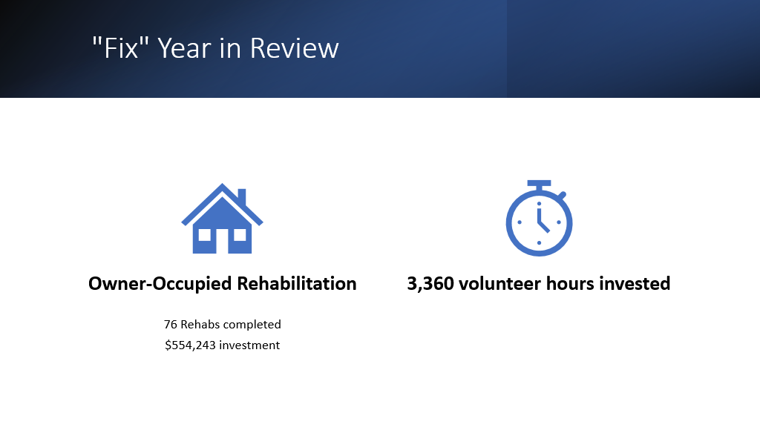

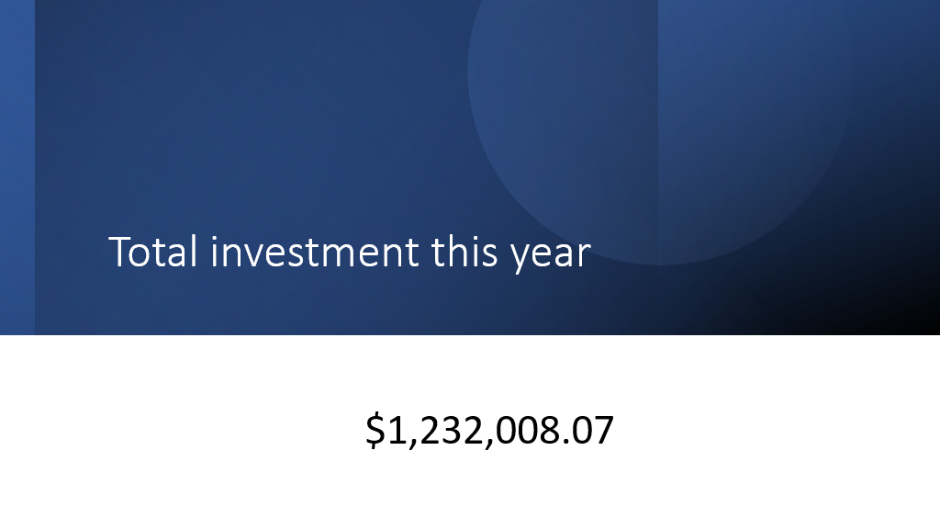

**Grants Update**

* Received
  + - Sisters of Charity - $5,000 - ‘gap filler’ funding
* Applied
  + - Continuum of Care (CoC) - $35,856 – Rapid Rehousing
    - Disaster Assistance Program (DAP) – SC Housing

**Old Business**

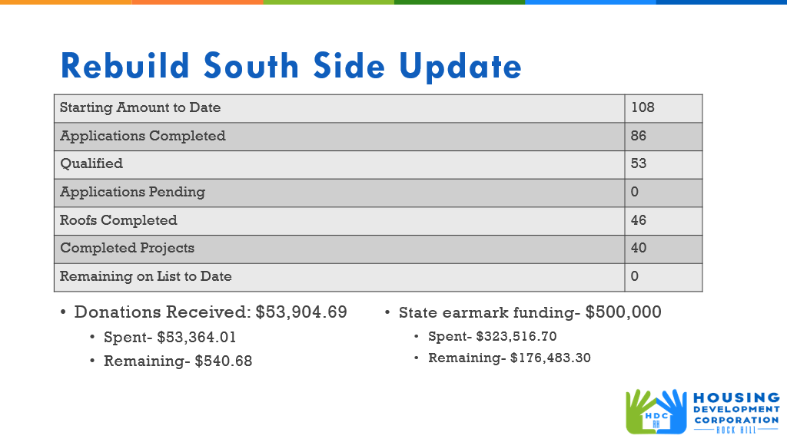

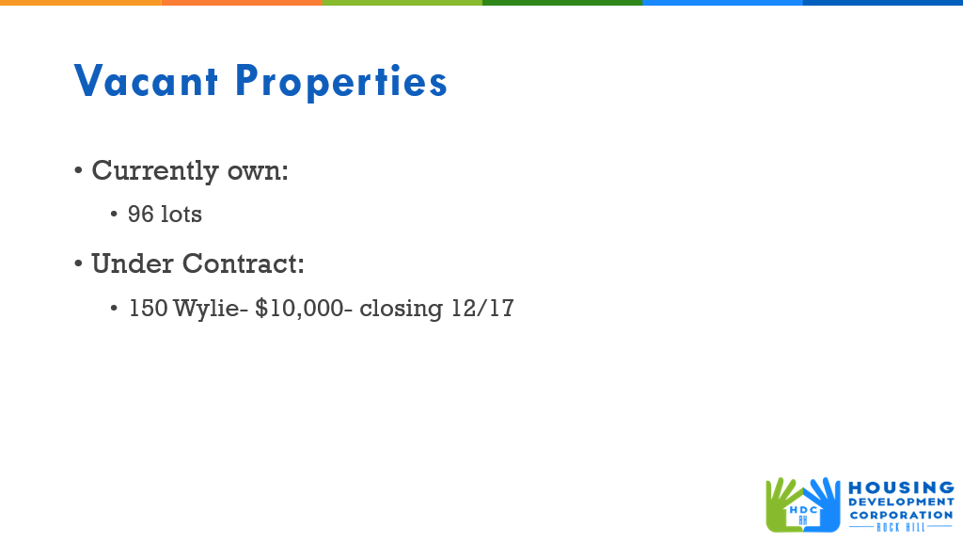

**Corinne gave an overview of the 3 Year Strategic Plan**

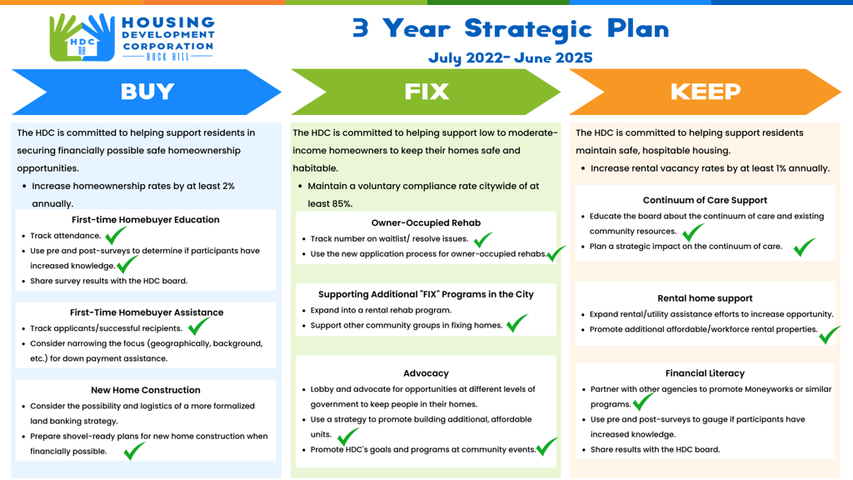

**New Business**

**Corinne advised the board on how the SRDP application will work**

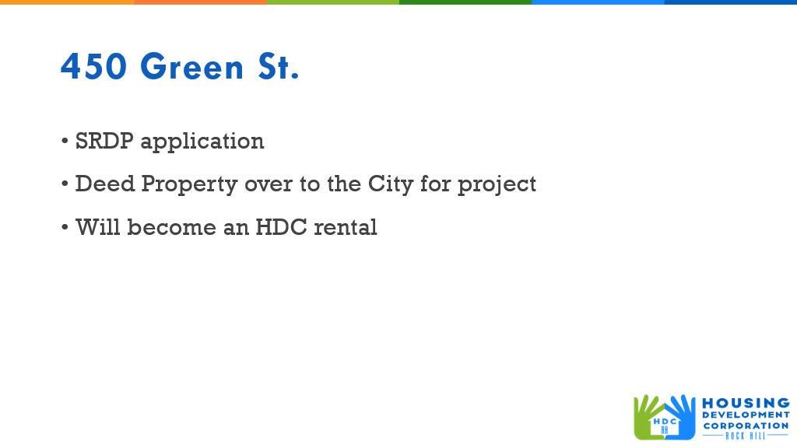

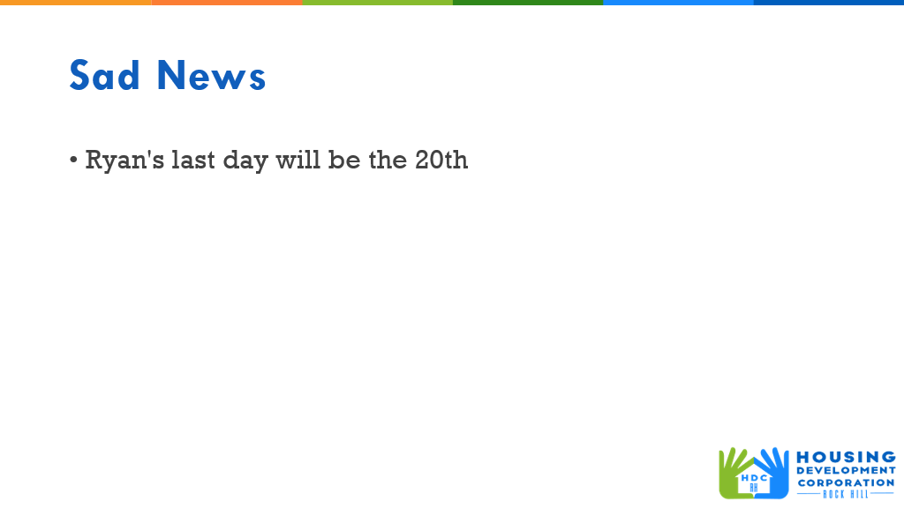

Ryan advised that December 20th, will be his last day with HDC, and working at HDC has been a joy, but an opportunity has presented itself that he can’t pass up. He wishes HDC the best in the future.

Perry Sutton said that the City council is very appreciative for the work that HDC has done during the Rebuild Southside Project.

**Adjourn**

With no further business, the meeting ended at 9:32 a.m.

Next Meetings: HDCRH Board Meeting, Thursday, January 9, 8:30am – **Operations Center, Room 136**

Submitted by: **Beverly Buchanan**  
 Beverly Buchanan, Secretary  
 Date: December 17, 2024

______________________  
Chairman/Vice Chairman  
Date: