Housing Development Corporation of Rock Hill Board Meeting

Thursday, February 8, 2024

A Board Meeting was held Thursday, February 8, at 8:30 a.m. at City Hall, Room 373.

Members present: Walter Hardin, Brent Faulkenberry, Will Jordan, David LeGrande, Mary Reid, Phyllis Fickling, Perry Sutton, Naomi Carpenter

Members absent: Anne Lambert, Sharon Hines, Tom Roper, Sandra Oborokumo, Derrick Lindsay

Staff Present: Corinne Sferrazza, Ryan Powell, Beverly Buchanan, David Martin, Sarah Bechtold, Danielle Sanders, Miguel Rullan, Jordan Hamrick

Call to Order: Walter Hardin called the meeting to order at 8:32 a.m. and thanked everyone for attending.

Minutes of the January 11, meeting was reviewed. Walter Hardin asked for a motion that the minutes be approved as presented. David LeGrande made a motion to approve. Will Jordan made the second. Unanimous approval.

Corinne introduced new member Brent Faulkenberry. Mr. Faulkenberry introduced himself as the City Council member for Ward 2 and looking forward to being on the board.

Walter Hardin welcomed Mr. Faulkenberry to the HDC board and gave an overview of what the HDC board does in helping people.

**Staff Reports**

**A. Financials**

Financial information was shared with Board members. Financial information can be e-mailed, or a hard copy can be mailed to Board Members if requested. Account balance information for the South State Community Checking Account (Sunset Park Houses) is $39,313.09. The Wells Fargo Account (HDC rentals) balance is $53,176.37. The TD Bank (Cottages) balance is $45,197.89. The NSP Rental Properties balance is $28,528.51. The TD General account is the main account with the most activity that includes utility and rental assistance transactions, deposits for assistance and proceeds for home sales, the balance is $225,957.13. Total Unrestricted Funding as of 1.31.2024: $155.579.85.

|  |  |
| --- | --- |
| **Finances** | |
| **Total Funds as of 1.31.2024** | **$602,383.72** |
| Restricted for Rental Properties | $166,215.78 |
| Restricted Grant Funds | $2,165.78 |
| Restricted/Held Funds for Projects | $274.013.70 |
| **Total unrestricted funds as of 1.31.24** | **$159,988.38** |

Corinne gave an overview of the different types of grant funding that HDC receives, as well as private donations, but most are from federal grants.

**Development Division Report  
BUY**

**New Construction**

* 1454 Crawford Rd.
  + Profit - $47,484.45
* 223 Baker Street
  + Property Purchase - $6,666
  + Pre-Work - $945
  + Rehab - $148,526.74
  + TOTAL - $156,137.74
  + Sale Proceeds - $182,558.75
  + Profit - $26,421.01
* Total Profit: $73,905.46

Ryan reported on the sale of 223 Baker Street. Ryan advised that lots have been identified for the next 2 new builds: Baker and Allen Street. Those projects will begin late summer or early fall.

**647 E. Black Street**

Total Development cost: $93,300

David Martin advised the following:

* House was donated to HDC
* Permits to move and build have been received
* Owner obtaining an appraisal for his donation
* HDC attorney is reviewing for liens before taking possession and moving the house
* The movers are on stand-by
* Waiting for clearance from the attorney
* The plan is to sell the property.

**First Time Homebuyers** –Jordan Hamrick advised on January FTHB students

Students - 40

Students who received certificates – 21

Closings with assistance – 1 closed, 2 in progress

Counseling sessions – 11

Opted for In-person – 8

Opted for Remote learning – 14

# enrolled in next in-person class - 21

Remaining 22/23 Funding: $0

CDBG 23/24 Funding - $58,070

Next Class – February 10, 2024

Jordan advised that a buyer is under contract for closing on 2/23/2024, and eligible for $5000 down payment assistance.

Ryan Powell advised that Jordan finished the first 2/3 of education for his real estate license and passed.

Corinne further advised that Jordan’s real estate education has been wonderful in the process of selling the HDC houses.

**FIX**

**Rehab Projects- CDBG – Southside Home Improvement Program (SHIP)**

|  |  |  |
| --- | --- | --- |
| **Stage** | **Amount of Units** | **SHIP** |
| **Pre-Work** | **5** | * Maximum $5000 |
| **Bidding** | **0** | * Exterior only |
| **In Construction** | **0** | * Roofs, HVACs, Porch, Decks, Handicap accessible ramps |
| **Completed** | **2** | * Ward 1 & 5 |

**Rehab Projects- – CDBG – Owner Occupied Rehab**

|  |  |
| --- | --- |
| **Stage** | **Amount of Units** |
| **Pre-Work** | **0** |
| **Bidding** | **0** |
| **In Construction** | **0** |
| **Completed** | **0** |

**Rehab Projects – HTF- Critical Home Repair & Home Repair**

|  |  |
| --- | --- |
| **Stage** | **Amount of Units** |
| **Pre-Work** | **4** |
| **Bidding** | **0** |
| **In Construction** | **0** |
| **Completed** | **0** |

**Rehab Projects**

CDBG 23/24

OOR - $4,236.30

Volunteer Projects - $40,000

SHIP - $30,164

|  |  |
| --- | --- |
| **Previous meeting amount** | **46** |
| **House sold** | **1** |
| **Homeowner completed work** | **1** |
| **ELIGIBLE HOUSEHOLDS ON WAITLIST** | **44** |

Phyllis Fickling asked for a report that categorizes how the waitlist has progressed to the current 44 eligible households. Corinne advised that she provide a list to show where the decrease in the waitlist has occurred.

**Summer Missions Volunteer Project**

David advised that 15 applications have been mailed.

**World Changers** – 200-300 Volunteers consisting of students from all over the country

15 projects: Paint, porch repair, siding (no roofs)

June 17-22, 2024.

**Salkehatchie-** State levelthrough United Methodist group – Meeting is scheduled for 2/8/2024,

**KEEP**

**Homeless Prevention Assistance**

**Funding Sources Remaining**

Sarah advised that HDC is out of funding for rental and utility assistance

**Emergency Solutions Grant – ESG**

Provides rental assistance, rent deposits, (30% AMI)

$0

**Emergency Food and Shelter Program**–EFSP

Provides rent, utility, and mortgage assistance

Total funding: $0

Sarah advised that Phase 41 application is due February 21st

**Rapid Rehousing Update**

Awarded a new round - $31,716

RRH Counseling sessions: 4

Benefits counseling sessions: 3

Miguel advised that one participant will be onboarding the program. Participant has been accepted for an apartment and inspection is next week.

Miguel gave an overview of what rapid rehousing is and how it works

**Rental Properties**

Corinne advised on the following rental properties during the month of January

|  |  |  |  |
| --- | --- | --- | --- |
| Gross income: $16,357.00 | Net income: $11,108.89 | Total properties: 31 | Total persons served: 63 – (1 vacancy) |

**Grants Update**

* Received
  + Rapid Rehousing 24/25 grant
  + $35,856
* Applying
  + EFSP Phase 41 – application due February 21st
    - Rent and Utility Assistance

**Client Stories**

Jordan Hamrick shared a client story regarding a First Time Homebuyer applicant

**Old Business**

Corinne thanked everyone that was able to attend the ribbon cutting at 509 Bynum on January 23rd and was a great event. It is officially the Holladay House in honor of the large donation from Laura Holladay. The application process is open for service agencies to apply and will close on March 1, 2024.

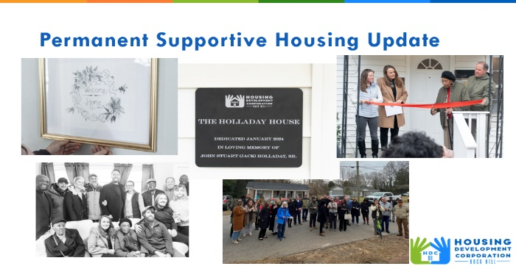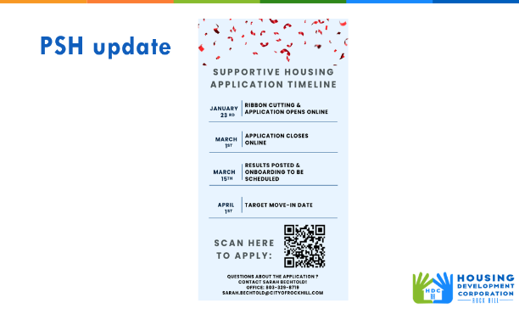

Corinne gave an update on the 3 Year Strategic Plan that was enacted 2022.

Highlights on how HDC has implemented projects and programs in the 3 Year Strategic Plan

|  |  |  |
| --- | --- | --- |
| * First-Time Homebuyer Assistance | * New Home Construction- completed 2 and sold, moving to next set of new-builds | * Rental home support   Expand rental/utility assistance efforts to increase opportunity- |
| * Support other community groups in fixing homes – partnered with Habitat | * Promote HDC’s goals and programs at community events | * Owner -Occupied Rehab * Track number on waitlist/resolve issues * Use the new application process (next year) |

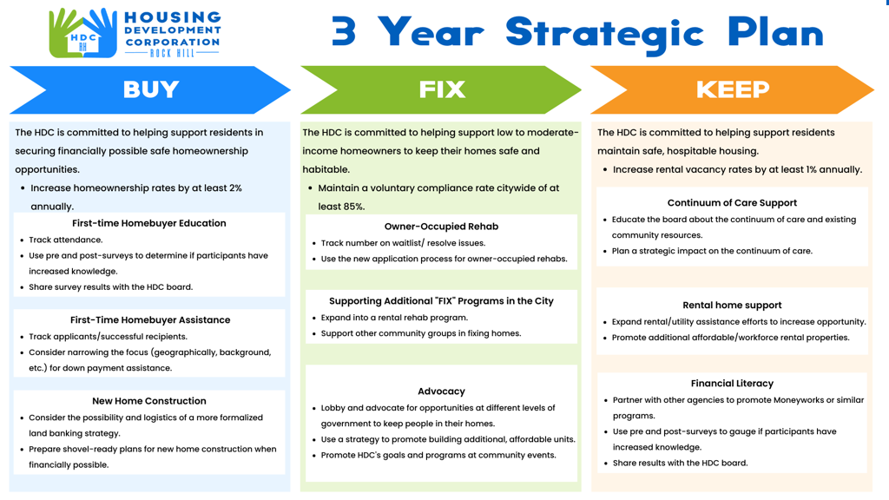

**New Business**

Heir’s Property

Jordan advised that he attended a meeting with Center for Heir’s property preservation organization, in the low country. Their goals are to assist homeowners who currently have their property tied up in family ownership, sorting out ownership, wills, creating wills, etc. They also provide education and legal services to families for them to be able to do whatever they want to do with their property. Jordan further advised that Stephanie Barnett with Habitat, Elaine Wilmore with Clinton Connection Action Plan and SC legal services were in attendance. Our goal is to lay the groundwork in the community before the Center for Heir’s property expands to this area. The Center for Heir’s property currently does not serve our area. The way to lay the groundwork is to provide an educational seminar here in the community about heir’s property and legal education. SC legal services agreed to help get local attorneys engaged so that people can receive legal counsel until the Center for Heir’s Property expands to this area. The estimated cost for the educational seminar is $2200. Jordan advised that the cost will probably be split with Habitat.

Habitat has their own initiative geared toward heirs’ property preservation so they are really going to take the ball and run with it with Clinton Connection Action plan to get the word out in the community and get their buy in on this sort of initiative. The educational seminar will probably take place late spring or early summer.

Phyllis advised that until that time, we need to think about how heirs’ property information is communicated throughout the community. Jordan advised that Elaine Wilmore and Stephanie Barnett advised that pamphlets will be created and distributed at community events as well as churches.

Danielle informed that today is Beverly’s birthday, and Sarah will be married by the March meeting. Congratulations from the board!

David LeGrande asked about Osceola, and Corinne advised that information will be provided at the March meeting.

**Adjourn**

With no further business, motion was made, seconded, and unanimously approved to adjourn.

Meeting adjourned at 9:34 a.m.

Upcoming Events/Meetings: HDCRH Board Meeting, 8:30 a.m., March 7, 2024.

Submitted by: _____________________  
 Beverly Buchanan, Secretary  
 Date: February 14, 2024

______________________  
Chairman/Vice Chairman  
Date: