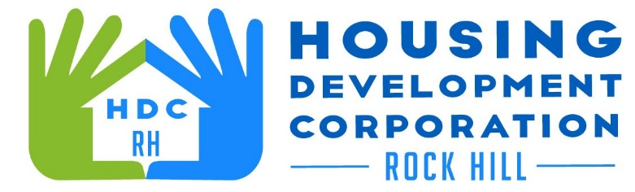

HDCRH MEETING

**December 12, 2024**

8:30 a.m.

Operations Center Rm. 136

1. Call to Order
2. Approval of November 14, 2024, meeting minutes.

3) Staff Reports

1. Financials and Development Division Reports

1. Old Business
   1. Strategic Plan Update
2. New Business
   1. Year in Review
3. Adjourn

Next Meeting: January 9, 2024 8:30am Operations Center Rm. 136

***Mission Statement:*** *The mission of the Housing Development Corporation of Rock Hill is to provide and improve housing opportunities for low-to moderate-income residents.*

***Vision:*** *Inform. Educate. Empower. By providing homeownership education and assistance; rehabilitation assistance to owner-occupied homes; increasing affordable housing options; and offering foreclosure prevention counseling.*

## Board Member Attendance 11/12/2024

Present:

* Walter Hardin-Chair
* Anne Lambert-Vice Chair
* Phyllis Fickling
* Sharon Hines
* Will Jordan
* Mary Reid
* David LeGrande
* Sandra Oborokumo

Absent:

* Brent Faulkenberry
* Perry Sutton
* Warren Baxter
* Naomi Carpenter
* Tom Roper