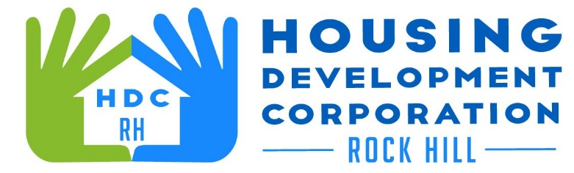

HDCRH MEETING

**November 10, 2022**

8:30 a.m.

City Hall Room 373

1. Call to Order
2. Approval of September 8, 2022, meeting minutes.

3) Staff Reports

1. Financials and Development Division Reports

1. New Business
   1. Review of 2021 Impact Report
2. Adjourn

Next Meeting: **8:30 am., December 8, 2022**

***Mission Statement:*** *The mission of the Housing Development Corporation of Rock Hill is to provide and improve housing opportunities for low-to moderate-income residents.*

***Vision:*** *Inform. Educate. Empower. By providing homeownership education and assistance; rehabilitation assistance to owner-occupied homes; increasing affordable housing options; and offering foreclosure prevention counseling.*