Housing Development Corporation of Rock Hill Board Meeting

Thursday, December 14, 2023

A Board Meeting was held Thursday, December 14, at 8:30 a.m. at City Hall, Room 373.

Members present: Walter Hardin, Anne Lambert, Sharon Hines, David LeGrande, Will Jordan, Mary Reid, Kathy Pender, Sandra Oborokumo, Derrick Lindsay

Members absent: Tom Roper, Naomi Carpenter, Phyllis Fickling, Perry Sutton, Nakia McGraw, Patricia McClurkin Sibley

Staff Present: Corinne Sferrazza, Ryan Powell, Jordan Hamrick, Beverly Buchanan, Miguel Rullan, David Martin, Sarah Bechtold, Danielle Sanders

Call to Order: Walter Hardin called the meeting to order at 8:34 a.m. and thanked everyone for attending.

Minutes of the November 9, meeting was reviewed. Walter Hardin asked for a motion that the minutes be approved as presented. Will Jordan made a motion to approve. Sandra Oborokumo made the second. Unanimous approval.

**Staff Reports**

**A. Financials**

Financial information was shared with Board members. Financial information can be e-mailed, or a hard copy can be mailed to Board Members if requested. Account balance information for the South State Community Checking Account (Sunset Park Houses) is $33,779.79. The Wells Fargo Account (HDC rentals) balance is $62,677.43. The TD Bank (Cottages) balance is $42,689.06. The NSP Rental Properties balance is $21,880.01. The TD General account is the main account with the most activity that includes utility and rental assistance transactions, deposits for assistance and proceeds for home sales, the balance is $297,512.43. Total Unrestricted Funding as of 11/30/2023: $111,692.32.

|  |  |
| --- | --- |
| **Finances** | |
| **Total Funds as of 11.30.2023** | **$644,169.29** |
| Restricted for Rental Properties | $161,026.29 |
| Restricted Grant Funds | $990.78 |
| Restricted/Held Funds for Projects | $370,459.90 |
| **Total unrestricted funds as of 10.31.23** | **$111,692.32** |

**Development Division Report  
BUY**

**New Construction**

1454 Crawford Rd.

* Listing price: $250,000
* Under contract: $240.000
* Anticipated closing date: 01/05/2024

233 Baker Street

* + Listing Price: $200,000
  + Under contract: $195,000
  + Anticipated closing date: 12/29/2023

**647 E. Black Street**

Total Development cost: $93,300

Ryan Powell advised that permits has been applied for and have received the first set of review comments. Currently working with contractor, architect and Planning to address their concerns.

The plan is to sell the property.

**First Time Homebuyers** –

Jordan Hamrick advised on November FTHB students

Students - 30

Students who received certificates – 5

Closings with assistance – 1 in progress

Counseling sessions – 15

Opted for In-person – 25

Opted for Remote learning – 5

# enrolled in next in-person class - 6

Remaining 22/23 Funding: $3,070

FTHB Proposed CDBG 23/24 Funding - $70,000

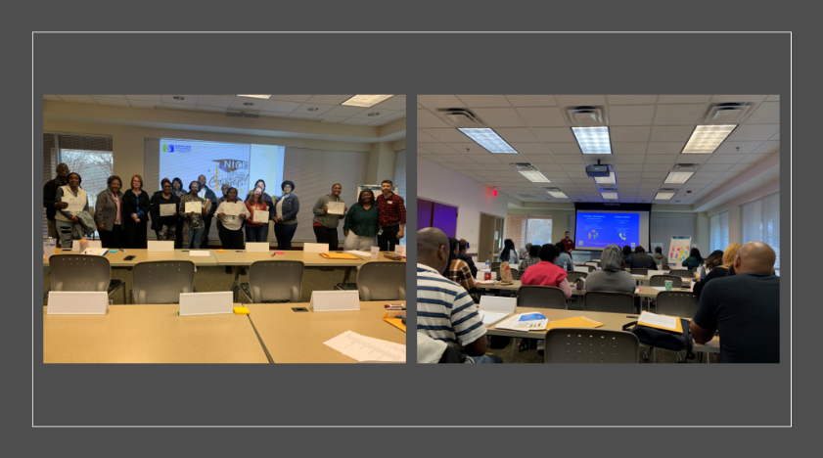

**FIX**

**Rehab Projects- CDBG – Southside Home Improvement Program (SHIP)**

|  |  |
| --- | --- |
| **Stage** | **Amount of Units** |
| **Pre-Work** | **1** |
| **Bidding** | **0** |
| **In Construction** | **0** |

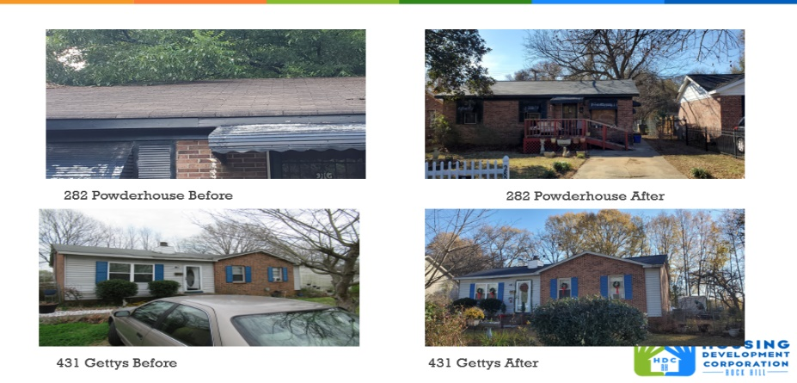

**Rehab Projects- – CDBG – Owner Occupied Rehab**

|  |  |
| --- | --- |
| **Stage** | **Amount of Units** |
| **Pre-Work** | **1** |
| **Bidding** | **0** |
| **In Construction** | **0** |
| **Complete** | **0** |

**Rehab Projects - HTF**

|  |  |
| --- | --- |
| **Stage** | **Amount of Units** |
| **Beneficiary Eligibility** | **0** |
| **Preliminary Property Eligibility** | **0** |
| **Preliminary Scope of Work** | **0** |
| **Full Home Repair App, SOW Inspection & Contractor Cred** | **0** |
| **Hazardous Material Notification** | **0** |
| **Financial Commitments** | **0** |
| **In Construction** | **0** |
| **Complete** | **0** |

**Rehab Projects**

CDBG 23/24

OOR - $18,594

Volunteer Projects - $40,000

SHIP - $30,164

Eligible households on the waitlist: 72

**KEEP**

**Homeless Prevention Assistance**

Sarah advised that during the month of November the following households were served

Rental – 1 household assisted - $1,514.30 spent

Mortgage- 0 household assisted - $0 spent

Utilities – 0 household assisted - $0 spent

**Funding Sources Remaining**

Sarah advised that HDC is officially out of funding for rental assistance

Emergency Solutions Grant – ESG

Provides rental assistance, rent deposits, (30% AMI)

$0

EFSP (Emergency Food and Shelter Program) –

Provides rent, utility, and mortgage assistance

Total funding: $0

Phase 40 award - $0

Rapid Rehousing Update

Awarded a new round - $31,716

RRH Counseling sessions: 4

Benefits counseling sessions: 3

Miguel Rullan advised that he is still working on onboarding people from the area prioritization list. It has been difficult getting people into the program due to various reasons.

**Rental Properties**

Danielle Sanders advised on the following rental properties during the month of November

|  |  |  |  |
| --- | --- | --- | --- |
| Gross income: $20,822 | Net income: $5,227.47 | Total properties: 30 | Total persons served: 63 – (1 vacancy) |

**Old Business**

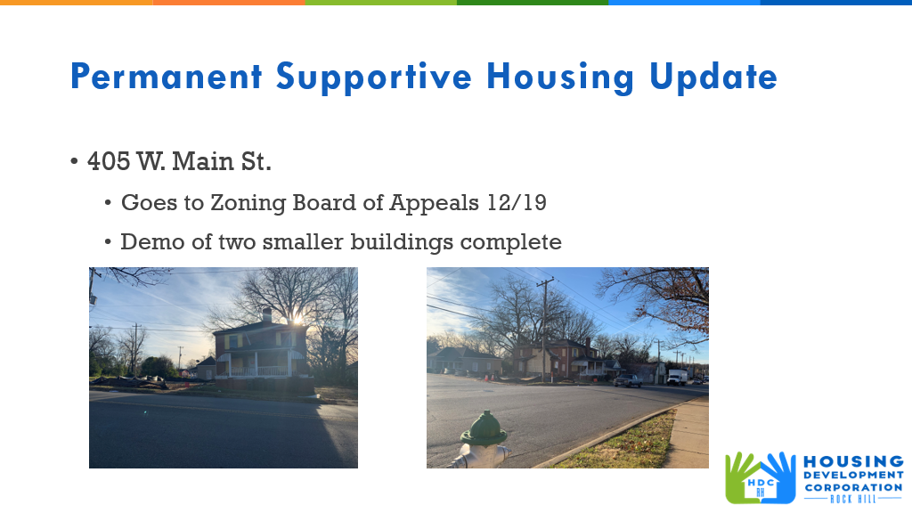

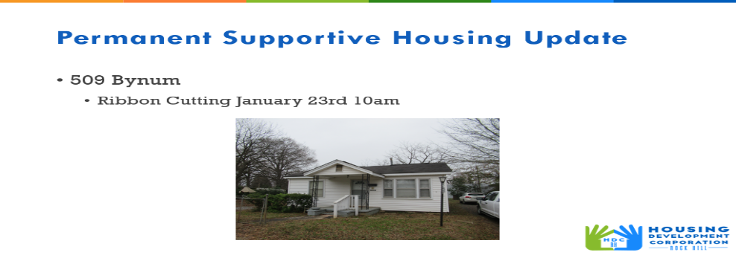

Corinne advised that Sarah will be working on Permanent Supportive housing guidelines to make sure they fit with HUD guidelines.

Corinne advised that the ribbon cutting for 509 Bynum is January 23rd at 10am. We will be getting a plaque in honor of Jack Holladay to put on the house, since it’s the ‘Holladay House’. We’re going to ask the mayor to speak, along with Laura Holladay as this house would not have been possible without the Holladay donation.

Corinne advised that HDC received a donation on December 13th, from Kathy Pender, the goal for this donation is to buy appliances for permanent supportive housing.

Ryan advised that January 5th, HDC staff will have a cleaning workday at 509 Bynum, everyone is welcome to participate.

**New Business**

Sandra Oborokumo thanked HDC staff for their work.

Derrick Lindsay advised that today is Kathy Pender’s last HDC board meeting, she is retiring. The HDC board and staff thanked her for her service.

**Adjourn**

With no further business, motion was made, seconded, and unanimously approved to adjourn.

Meeting adjourned at 9:23 a.m.

Upcoming Events/Meetings: HDCRH Board Meeting, 8:30 a.m., January 11, 2024.

Submitted by: _______________________  
 Beverly Buchanan, Secretary  
 Date: December 18, 2023

______________________  
Chairman/Vice Chairman  
Date: