Housing Development Corporation of Rock Hill Board Meeting

Thursday, February 10, 2022

A Board Meeting was held Thursday, January 13, at 8:30 a.m. via Microsoft Teams.

Members on Call: Walter Hardin, Will Jordan, Derrick Lindsay, Sandra Oborokumo, Phyllis Fickling, Naomi Carpenter, Mary Reid, Anne Lambert

Members absent: David LeGrande, Tom Roper, Sharon Hines, Nakia McGraw, Patricia McClurklin

Staff On Call: Corinne Sferrazza, Jennifer Wilford, Beverly Buchanan, Jordan Hamrick, Ed Causebrook, Ryan Powell, Sarah Bechtold, Danielle Sanders

Guest: Harley Hubbard

Call to Order: Walter Hardin called the meeting to order at 8:33 a.m. and thanked everyone for attending.

Minutes of the January 13, meeting was reviewed. Walter Hardin asked for a motion that the minutes be approved as presented. Motions were made for the minutes, seconded, and unanimously approved.

**Staff Reports**

Financials  
Financial information was shared with Board members. Financial information can be e-mailed, or a hard copy can be mailed to Board Members if requested. Account balance information for the South State Community Checking Account is $368,580.93. South State Money Market Account balance is $7,533.34. The Wells Fargo Account is used for rental properties and the balance is $63,561.20. The TD General account is the main account with the most activity that includes utility and rental assistance transactions, deposits for assistance and proceeds for home sales, the balance is $319,475.12.

Development Division Report  
BUY

**New Construction**

New construction is on hold.

**First Time Homebuyers** –

Jordan Hamrick advised that in January there were 20 students.

Students that received certificates – 4

Closings with assistance – 0

Counseling sessions – 4

**FIX**

**Rehab Projects**

|  |  |
| --- | --- |
| 565 Washington St – Ward 1 – Roof replacement | 380 Baker St. – Ward 1 |
| 1576 Brentfield Dr. – Ward 1 – Water leaks | 710 Rockwood Dr. – Ward 5 |
| 347 Frank St. – Ward 1 - HVAC | 614 Arch Dr. - Ward 5 - HVAC |
| 759 Rockwood Ward 5 – kitchen, bathroom | 1153 Constitution Blvd. – Ward 1 |
| 927 Saluda – Ward 5 – roof, water leak, bathroom | 314 Whitner St. – Ward 5 |
| 770 Green St. – Ward 1 - bathroom | 830 Saluda St. – Ward 5 |
| 1518 Crawford – Ward 1 - roof |  |
| 127 Highland St. – Ward 5-Roof/structural repair |  |
| 522 Keels Ave – Ward 5 – Bathroom/structural |  |
| 431 Gettys St. – Ward 1 |  |

Eligible households on the waitlist: 157

**KEEP**

**Homeless Prevention Assistance**

Sarah Bechtold advised that during the month of January the following households were served.

Rental – 14 households assisted - $34,894.69 spent

Mortgage- 0 household assisted - $0 spent

Utilities – 16 households assisted - $8,212.43 spent

ESG (Emergency Solutions Grant) – Coronavirus Phase II (ESG-CVII)

Provides rental assistance, rent deposits, utility assistance, and utility deposits (50% AMI)

$599,144.65 spent total, $39,437.49 remaining

Community Development Block Grant – Coronavirus (CDBG-CV)

Mortgage assistance – $3,752.00 left in funding

Rental Assistance - $2,045.80 left in funding

**Rent**

**Rental Properties**

Danielle Sanders advised on the following rental properties during the month of January

|  |  |  |  |
| --- | --- | --- | --- |
| Gross income: $16,656.41 | Net income: $12,638.61 | Total properties: 27 | Total persons served: 63 |

**Sunset Park SRDP**

6 affordable rental units – 30%, 60% and 80% AMI -1 mobility unit, 1 sensory unit

* 3 Tenants officially moved into units -
  + 460 Fewell – Occupied
  + 753 Carolina - Occupied
  + 360 Scoggins – Occupied
* 371 Baker – Occupied

353 Baker – Tenant is scheduled to move in on February 16th

813 Harrison –Have tenant approved, waiting on CO

* 859 Finley View – Workforce housing – 120% AMI – Occupied as of January 20th
* 307 Workman – Tenant is scheduled to move in on March 1st.

**Counseling Sessions**

Corinne advised on counseling sessions for January.

Benefits sessions: 0 Foreclosure sessions: 0 Rapid Rehousing sessions: 8

**Special Report:**

**Staff Updates:**

Corinne advised that Miguel Rullan from Neighborhood Services will be joining HDC on February 14th, as the new Case Manager.

**Client Stories:**

Sarah shared client stories with board members

**New Business**

**Housing Development Committee Update**

Walter Hardin advised that the sub-committee has met and made the following recommendations. Ed Causebrook gave an overview of the recommended updates, as well as the guidelines for HTF and CDBG funding.

Ed further advised on the following concerns:

* Current rehab applicants on the wait list will not be dropped from the rehab program
* Current rehab applicants that do not fall within the new eligible activities will be placed on a volunteer list. Applicants will be contacted and advised of the volunteer projects available to see if they would like to receive services.

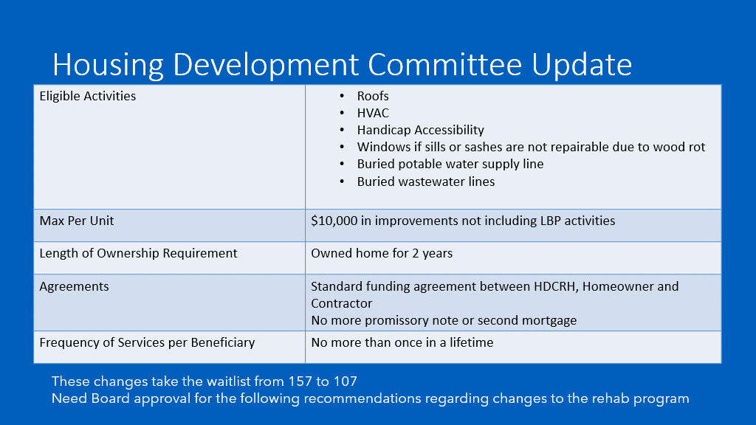

After considerable discussion, Corinne asked for clarity regarding the frequency of services, whether the board wanted it specific to beneficiary or the property. The board clarified that it should be limited to the beneficiary only and not the property.

* Current rehab applicants will receive a letter advising of the new changes made to the program

After discussion, Walter Harden made a motion that the HDC Board adopt therecommendations as presented by the sub-committee, and Naomi Carpenter seconded the motion and the motion passed unanimously.

**Miscellaneous Business**

**Veteran House Update**

The VET house is complete with certificate of occupancy

With no further business, motion was made, seconded, and unanimously approved to adjourn the meeting.

Meeting adjourned at 9:31 a.m.

Upcoming Events/Meetings: HDCRH Board Meeting, 8:30 a.m. March 10, 2022.

Submitted by: _______________________  
 Beverly Buchanan, Secretary  
 Date: February 15, 2022

______________________  
Chairman/Vice Chairman  
Date: