Housing Development Corporation of Rock Hill Board Meeting

Thursday, March 9, 2023

A Board Meeting was held Thursday, March 9, at 8:30 a.m. at City Hall, Room 373.

Members present: Will Jordan, Anne Lambert, Phyllis Fickling, Perry Sutton, Naomi Carpenter, Sandra Oborokumo, Sharon Hines, Mary Reid, Tom Roper

Members absent: Walter Hardin, David LeGrande, Kathy Pender, Nakia McGraw, Patricia McClurkin Sibley

Staff Present: Corinne Sferrazza, Jordan Hamrick, Beverly Buchanan, Ryan Powell, Sarah Bechtold, Miguel Rullan, Danielle Sanders, Ariah Massey, Hakim Diaz, Jennifer McAdams, Mary Beth Edwards

Guest: Harley Hubbard

Call to Order: Anne Lambert called the meeting to order at 8:32 a.m. and thanked everyone for attending.

Minutes of the February 9, meeting was reviewed. Anne Lambert asked for a motion that the minutes be approved as presented. Motions were made for the minutes, seconded, and unanimously approved.

**Staff Reports**

**A. Financials**

Financial information was shared with Board members. Financial information can be e-mailed, or a hard copy can be mailed to Board Members if requested. Account balance information for the South State Community Checking Account (Sunset Park Houses) is $82,509.24. The Wells Fargo Account (HDC rentals) balance is $64,499.60. The TD Bank (Cottages) balance is $30,226.68. The NSP Rental Properties balance is $17,469.34. The TD General account is the main account with the most activity that includes utility and rental assistance transactions, deposits for assistance and proceeds for home sales, the balance is $253,185.00.

Corinne advised that she has re-created the Financial Summary Report which has more details and will be submitted each month going forward.

**Development Division Report**BUY

**New Construction**

Southside Properties – Planning Stage

Will be for sale units

1454 Crawford Rd. – 3 Bedroom 2 Bath

TDC- $158,839.80

233 Baker Street – 2 Bedroom 1 Bath

$146,517.65

Contract signed waiting for timeline

**First Time Homebuyers** –

Jordan Hamrick advised that in February there were 19 students.

Students who received certificates – 19

Closings with assistance – 0

Counseling sessions – 15

Opted for In-person – 16

Opted for Remote learning – 3

# enrolled in next in-person class - 23

Next FTHB class on Saturday, April 8, 2023, 8:30am-12:30pm

FTHB Proposed CDBG 23/24 Funding - $70,000

**FIX**

**Rehab Projects- CDBG**

|  |  |
| --- | --- |
| **Stage** | **Amount of Units** |
| **Pre-Work** | **11** |
| **Bidding** | **0** |
| **In Construction** | **0** |
| **Complete** | **0** |

**Rehab Projects – HTF**

|  |  |
| --- | --- |
| **Stage** | **Amount of Units** |
| **Pre-Work** | **3** |
| **Bidding** | **0** |
| **In Construction** | **0** |
| **Complete** | **0** |

**Corinne reported:**

Rehab Projects

CDBG 21/22 Remaining - $840.34

CDBG 22/23 Remaining - $98,965

Proposed CDBG 23/24 OOR - $100,000

Volunteer Projects - $40,000

Eligible households on the waitlist: 84

Planning for World Changers and Salkehatchie summer of 2023 - Volunteers

World Changers – 11 projects - will focus mainly on roof replacements, exterior siding, and painting – June 19-24, 2023.

United Methodist group Salkehatchie – 3 projects - 40-50 volunteers – June 24-July 1, 2023

Project Sweat (WestMinster) will begin mid-July 2023

Projects mostly in Ward 1&2

Ryan advised that the administrative work has begun for the summer projects

**KEEP**

**Homeless Prevention Assistance**

Sarah advised that during the month of February the following households were served.

Rental – 10 households assisted - $17,963.50 spent

Mortgage- 0 household assisted - $0 spent

Utilities – 24 households assisted - $13,328.03 spent

**Funding Sources**

Emergency Solutions Grant – ESG

Provides rental assistance, rent deposits, utility assistance, and utility deposits (30% AMI)

$1,173.68

Community Development Block Grant – Coronavirus (CDBG-CV)

Mortgage assistance – $0 left in funding

Rental Assistance - $0 left in funding

Utility Assistance For Working Families

United Way funded program

Provides utility assistance for working families in York County

Completed funding: served 28 households – 90 clients

EFSP (Emergency Food and Shelter Program) –

Provides rent, utility, and mortgage assistance

Total funding: $85,078.54 (waiting for second ½) Phase 40 award - $55,000

**Rental Properties**

Danielle Sanders advised on the following rental properties during the month of February

|  |  |  |  |
| --- | --- | --- | --- |
| Gross income: $17,801 | Net income: $2,997.85 | Total properties: 30 | Total persons served: 66 |

New homeowner moving in 297 Cornelius Drive - HDC rentals are now at 100 % occupancy

**Counseling Sessions**

Counseling sessions for February

Benefits sessions: 0 Foreclosure sessions: 0 Rapid Rehousing sessions: 0

**Client Stories**

Sarah Bechtold shared a client story

**Old Business**

1. **LifeHouse MOU & Agreement Update**

HDC Donates property at 746 McDow Drive to Life House Women’s Shelter

MOU approved

Agreement being circulated

 Corinne thanked the HDC board members for their quick response in approving the MOU agreement.

After discussion regarding the Purchase and Sale agreement, it was suggested to change Item #5 years from the date of conveyance of the property to thirty (30). Corinne advised that she is going to make the suggestion.

Corrine advised the next focus will be Reviewing bylaws and board expectations, which will roll out piece by piece

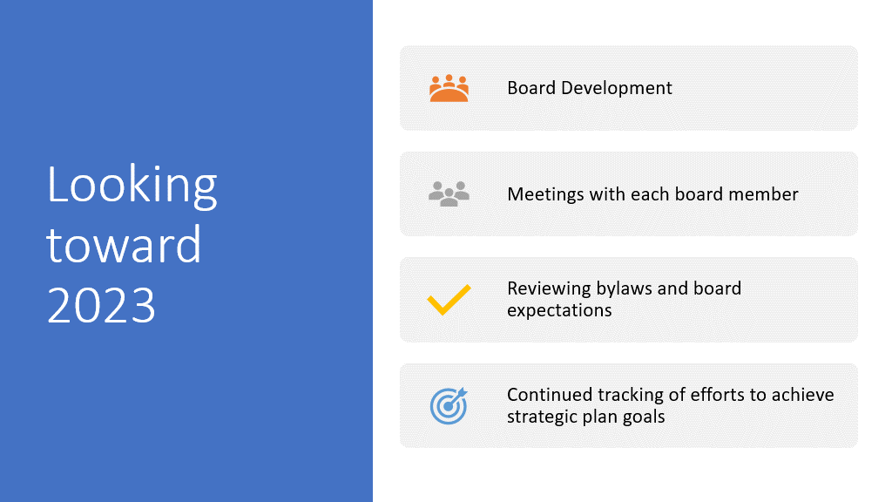

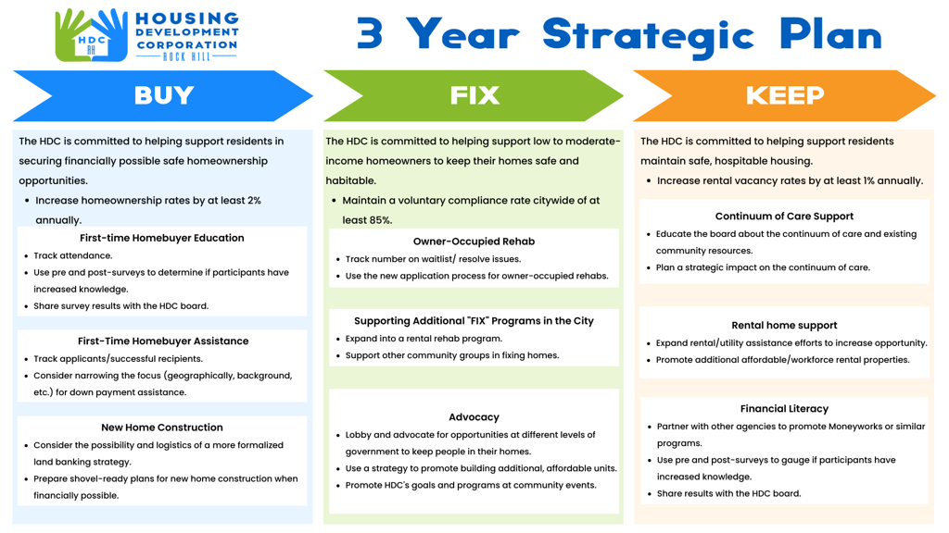

**New Business**

**Amazon Wish List**

* The HDC has created an Amazon wish list – Amazon.com

**Staff Member Update**

* Jennifer McAdams

Jennifer advised that today is her last HDC board meeting, she is leaving the City of Rock Hill and her last day is March 28, 2023.

Jennifer stated that it has been an honor and pleasure to work with the HDC board and to see how far it has come; and looking forward to where it is going.

With no further business, motion was made, seconded, and unanimously approved to adjourn.

Meeting adjourned at 9:06 a.m.

Upcoming Events/Meetings: HDCRH Board Meeting, 8:30 a.m., April 13, 2023.

Submitted by: _______________________  
 Beverly Buchanan, Secretary  
 Date: March 14, 2023

______________________  
Chairman/Vice Chairman  
Date: