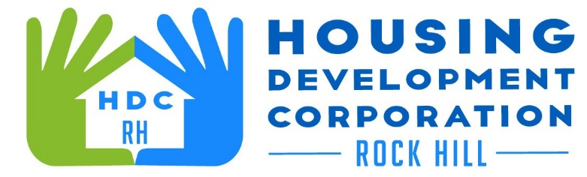

HDCRH MEETING

**April 8, 2021**

8:30 a.m.

via Zoom Meetings

1. Call to Order
2. Approval of February 11, 2020 minutes.

3) Staff Reports (included in packet)

1. Financials and Development Division Reports

1. Old Business
   1. Vet Benefit (Hero House) update
2. New Business
   1. Staff updates
3. Miscellaneous Business
4. Adjourn

Next Meeting: 8:30 a.m., May 13, 2021

***Mission Statement:*** *The mission of the Housing Development Corporation of Rock Hill is to provide and improve housing opportunities for low-to moderate-income residents.*

***Vision:*** *Inform. Educate. Empower. By providing homeownership education and assistance; rehabilitation assistance to owner-occupied homes; increasing affordable housing options; and offering foreclosure prevention counseling.*