Housing Development Corporation of Rock Hill Board Meeting

Thursday, July 14, 2022

A Board Meeting was held Thursday, July 14, at 8:30 a.m. at City Hall, Room 373.

Members present: Walter Hardin, Anne Lambert, Will Jordan, Sandra Oborokumo, Sharon Hines, David LeGrande, Mary Reid, Phyllis Fickling,

Members absent: Tom Roper, Nakia McGraw, Patricia McClurkin Sibley, Kathy Pender, Perry Sutton

Staff Present: Corinne Sferrazza, Jennifer McAdams, Jordan Hamrick, Beverly Buchanan, Ryan Powell, Ed Causebrook, Danielle Sanders

Guest: Alexis Simpson, Harley Hubbard

Call to Order: Walter Hardin called the meeting to order at 8:38 a.m. and thanked everyone for attending.

Minutes of the June 9 meeting was reviewed. Walter Hardin asked for a motion that the minutes be approved as presented. Motions were made for the minutes, and seconded, but there was not a quorum to approve the minutes.

**Staff Reports**

**A. Financials**

Financial information was shared with Board members. Financial information can be e-mailed, or a hard copy can be mailed to Board Members if requested. Account balance information for the South State Community Checking Account (Sunset Park Houses) is $230,817.39. The Wells Fargo Account (HDC rentals) balance is $49,080.94. The TD Bank (Cottages) balance is $36,037.78. The NSP Rental Properties balance is $33,077.34. The TD General account is the main account with the most activity that includes utility and rental assistance transactions, deposits for assistance and proceeds for home sales, the balance is $321,608.69.

Development Division Report  
BUY

**New Construction**

Southside Properties – Planning Stage

Will be for sale units

Ed Causebrook advised that he is identifying 2 lots to be used for construction

**First Time Homebuyers** –

Jordan Hamrick advised that in June there were 33 students.

Students that received certificates – 22

Closings with assistance – 0

Counseling sessions – 8

**FIX**

Ryan Powell reported on the owner-occupied rehab projects

**Rehab Projects- CDBG**

|  |  |
| --- | --- |
| **Stage** | **Amount of Units** |
| **Pre-Work** | **4** |
| **Bidding** | **2** |
| **In Construction** | **2** |
| **Complete** | **2** |

**Rehab Projects – HTF**

|  |  |
| --- | --- |
| **Stage** | **Amount of Units** |
| **Pre-Work** | **4** |
| **Bidding** | **0** |
| **In Construction** | **1** |
| **Complete** | **1** |

**Corinne reported:**

CDBG Funding Remaining - $171,590.26

Eligible households on the waitlist: 116

Ryan advised on the youth volunteer groups Rehab Projects

* St. John’s United Methodist youth group @ 1114 Flint Street – HDC rental property
* Westminster Church – Project Sweat @ 770 Green Street -CBDG project

**KEEP**

**Homeless Prevention Assistance**

Corinne advised that during the month of June the following households were served.

Rental – 7 households assisted - $14,392.69 spent

Mortgage- 0 household assisted - $0 spent

Utilities – 13 households assisted - $8,745.08 spent

ESG (Emergency Solutions Grant) – Coronavirus Phase II (ESG-CVII)

Provides rental assistance, rent deposits, utility assistance, and utility deposits (50% AMI)

$480,924.24 spent total, $11,606.52 remaining

Community Development Block Grant – Coronavirus (CDBG-CV)

Mortgage assistance – $0 left in funding

Rental Assistance - $16,920.86 left in funding

EFSP (Emergency Food and Shelter Program) –

$250,000 has been awarded by United Way, to be used for rental, utility, and mortgage

Funds have not been distributed yet

Utility Assistance For Working Families

United Way funded program

Provides utility assistance for working families in York County - $8000

**Rent**

**Rental Properties**

Danielle Sanders advised on the following rental properties during the month of June

|  |  |  |  |
| --- | --- | --- | --- |
| Gross income: $12,047.32 | Net income: $13,971.70 | Total properties: 30 | Total persons served: 50 |

**Counseling Sessions**

Corinne reported on counseling sessions for June.

Benefits sessions: 1 Foreclosure sessions: 0 Rapid Rehousing sessions: 3

**B. Supportive Housing Update**

Corinne gave an overview of the follow-up Supportive Housing Meeting

* 310 Maple St.
* 3 Service Providers applied
* 1 Application with 2 providers on the same application
* Family Promise of York County chosen as provider

Family Promise has identified a client to move in

**New Business**

**Strategic Plan approval**

**After discussion regarding heir’s property, it was decided that it will fall under the Fix-Advocacy category of the strategic plan. Phyllis Fickling made a motion to accept the 3-year Strategic Plan as written, motion was seconded by Sandra Oborokumo and passed unanimously.**

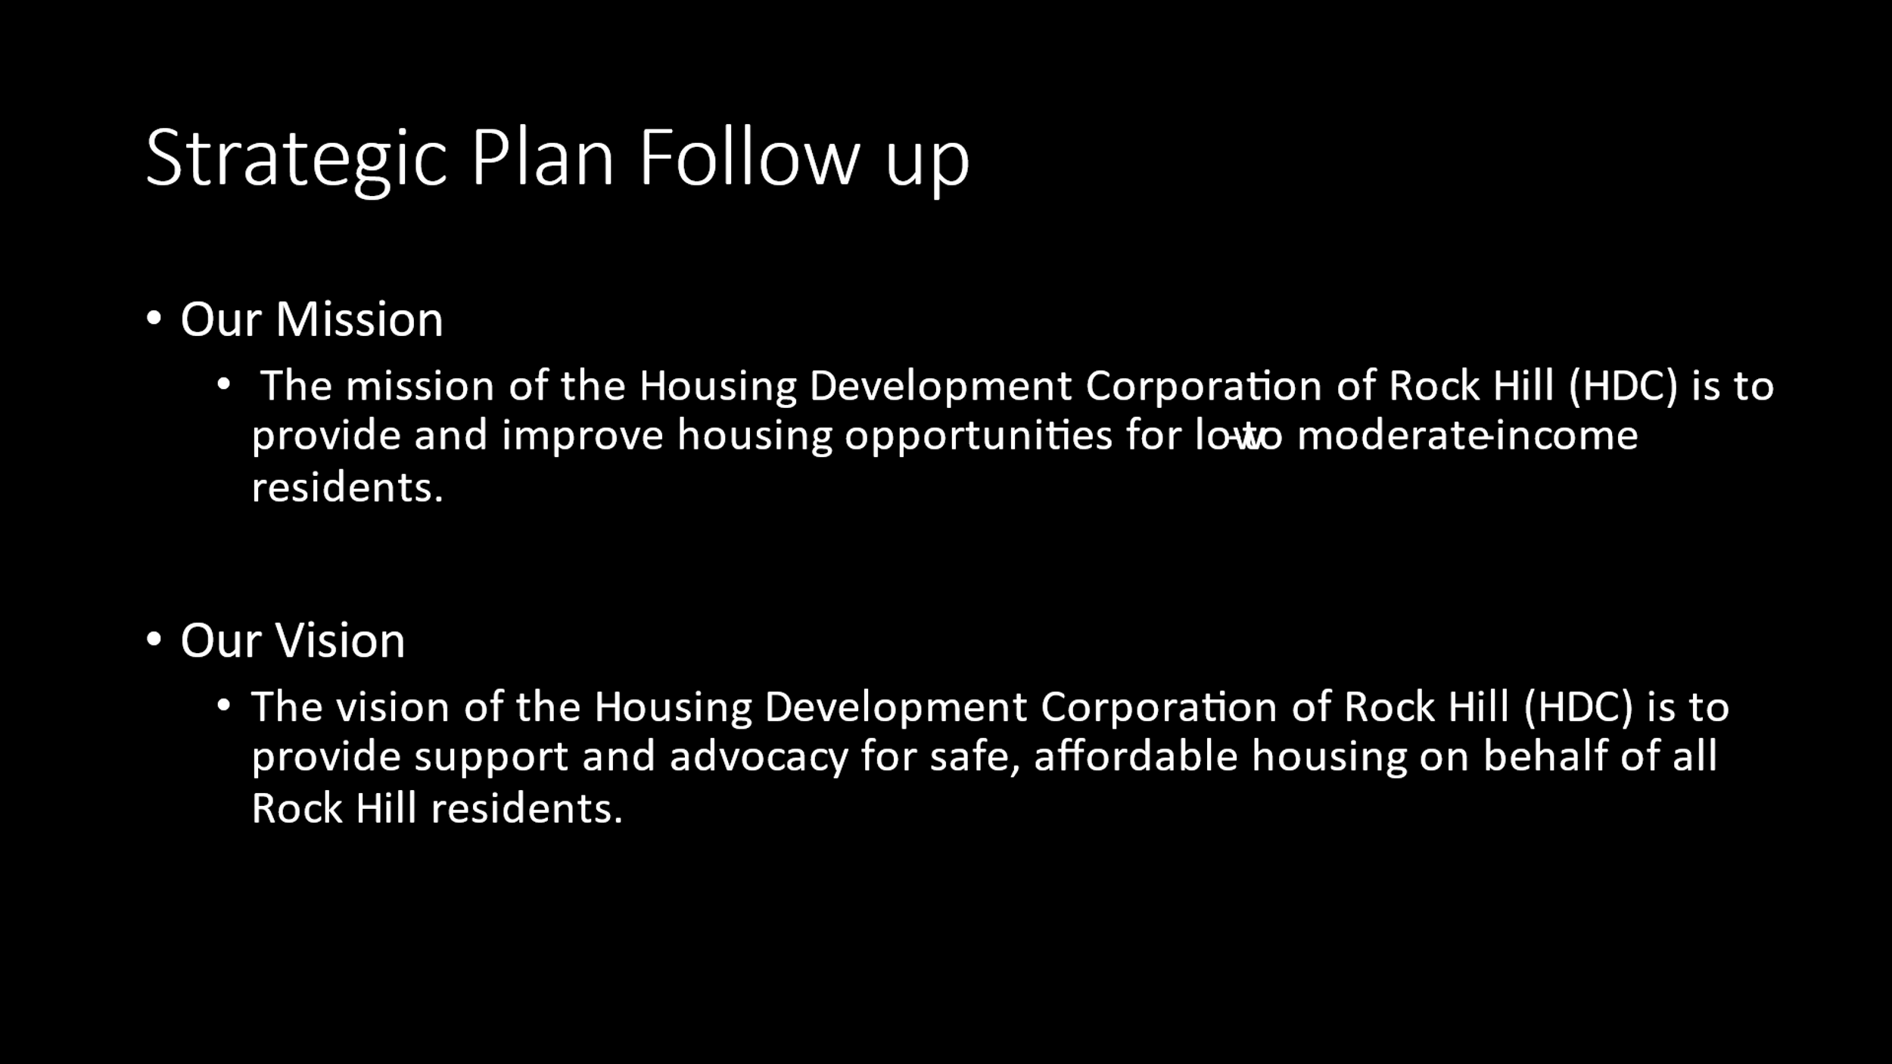

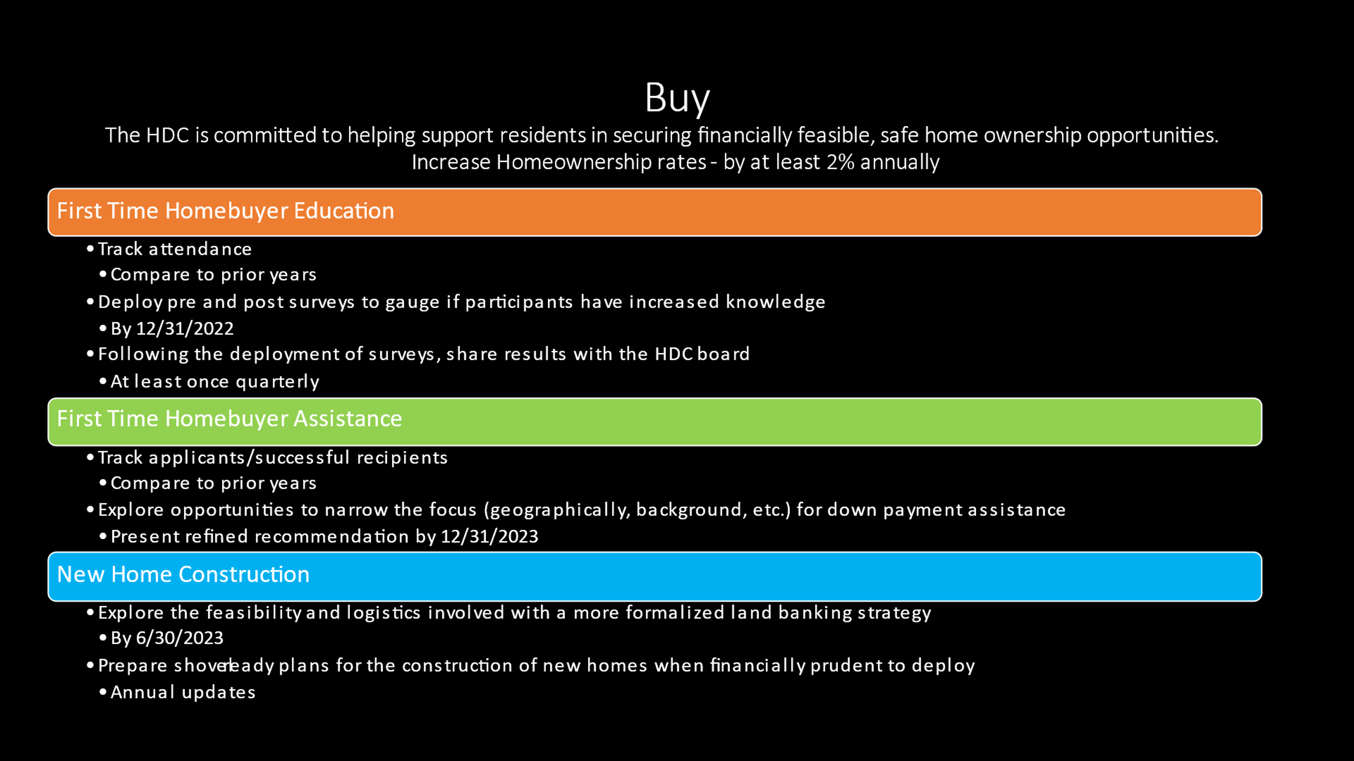

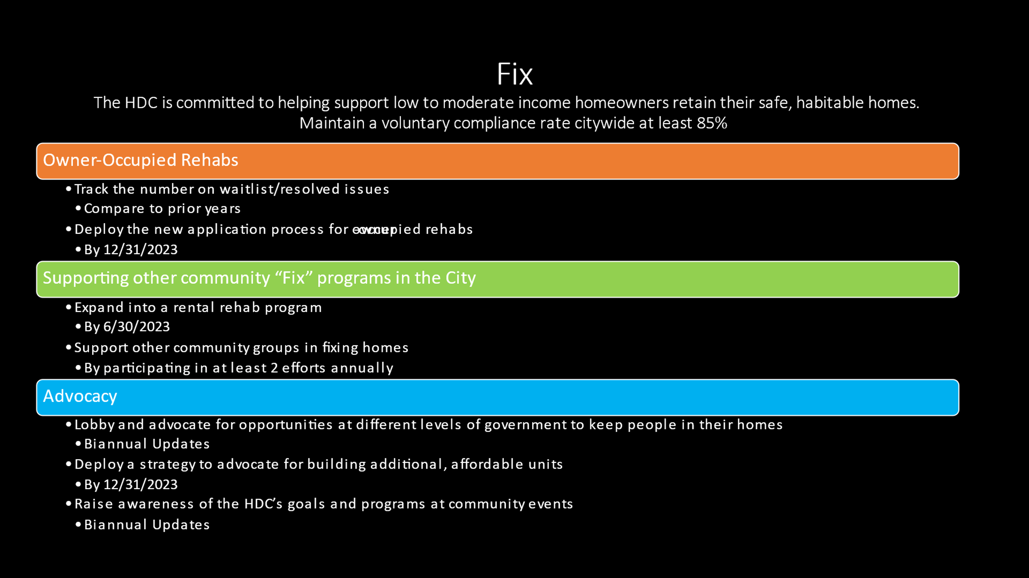

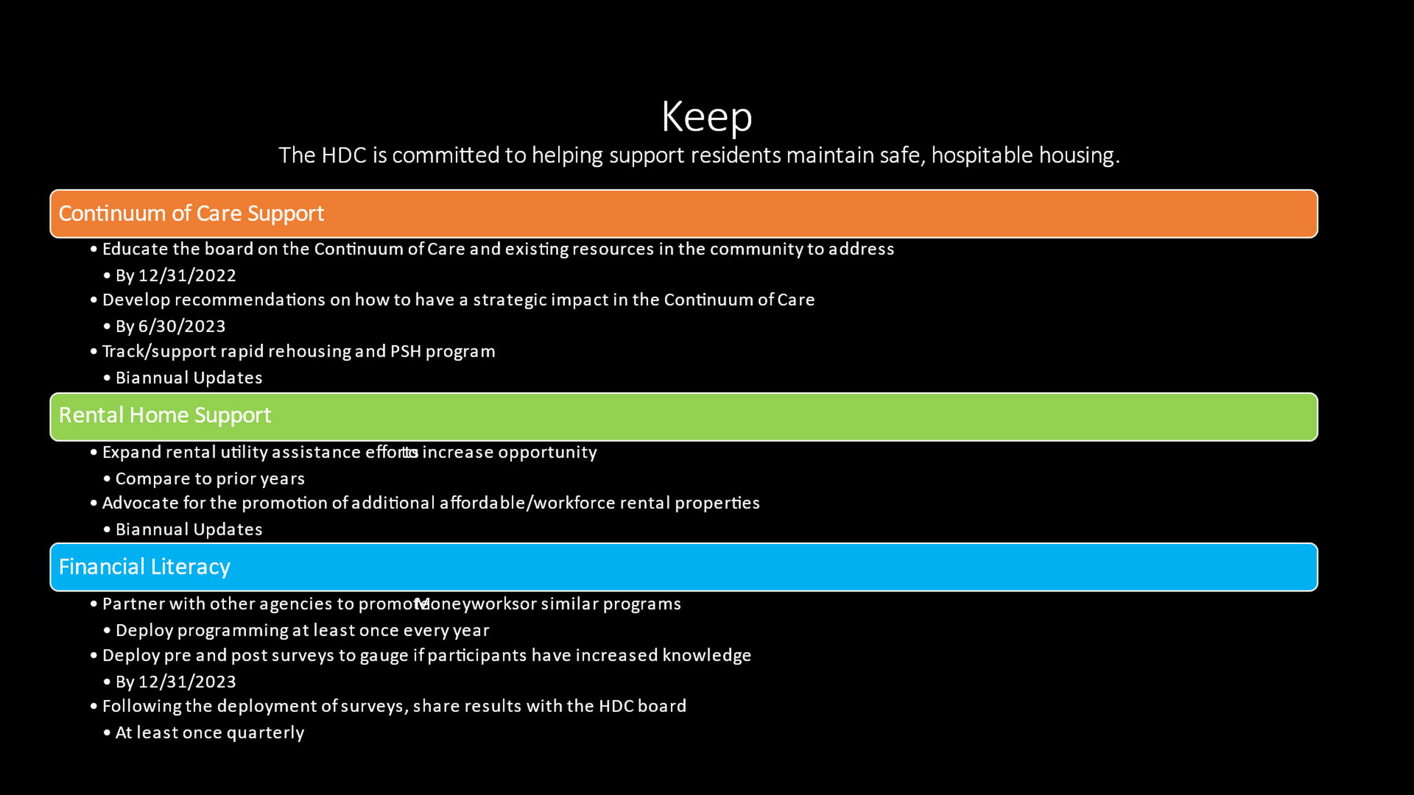

With no further business, motion was made, seconded, and unanimously approved to adjourn the meeting.

Meeting adjourned at 9:19 a.m.

Upcoming Events/Meetings: HDCRH Board Meeting, 8:30a.m., August 11, 2022.

Submitted by: _______________________  
 Beverly Buchanan, Secretary  
 Date: July 14, 2022

______________________  
Chairman/Vice Chairman  
Date: