Housing Development Corporation of Rock Hill Board Meeting

Thursday, November 9, 2023

A Board Meeting was held Thursday, November 9, at 8:30 a.m. at City Hall, Room 373.

Members present: Anne Lambert, Sharon Hines, Will Jordan, Tom Roper, Mary Reid, Kathy Pender, Sandra Oborokumo, Phyllis Fickling, Perry Sutton

Members absent: Walter Hardin, David LeGrande, Naomi Carpenter, Derrick Lindsay, Nakia McGraw, Patricia McClurkin Sibley

Staff Present: Corinne Sferrazza, Ryan Powell, Jordan Hamrick, Beverly Buchanan, Miguel Rullan, David Martin, Sarah Bechtold, Danielle Sanders

Guest: Harley Hubbard

Call to Order: Anne Lambert called the meeting to order at 8:33 a.m. and thanked everyone for attending.

Minutes of the September 14, meeting was reviewed. Anne Lambert asked for a motion that the minutes be approved as presented. Sandra Oborokumo had a few questions regarding the meaning of “rough” pertaining to new construction and the Federal Home Loan, and after explanation, motions were made for the approval of minutes, seconded, and unanimously approved.

**Staff Reports**

**A. Financials**

Financial information was shared with Board members. Financial information can be e-mailed, or a hard copy can be mailed to Board Members if requested. Account balance information for the South State Community Checking Account (Sunset Park Houses) is $33,324.24. The Wells Fargo Account (HDC rentals) balance is $74,933.09. The TD Bank (Cottages) balance is $40,833.45. The NSP Rental Properties balance is $23,055.83. The TD General account is the main account with the most activity that includes utility and rental assistance transactions, deposits for assistance and proceeds for home sales, the balance is $352,945.80.

Total Unrestricted Funding as of 10/31/2023: $166,487.43.

|  |  |
| --- | --- |
| **Finances** | |
| **Total Funds as of 10.31.2023** | **$704,643.38** |
| Restricted for Rental Properties | $165,190.97 |
| Restricted Grant Funds | $2,505.08 |
| Restricted/Held Funds for Projects | $370,459.90 |
| **Total unrestricted funds as of 10.31.23** | **$166,487.43** |

**Development Division Report**BUY

**New Construction**

1454 Crawford Rd.

* 100% Complete
* Listing price: $250,000

233 Baker Street

* + 100% Complete
  + Listing Price: $200,000

Ryan Powell advised that both houses have been issued a certificate of occupancy and have been listed with Lee & Associates.

**647 E. Black Street**

David Martin advised that a commercial developer has donated a house to HDC.

The house sits on property that the developer is selling. HDC will be responsible for moving the house off the property to 647 E. Black Street, in Rock Hill.

The house is 1610 sq. ft. with 3 bedrooms, 2 baths.

A local moving contractor has agreed to move the house for $17,500. The moving contractor will also remove the brick, front porch, and carport free due to HDC’s initiative.

Ryan Powell advised that HDC is currently working with Planning for zoning requirements.

Once the house has been relocated to 647 E. Black Street, some renovations will be required.

Ryan further stated that the plan is to sell the property and deed restrictive for affordable housing.

Ryan advised that the board will be updated as HDC moves forward.

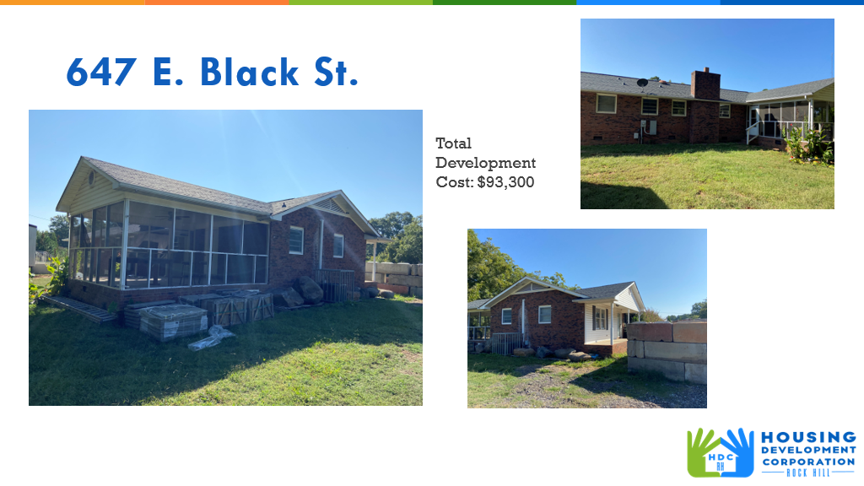

**First Time Homebuyers** –

Jordan Hamrick advised on FTHB students

Students - 37

Students who received certificates – 18

Closings with assistance – 1

Counseling sessions – 11

Opted for In-person – 24

Opted for Remote learning – 13

# enrolled in next in-person class - 5

Remaining 22/23 Funding: $3,070

FTHB Proposed CDBG 23/24 Funding - $70,000

**FTHB who was approved for $10,000 down payment assistance in October**

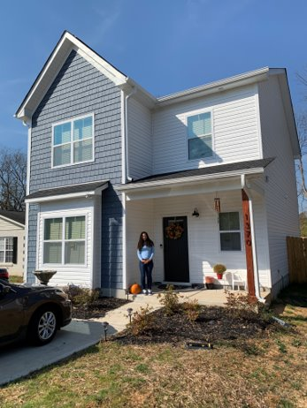

Jordan advised that he was invited to speak to teachers at the Rock Hill School District, and there was a lot of interest in the First Time Homebuyers Program.

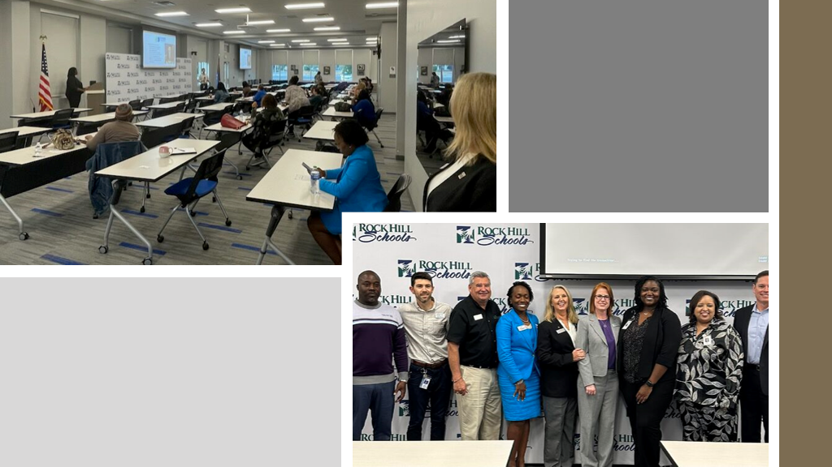

**FIX**

**Rehab Projects- CDBG – Southside Home Improvement Program (SHIP)**

|  |  |
| --- | --- |
| **Stage** | **Amount of Units** |
| **Pre-Work** | **2** |
| **Bidding** | **0** |
| **In Construction** | **0** |
| **Complete** | **0** |

* David Martin advised on SHIP (Southside Home Improvement Program
* Only for City of Rock Hill Ward 1 & Ward 5
* $5000 cap in order not to involve lead base paint
* Exterior projects only: roofs, HVAC, windows, ramps, siding, fascia, and porch
* For clients that have been on the Rehab waitlist for a long time, and their project does not involve lead base paint

**Rehab Projects- – CDBG – Owner Occupied Rehab**

|  |  |
| --- | --- |
| **Stage** | **Amount of Units** |
| **Pre-Work** | **0** |
| **Bidding** | **0** |
| **In Construction** | **0** |
| **Complete** | **0** |

**Rehab Projects - HTF**

|  |  |
| --- | --- |
| **Stage** | **Amount of Units** |
| **Beneficiary Eligibility** | **0** |
| **Preliminary Property Eligibility** | **0** |
| **Preliminary Scope of Work** | **0** |
| **Full Home Repair App, SOW Inspection & Contractor Cred** | **2** |
| **Hazardous Material Notification** | **0** |
| **Financial Commitments** | **0** |
| **In Construction** | **0** |
| **Complete** | **0** |

**Rehab Projects**

CDBG 23/24

OOR - $28,498.10

Volunteer Projects - $40,000

SHIP - $40,000

Eligible households on the waitlist: 72

**Partnership Opportunity: David advised on this program**

**-**OOR for elderly households

-Referred 5 projects to Habitat

*HVAC, Roof, Porch Repair, Windows, Foundation, Floors, plumbing, siding repair

**KEEP**

**Homeless Prevention Assistance**

Sarah advised that during the month of September/October the following households were served

Rental – 12 households assisted - $33,485.70 spent

Mortgage- 0 household assisted - $0 spent

Utilities – 0 household assisted - $0 spent

**Funding Sources Remaining**

Emergency Solutions Grant – ESG

Provides rental assistance, rent deposits, (30% AMI)

$1,514.30

EFSP (Emergency Food and Shelter Program) –

Provides rent, utility, and mortgage assistance

Total funding: $0

Phase 40 award - $0

Rapid Rehousing Update

Awarded a new round - $31,716

RRH Counseling sessions: 4

Benefits counseling sessions: 3

Miguel Rullan advised that he is still working on onboarding people from the area prioritization list. It has been difficult getting people into the program due to their vulnerability scoring due to various reasons.

**Rental Properties**

Danielle Sanders advised on the following rental properties during the month of September/October

|  |  |  |  |
| --- | --- | --- | --- |
| Gross income: $21,217 | Net income: $11,925.32 | Total properties: 30 | Total persons served: 63 – (1 vacancy) |

**Old Business**

**Annual Meeting Discussion**

**Corinne thanked everyone for their participation**

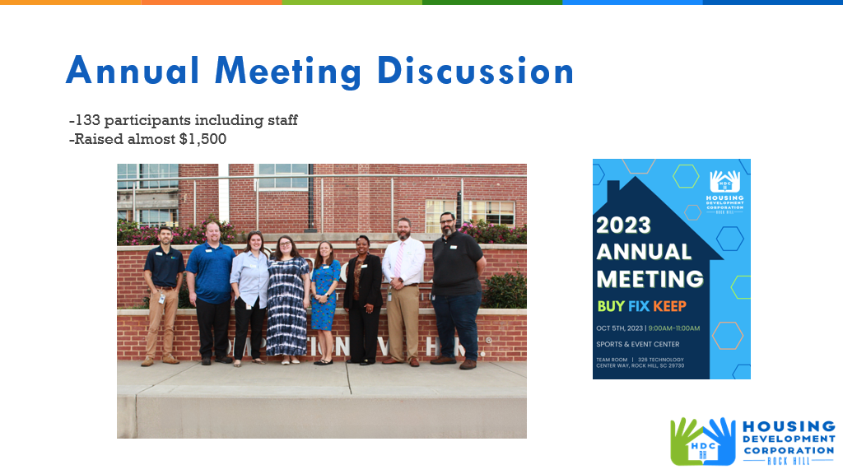

Ryan advised that plans are moving along

* Waiting for grant to clear
* Asbestosis abatement has been completed
* Working with planning on the demolition permit
* Removal of flooring has taken place
* Contracted a structural engineer- will make recommendations on foundation

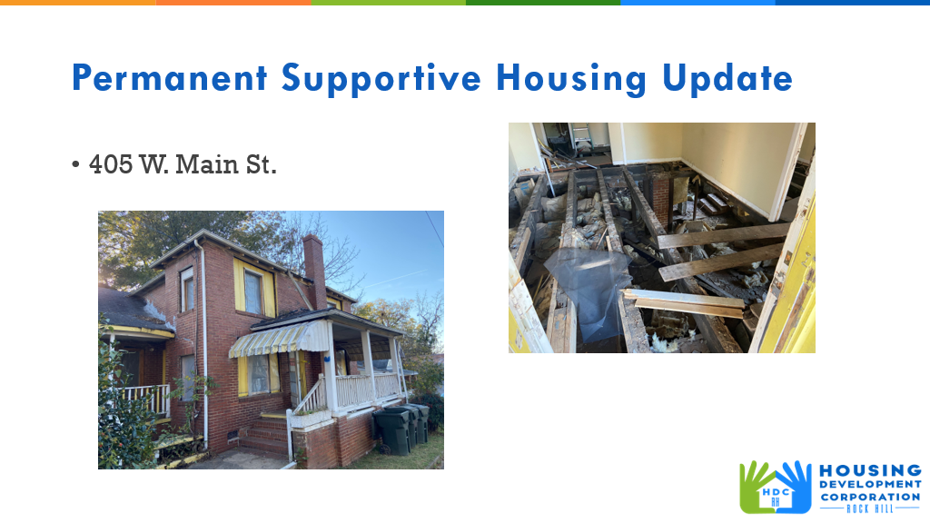

 Ryan advised that construction is moving along

* Rough in is complete
* Painting should be complete this week
* House is now a 3 bedroom, 2 baths (previously 4BR, 1BT)

By end of November, should be complete

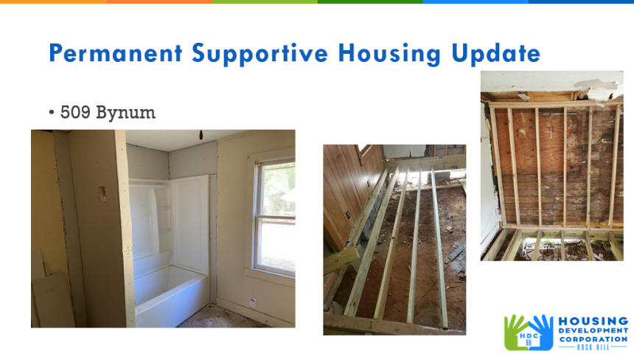

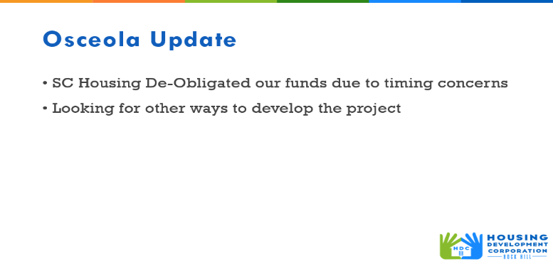

**New Business**

Phyllis Fickling asked for an update on the heirs’ property project. Jordan advised that Elaine Wilmore is working on that project through Clinton Connect, and he will contact Elaine to get a meeting scheduled.

***Happy belated birthday to Councilman Perry Sutton!***

**Adjourn**

With no further business, motion was made, seconded, and unanimously approved to adjourn.

Meeting adjourned at 9:37 a.m.

Upcoming Events/Meetings: HDCRH Board Meeting, 8:30 a.m., December 14, 2023.

Submitted by: _______________________  
 Beverly Buchanan, Secretary  
 Date: November 10, 2023

______________________  
Chairman/Vice Chairman  
Date: