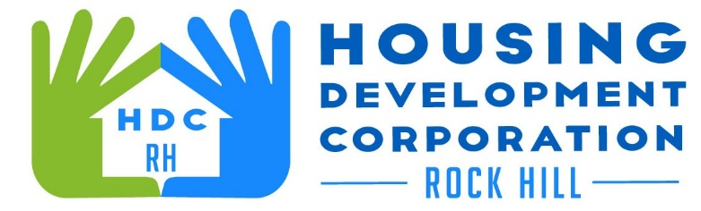

HDCRH MEETING

**June 10, 2021**

8:30 a.m.

via Zoom Meetings

1. Call to Order
2. Approval of May 13, 2021 minutes.

3) Staff Reports (included in packet)

1. Financials and Development Division Reports
2. Staff stories

1. Old Business
   1. Vet Benefit (Hero House) update
   2. Annual Meeting
   3. Subcommittees
2. New Business
   1. Lots on Finley Road (Soho Housing Partners)
   2. Strategic Plan discussion
3. Miscellaneous Business
4. Adjourn

Next Meeting: 8:30 a.m., July 13, 2021 – Annual Meeting -- Sunset Park

***Mission Statement:*** *The mission of the Housing Development Corporation of Rock Hill is to provide and improve housing opportunities for low-to moderate-income residents.*

***Vision:*** *Inform. Educate. Empower. By providing homeownership education and assistance; rehabilitation assistance to owner-occupied homes; increasing affordable housing options; and offering foreclosure prevention counseling.*