Housing Development Corporation of Rock Hill Board Meeting

Thursday, June 8, 2023

A Board Meeting was held Thursday, June 8, at 8:30 a.m. at City Hall, Room 373.

Members present: Walter Hardin, Anne Lambert, David LeGrande, Naomi Carpenter, Sandra Oborokumo, Sharon Hines, Will Jordan, Tom Roper, Perry Sutton, Derrick Lindsay

Members absent: Mary Reid, Phyllis Fickling, Nakia McGraw, Patricia McClurkin Sibley

Staff Present: Corinne Sferrazza, Jordan Hamrick, Beverly Buchanan, Ryan Powell, Sarah Bechtold, Miguel Rullan, Danielle Sanders

Call to Order: Walter Hardin called the meeting to order at 8:34 a.m. and thanked everyone for attending.

Minutes of the May 11, meeting was reviewed. Walter Hardin asked for a motion that the minutes be approved as presented. Motions were made for the minutes, seconded, and unanimously approved.

**Staff Reports**

**A. Financials**

Financial information was shared with Board members. Financial information can be e-mailed, or a hard copy can be mailed to Board Members if requested. Account balance information for the South State Community Checking Account (Sunset Park Houses) is $90,616.11. The Wells Fargo Account (HDC rentals) balance is $73,150.28. The TD Bank (Cottages) balance is $34,634.06. The NSP Rental Properties balance is $17,263.57. The TD General account is the main account with the most activity that includes utility and rental assistance transactions, deposits for assistance and proceeds for home sales, the balance is $257,411.31.

Total Unrestricted Funding as of 5/30/2023: $541,230.35

**Development Division Report**BUY

**New Construction**

Southside Properties - Will be for sale units

Ryan Powell advised that the new construction projects are moving along

1454 Crawford Rd. – 3 Bedroom 2 Bath

TDC- $158,839.80

Brick foundation complete, rough plumbing underway

14% complete

233 Baker Street – 2 Bedroom 1 Bath

$146,517.65

Footers poured, foundation material on site

10% complete

**First Time Homebuyers** –

Jordan Hamrick advised that in May there were 52 students.

Students who received certificates – 5

Closings with assistance – 0

Counseling sessions – 15

Opted for In-person – 41

Opted for Remote learning – 11

# enrolled in next in-person class - 41

***Next FTHB class on Saturday***, June 10, 2023, 8:30am-12:30pm

Remaining 22/23 Funding: $10,070

FTHB Proposed CDBG 23/24 Funding - $70,000

Jordan advised that he met with Dewayne Alford with the City of Rock Hill Housing Authority to discuss a potential partnership. The housing authority has been approved to rehab HUD homes in the Lancaster, Chester, and York County area, and they would love for our First Time Homebuyers applicants to have an opportunity to purchase these homes that will be sold at an affordable rate.

Jordan advised that as of right now, it’s just in the discussion phase.

**FIX**

**Rehab Projects- CDBG – Volunteer Projects**

|  |  |
| --- | --- |
| **Stage** | **Amount of Units** |
| **Pre-Work** | **14** |
| **Bidding** | **0** |
| **In Construction** | **0** |
| **Complete** | **0** |

**Rehab Projects – HTF**

|  |  |
| --- | --- |
| **Stage** | **Amount of Units** |
| **Beneficiary Eligibility** | **0** |
| **Preliminary Property Eligibility** | **0** |
| **Preliminary Scope of Work** | **2** |
| **Full Home Repair App, SOW Inspection & Contractor Cred** | **0** |
| **Hazardous Material Notification** | **0** |
| **Financial Commitments** | **0** |
| **In Construction** | **0** |
| **Complete** | **0** |

**Corinne reported:**

Rehab Projects

CDBG 22/23 Remaining - $98,965

Proposed CDBG 23/24 OOR - $100,000

Volunteer Projects - $40,000

Eligible households on the waitlist: 78

**Reduction in waitlist**

|  |
| --- |
| * 11 – applicants deceased |
| * 5 – properties sold/conveyed |
| * 14 - active projects |
| * Not able to contact applicants   (certified letters, phone calls) |
| * Services no longer needed |

World Changers and Salkehatchie summer of 2023 - Volunteers

**World Changers** – 350 Volunteers consisting of adults and students from all over the country 12 projects: 9 roof replacements & 3 general home repairs

June 19-24, 2023.

**Salkehatchie-** State levelthrough United Methodist group – 2 projects – 1 CDBG project & 1 HNS project - smaller group of volunteers- June 24-July 1, 2023

**Project Sweat (Westminster)** will begin mid-July 2023

Projects mostly in Ward 1 & 2

**KEEP**

**Homeless Prevention Assistance**

Sarah advised that during the month of May the following households were served.

Rental – 5 households assisted - $13,024.28 spent

Mortgage- 0 household assisted - $0 spent

Utilities – 1 household assisted - $801.04 spent

**Funding Sources**

Emergency Solutions Grant – ESG

Provides rental assistance, rent deposits, utility assistance, and utility deposits (30% AMI)

$0

EFSP (Emergency Food and Shelter Program) –

Provides rent, utility, and mortgage assistance

Total funding: $69,209.64

Phase 40 award - $49,446.76

Rapid Rehousing Update

Awarded a new round - $31,716

August start date

**Rental Properties**

Danielle Sanders advised on the following rental properties during the month of May

|  |  |  |  |
| --- | --- | --- | --- |
| Gross income: $19,822 | Net income: $16,239.65 | Total properties: 30 | Total persons served: 68 – (100% occupancy) |

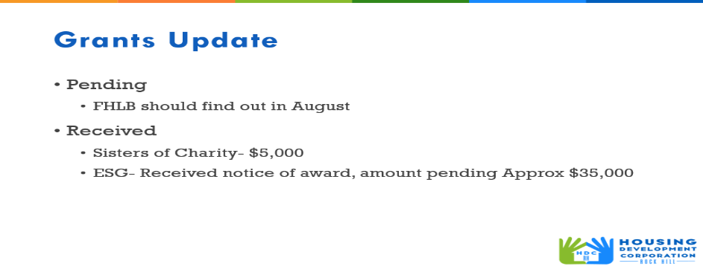

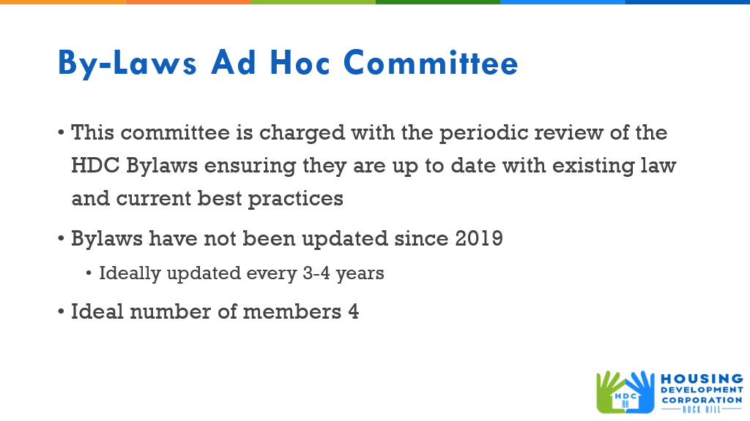

* First Committee Meeting – June 15th 3:00-4:00 pm
* Location: the red house – 332 W. Main St.
* Staff Lead: Sarah
* Committee Members: Sarah, Naomi, Sharon, and Walter

**Old Business**

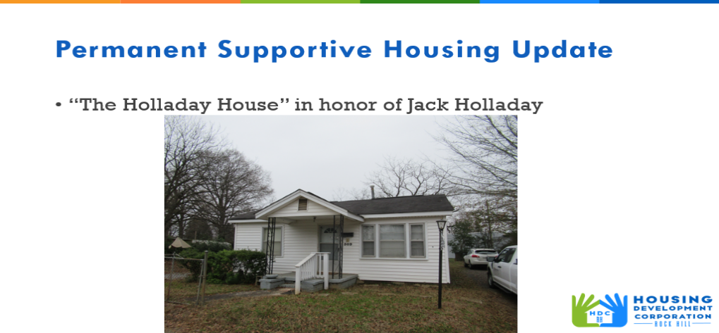

* Donation of $61,000 to rehab 509 Bynum

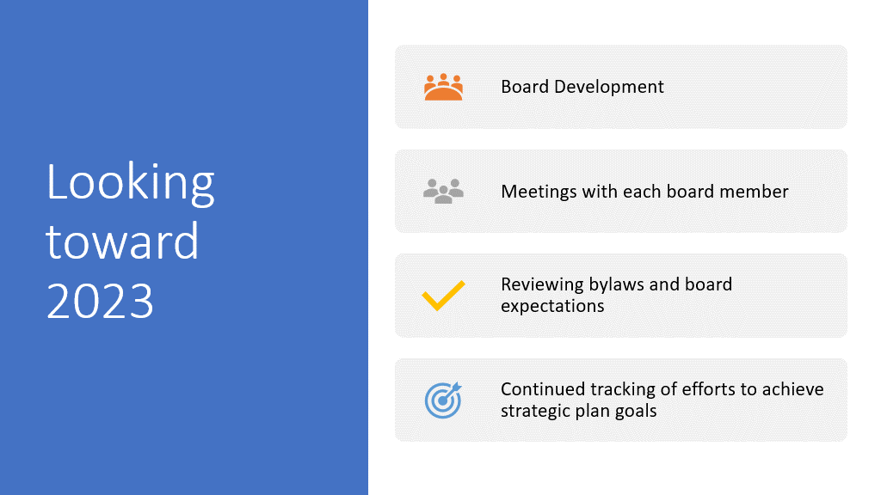

**New Business**

**Adjourn**

With no further business, motion was made, seconded, and unanimously approved to adjourn.

Meeting adjourned at 9:12 a.m.

Upcoming Events/Meetings: HDCRH Board Meeting, 8:30 a.m., July 13, 2023.

Submitted by: _______________________  
 Beverly Buchanan, Secretary  
 Date: June 12, 2023

______________________  
Chairman/Vice Chairman  
Date: