Housing Development Corporation of Rock Hill Board Meeting

Thursday, February 9, 2023

A Board Meeting was held Thursday, February 9, at 8:30 a.m. at City Hall, Room 373.

Members present: Walter Hardin, Anne Lambert, David LeGrande, Phyllis Fickling, Kathy Pender, Perry Sutton, Naomi Carpenter, Sandra Oborokumo, Sharon Hines, Mary Reid, Tom Roper

Members absent: Will Jordan, Nakia McGraw, Patricia McClurkin Sibley

Staff Present: Corinne Sferrazza, Jordan Hamrick, Beverly Buchanan, Ed Causebrook, Ryan Powell, Sarah Bechtold, Miguel Rullan, Ariah Massey

Guest: Harley Hubbard

Call to Order: Walter Hardin called the meeting to order at 8:31 a.m. and thanked everyone for attending.

Minutes of the January 12, meeting was reviewed. Walter Hardin asked for a motion that the minutes be approved as presented. Motions were made for the minutes, seconded, and unanimously approved.

**Board Development Exercise**

Name: Everyone introduced themselves

What brings you on the board? Everyone gave an overview of what brought them to the board

**Staff Reports**

**A. Financials**

Financial information was shared with Board members. Financial information can be e-mailed, or a hard copy can be mailed to Board Members if requested. Account balance information for the South State Community Checking Account (Sunset Park Houses) is $82,447.22. The Wells Fargo Account (HDC rentals) balance is $61,388.08. The TD Bank (Cottages) balance is $28,354.68. The NSP Rental Properties balance is $15,422.14. The TD General account is the main account with the most activity that includes utility and rental assistance transactions, deposits for assistance and proceeds for home sales, the balance is $266,994.02.

**Development Division Report**BUY

**New Construction**

Southside Properties – Planning Stage

Will be for sale units

1454 Crawford Rd. – 3 Bedroom 2 Bath

TDC- $158,839.80

233 Baker Street – 2 Bedroom 1 Bath

$146,517.65

Landscape planning which was not required in the past

Waiting to sign contracts

**First Time Homebuyers** –

Jordan Hamrick advised that in January there were 18 students.

Students who received certificates – 5

Closings with assistance – 1

Counseling sessions – 15

Opted for In-person – 21

Opted for Remote learning – 7

Next FTHB class on Saturday, February 11, 2023

FTHB Proposed CDBG 23/24 Funding - $70,000

**FIX**

**Rehab Projects- CDBG**

|  |  |
| --- | --- |
| **Stage** | **Amount of Units** |
| **Pre-Work** | **0** |
| **Bidding** | **0** |
| **In Construction** | **0** |
| **Complete** | **1** |

**Rehab Projects – HTF**

|  |  |
| --- | --- |
| **Stage** | **Amount of Units** |
| **Pre-Work** | **2** |
| **Bidding** | **0** |
| **In Construction** | **0** |
| **Complete** | **0** |

**Corinne reported:**

Rehab Projects

CDBG 21/22 Remaining - $840.34

CDBG 22/23 Remaining - $100,000

Proposed CDBG 23/24 OOR - $100,000

Volunteer Projects - $40,000

Eligible households on the waitlist: 90

Planning for World Changers and Salkehatchie summer of 2023 - 377 Volunteers

World Changers will focus mainly on roof replacements

Ryan advised that the administrative work has begun for the summer projects

**KEEP**

**Homeless Prevention Assistance**

Sarah advised that during the month of January the following households were served.

Rental – 10 households assisted - $16,688.73 spent

Mortgage- 0 household assisted - $0 spent

Utilities – 18 households assisted - $7,924.84 spent

**Funding Sources**

Emergency Solutions Grant – ESG

Provides rental assistance, rent deposits, utility assistance, and utility deposits (30% AMI)

$18,305.87

Community Development Block Grant – Coronavirus (CDBG-CV)

Mortgage assistance – $0 left in funding

Rental Assistance - $0 left in funding

Utility Assistance For Working Families

United Way funded program

Provides utility assistance for working families in York County - $2,940.00

EFSP (Emergency Food and Shelter Program) –

Provides rent, utility, and mortgage assistance

Total funding: $245,627 (waiting for)

**Rental Properties**

Danielle Sanders advised on the following rental properties during the month of January

|  |  |  |  |
| --- | --- | --- | --- |
| Gross income: $18,337.00 | Net income: $12,713.60 | Total properties: 30 | Total persons served: 66 |

**Counseling Sessions**

Counseling sessions for January

Benefits sessions: 0 Foreclosure sessions: 0 Rapid Rehousing sessions: 0

**Old Business**

1. MOU (Memorandum of Understanding) with Life House Women’s Shelter

Corinne asked the board members if they had any comments or concerns

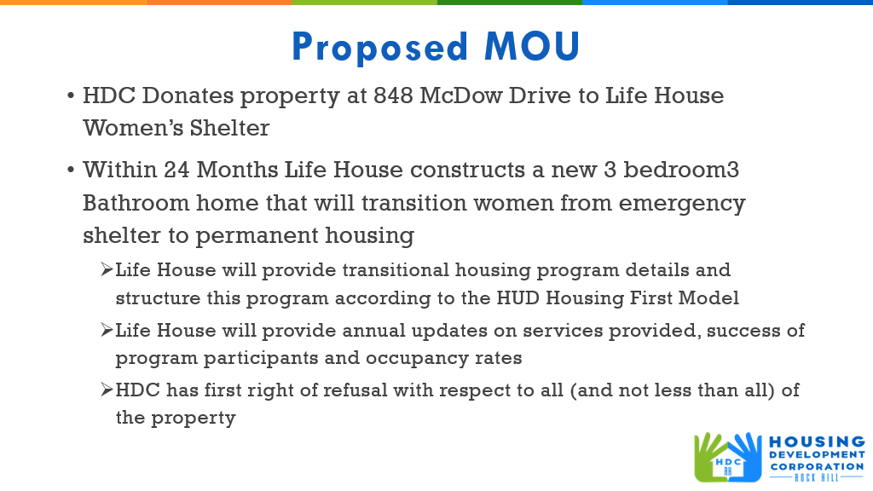

 After discussion, Corinne advised that she would make changes to the draft and send out to board members for review.

1. Update on Adult Enrichment Center

Adult Enrichment Center currently located at 359 Park Ave has decided to

stay in their current building. The partnership is no longer on the table

1. Board Member Meeting Update

Corinne has met with 9 Board members and asked the same questions to each person

* Main purpose of HDC

Role of the board

What do you bring to the board?

Where should HDC focus in the new year?

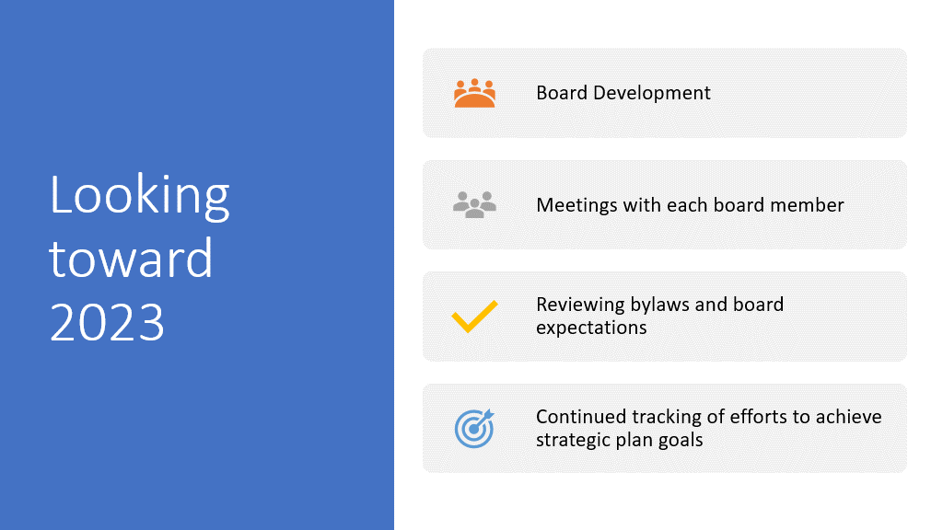

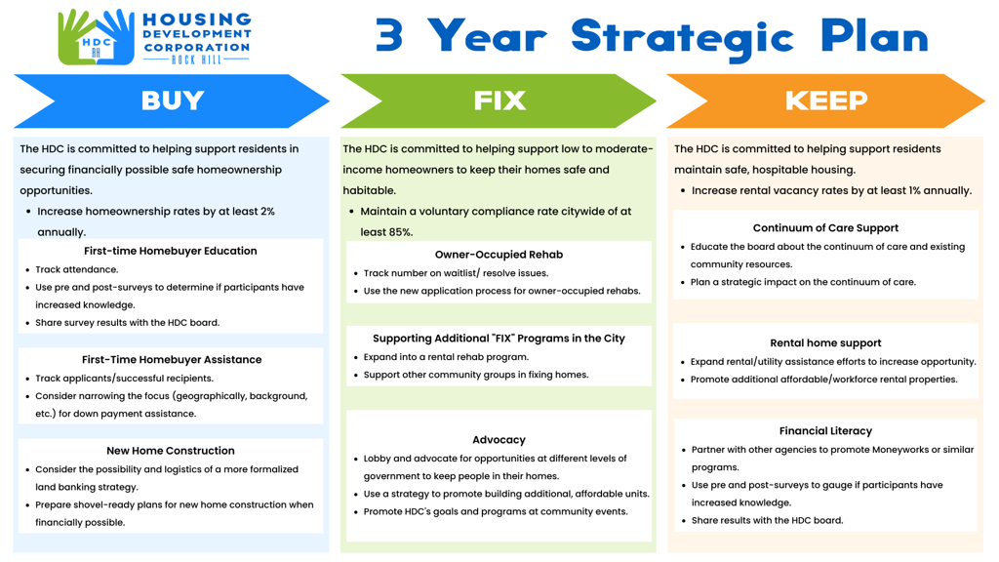

**New Business**

1. **Document Retention Policy**

Tom Roper made a motion to approve the HDCRH Document Retention Policy, Kathy Pender seconded, and the motion passed unanimously.

1. **Faith-Based Partners**

Beginning project of reaching out to our faith-based partners in York County

General introduction of who we are, what we do, why we do it

Walter Hardin asked that everyone keep Will Jordan and his wife in their thoughts and prayers.

With no further business, motion was made, seconded, and unanimously approved to adjourn.

Meeting adjourned at 9:32 a.m.

Upcoming Events/Meetings: HDCRH Board Meeting, 8:30 a.m., March 9, 2023.

Submitted by: _______________________  
 Beverly Buchanan, Secretary  
 Date: February 20, 2023

______________________  
Chairman/Vice Chairman  
Date: