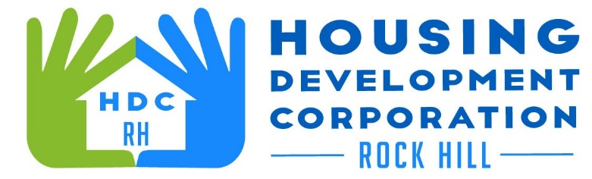

HDCRH MEETING

**January 14, 2021**

8:30 a.m.

via Zoom Meetings

1. Call to Order
2. Approval of November 12, 2020 minutes.

3) Staff Reports (included in packet)

1. Financials and Development Division Reports

1. Old Business
   1. Agape project
2. New Business
   1. The Transition
   2. The Move
3. Miscellaneous Business
4. Adjourn

Next Meeting: 8:30 a.m., February 11, 2021

***Mission Statement:*** *The mission of the Housing Development Corporation of Rock Hill is to provide and improve housing opportunities for low-to moderate-income residents.*

***Vision:*** *Inform. Educate. Empower. By providing homeownership education and assistance; rehabilitation assistance to owner-occupied homes; increasing affordable housing options; and offering foreclosure prevention counseling.*