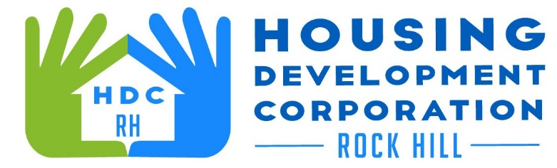

HDCRH MEETING

**August 24, 2021**

8:30 a.m.

Zoom Meeting

1. Call to Order
2. Approval of June, 2021 minutes and July, 2021 (Annual Meeting) minutes.

3) Staff Reports (included in packet)

1. Financials and Development Division Reports
2. Staff stories

1. Old Business
   1. 1217-1219 Watson Street update
2. New Business
   1. Board member term renewals
   2. Board officer elections
   3. Signing/Authority Resolution
   4. Homestead properties
   5. Wells Fargo grant
3. Miscellaneous Business
   1. Subcommittees
4. Adjourn

Next Meeting: 8:30 a.m., September 9, 2021

***Mission Statement:*** *The mission of the Housing Development Corporation of Rock Hill is to provide and improve housing opportunities for low-to moderate-income residents.*

***Vision:*** *Inform. Educate. Empower. By providing homeownership education and assistance; rehabilitation assistance to owner-occupied homes; increasing affordable housing options; and offering foreclosure prevention counseling.*