Housing Development Corporation of Rock Hill Board Meeting

Thursday, June 9, 2022

A Board Meeting was held Thursday, June 9, at 8:30 a.m. at City Hall, Room 373.

Members present: Anne Lambert, Will Jordan, Sandra Oborokumo, Naomi Carpenter, Sharon Hines

Members absent: Walter Hardin, Tom Roper, David LeGrande, Phyllis Fickling, Nakia McGraw, Patricia McClurkin Sibley, Mary Reid, Kathy Pender, Perry Sutton

Staff Present: Corinne Sferrazza, Jennifer McAdams, Jordan Hamrick, Beverly Buchanan, Ryan Powell, Sarah Bechtold, Danielle Sanders, Ed Causebrook

Guest: Alexis Simpson, Derrick Lindsay

Call to Order: Anne Lambert called the meeting to order at 8:37 a.m. and thanked everyone for attending.

Minutes of the May 12 meeting was reviewed. Anne Lambert asked for a motion that the minutes be approved as presented. Motions were made for the minutes, and seconded, but there was not a quorum to approve the minutes.

**Staff Reports**

**A. Financials**

Financial information was shared with Board members. Financial information can be e-mailed, or a hard copy can be mailed to Board Members if requested. Account balance information for the South State Community Checking Account (Sunset Park Houses) is $277,666.65. The Wells Fargo Account (HDC rentals) balance is $47,819.72. The TD Bank (Cottages) balance is $35,780.53. The NSP Rental Properties balance is $48,621.45. The TD General account is the main account with the most activity that includes utility and rental assistance transactions, deposits for assistance and proceeds for home sales, the balance is $303,180.39.

Development Division Report  
BUY

**New Construction**

Southside Properties – Planning Stage

Will be for sale units

Ed Causebrook advised that he has begun researching which properties will be used

**First Time Homebuyers** –

Jordan Hamrick advised that in May there were 35 students.

Students that received certificates – 4

Closings with assistance – 0

Counseling sessions – 13

June 11, 2022 – First Time HomeBuyers workshop at Operations Center 8:30-12:30

**FIX**

Ryan Powell reported on the rehab projects

**Rehab Projects- CDBG**

|  |  |
| --- | --- |
| **Stage** | **Amount of Units** |
| **Pre-Work** | **1** |
| **Bidding** | **5** |
| **In Construction** | **2** |
| **Complete** | **0** |

**Rehab Projects – HTF**

|  |  |
| --- | --- |
| **Stage** | **Amount of Units** |
| **Pre-Work** | **4** |
| **Bidding** | **1** |
| **In Construction** | **0** |
| **Complete** | **1** |

**Corinne reported:**

CDBG Funding Remaining - $169,831.73

Eligible households on the waitlist: 116

Ryan advised on the following volunteer groups that will be working over the summer on rehab projects – Youth groups with adult supervision

Rehab Projects

Upcoming Volunteer Projects

* City of Rock Hill PRT – youth council
* Westminister Church – will focus on the rehab volunteer wait list
* Rolling in Rock Hill
* World Changers – June 2023
* St. John’s United Methodist youth group

**KEEP**

**Homeless Prevention Assistance**

Sarah Bechtold advised that during the month of May the following households were served.

Rental – 2 households assisted - $6,232.95 spent

Mortgage- 0 household assisted - $0 spent

Utilities – 6 households assisted - $2,506.70 spent

ESG (Emergency Solutions Grant) – Coronavirus Phase II (ESG-CVII)

Provides rental assistance, rent deposits, utility assistance, and utility deposits (50% AMI)

$467,329.97 spent total, $9,145.59 remaining

Community Development Block Grant – Coronavirus (CDBG-CV)

Mortgage assistance – $0 left in funding

Rental Assistance - $16,920.86 left in funding

EFSP (Emergency Food and Shelter Program) –

$250,000 has been awarded by United Way, to be used for rental, utility, and mortgage

Funds have not been distributed yet

Utility Assistance For Working Families

United Way funded program

Provides utility assistance for working families in York County - $8000

**Rent**

**Rental Properties**

Danielle Sanders advised on the following rental properties during the month of May

|  |  |  |  |
| --- | --- | --- | --- |
| Gross income: $11,783.04 | Net income: $4,527.04 | Total properties: 30 | Total persons served: 56 |

**Counseling Sessions**

Corinne reported on counseling sessions for May.

Benefits sessions: 3 Foreclosure sessions: 0 Rapid Rehousing sessions: 6

**New Funding- Sisters of Charity - $5000**

**Corinne gave an overview of how the funds will be used**

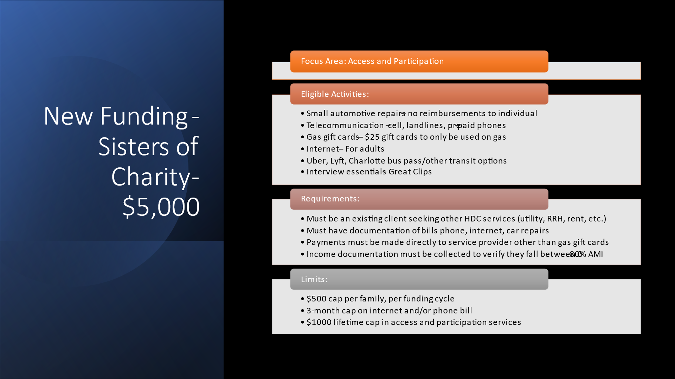

**B. Supportive Housing Update**

Corinne gave an overview of the follow-up Supportive Housing Meeting

Meeting was held at 310 Maple St., and 4 Service Providers attended to learn about the opportunity. The letter of intent is due June 17th to Anne and decision to be made by July 1st.

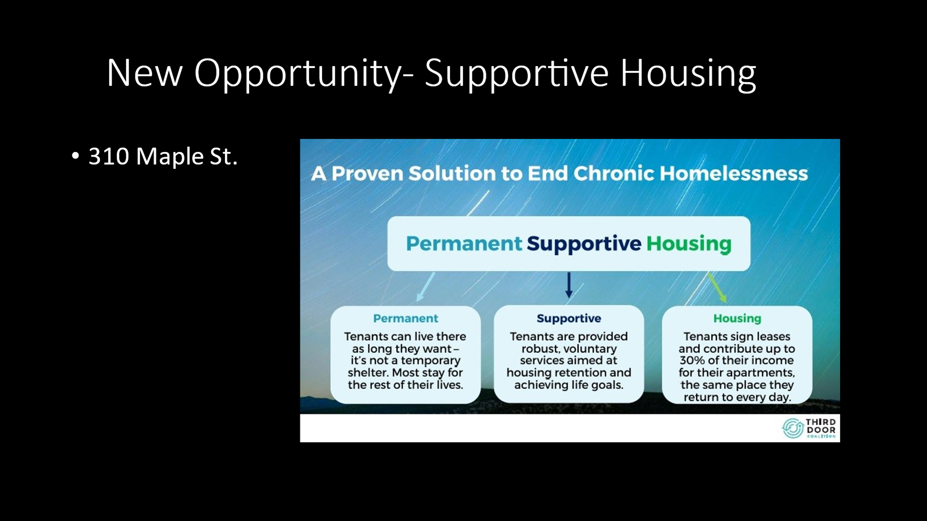

**New Business**

**Corinne reviewed the Strategic Plan with the board and asked everyone to continue to review the draft.**

**Jennifer advised that it is important to get feedback from the board before finalization and adoption. We also want to make sure we are tracking what the board wants.**

**Strategic Plan Follow-Up**

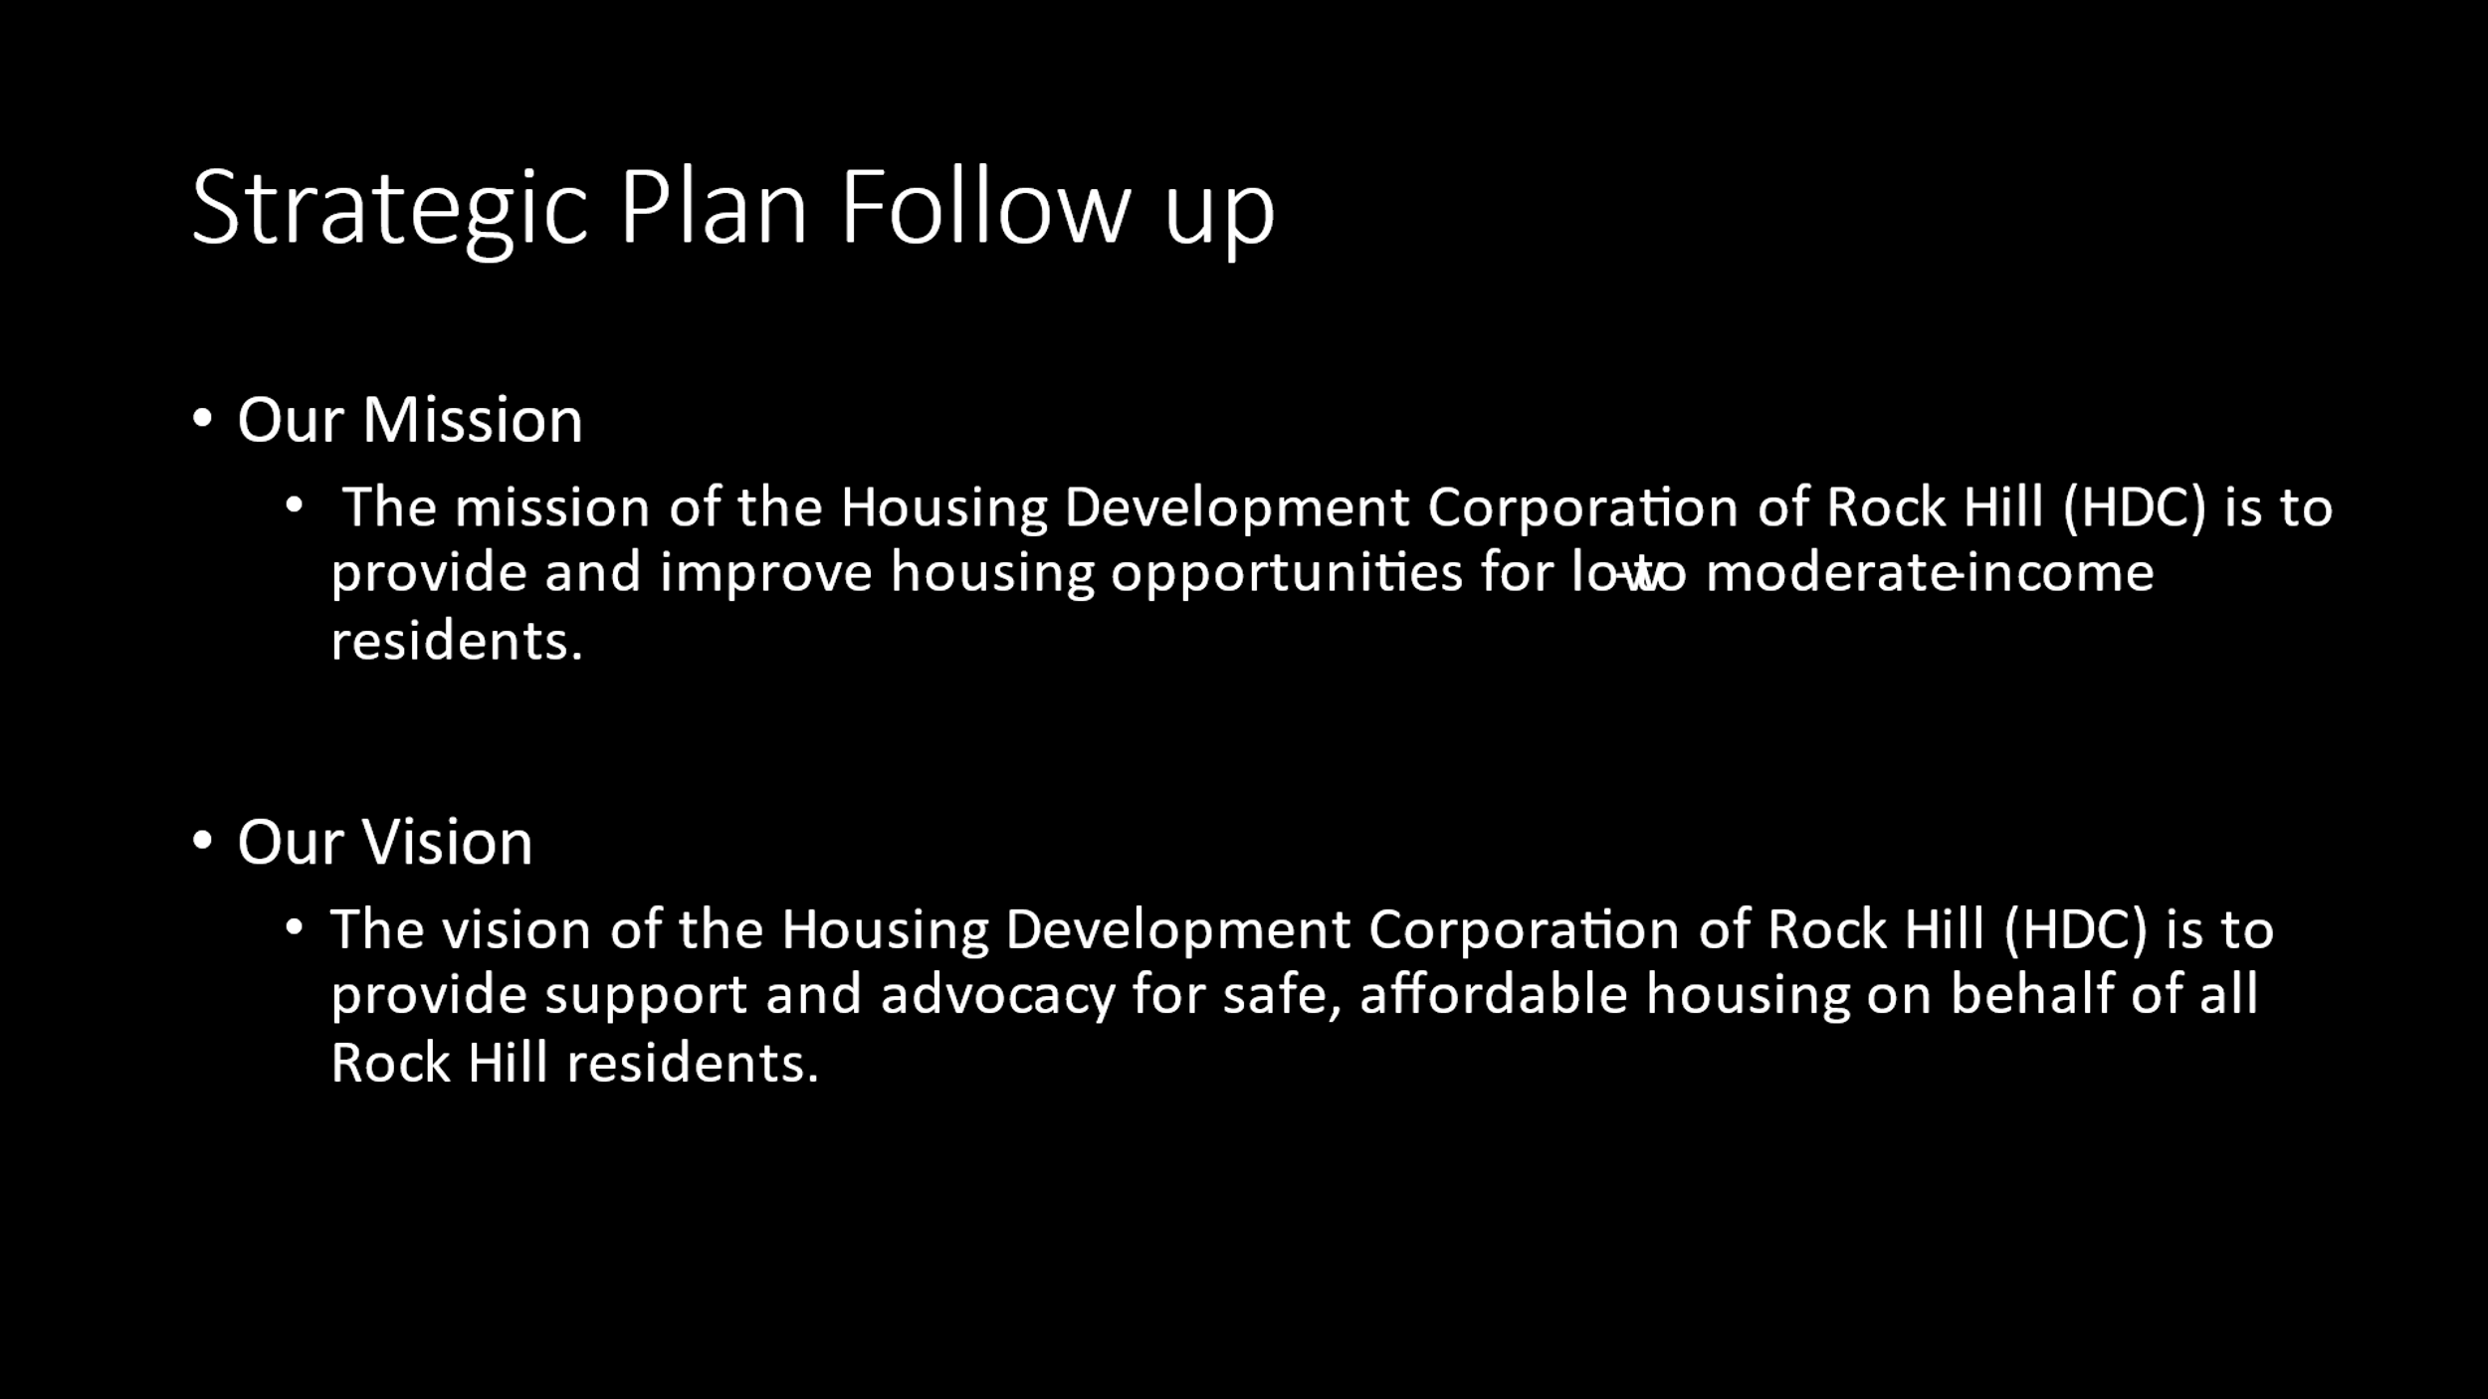

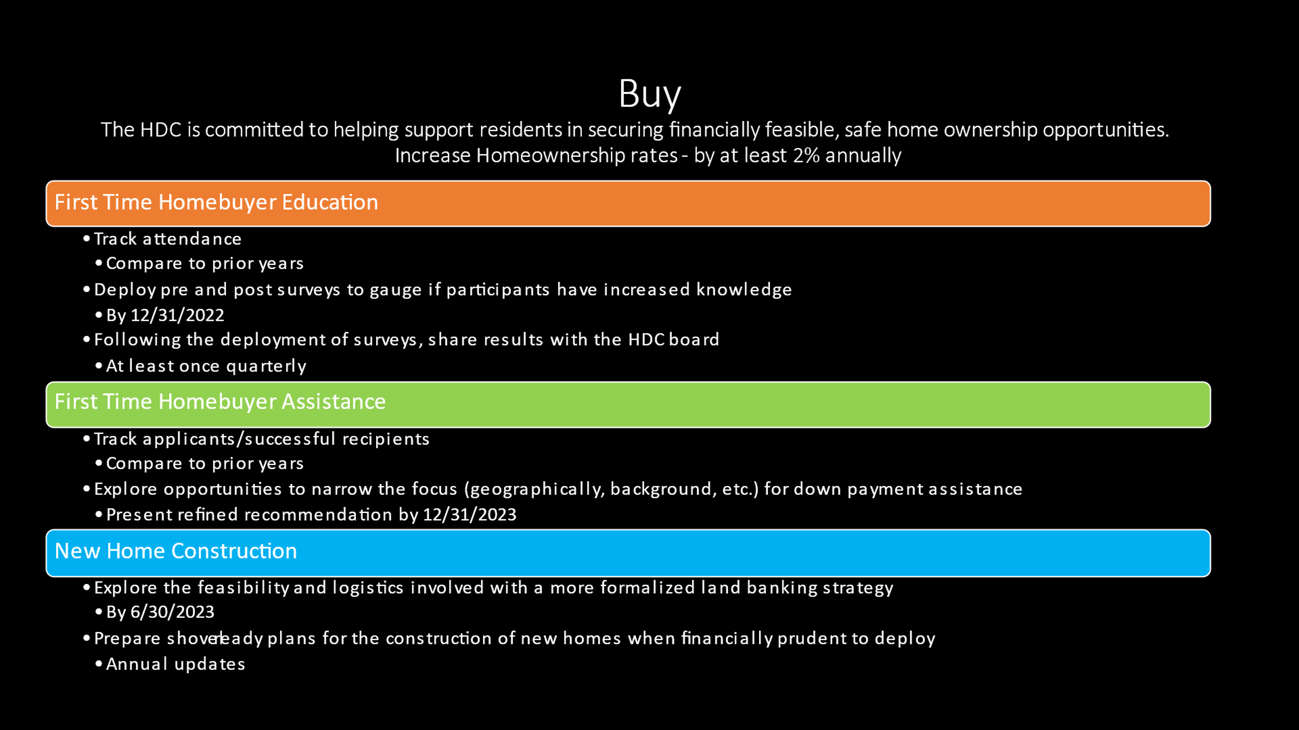

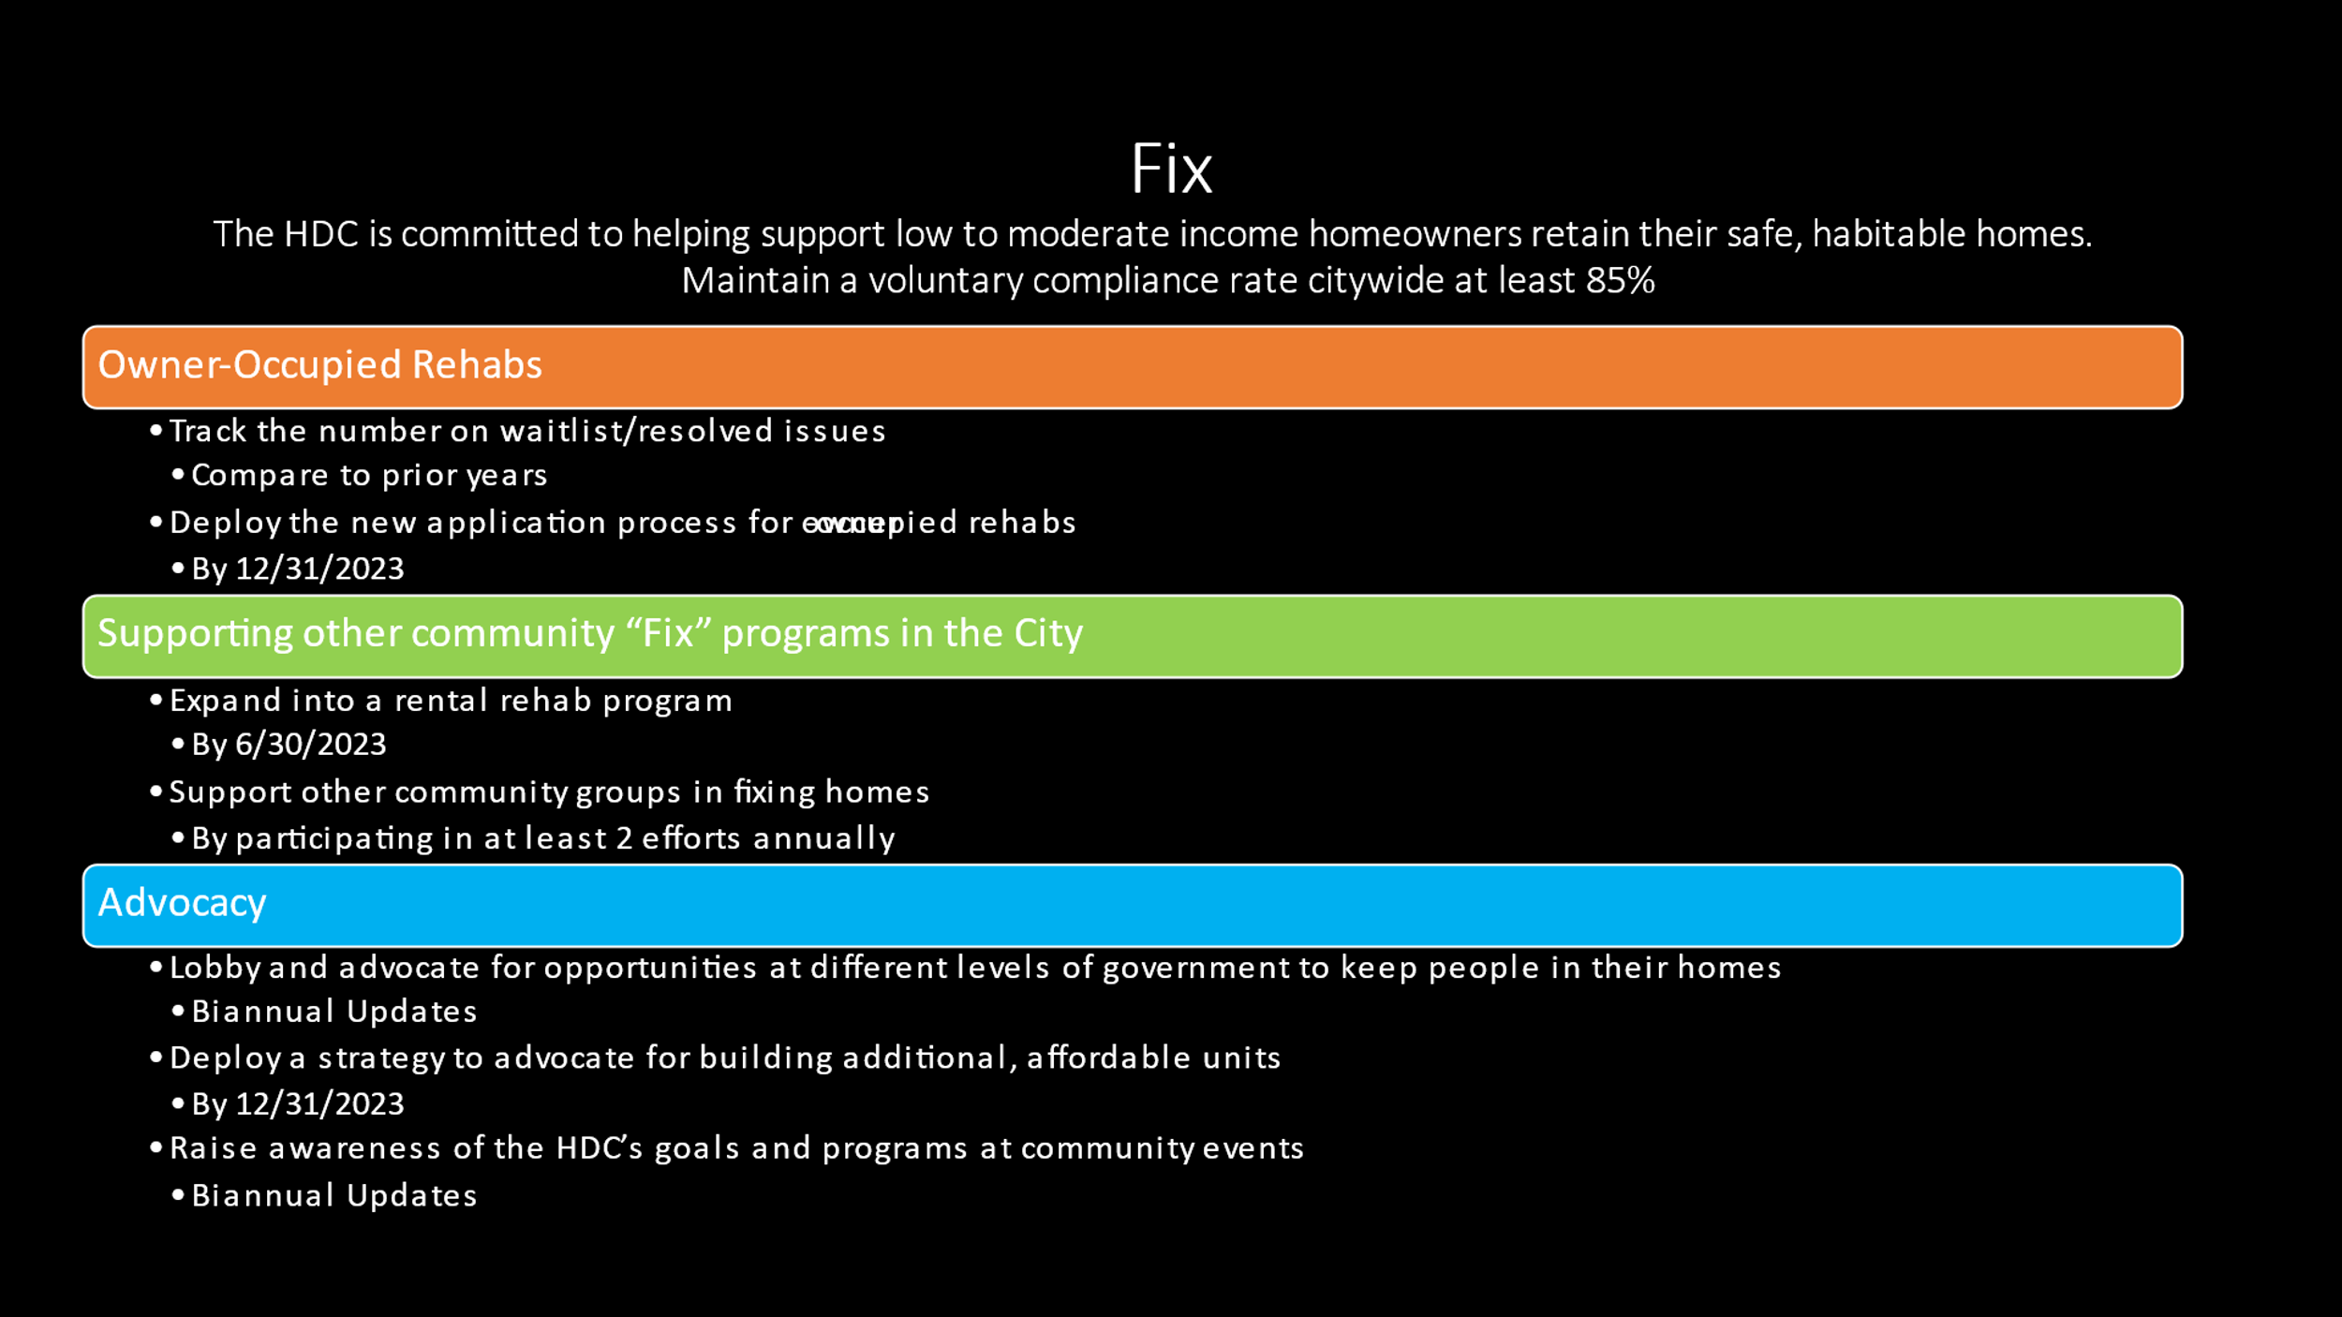

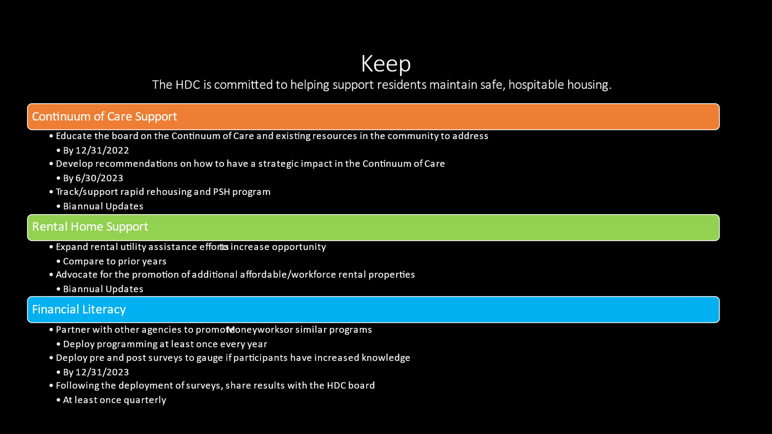

With no further business, motion was made, seconded, and unanimously approved to adjourn the meeting.

Meeting adjourned at 9:27 a.m.

Upcoming Events/Meetings: HDCRH Board Meeting, 8:30a.m. July 14, 2022.

Submitted by: _______________________  
 Beverly Buchanan, Secretary  
 Date: June 15, 2022

______________________  
Chairman/Vice Chairman  
Date: