Housing Development Corporation of Rock Hill Board Meeting

Thursday, August 8, 2024

A Board Meeting was held Thursday, August 8, at 8:30 a.m. at City Hall, Room 373.

Members present: Will Jordan, David LeGrande, Anne Lambert, Sandra Oborokumo, Perry Sutton

Members absent: Walter Hardin, Naomi Carpenter, Brent Faulkenberry, Sharon Hines, Warren Baxter, Phyllis Fickling, Tom Roper, Mary Reid

Staff Present: Corinne Sferrazza, Ryan Powell, David Martin, Beverly Buchanan, Hakim Diaz, Sarah Bechtold

Call to Order: Ann Lambert called the meeting to order at 8:40 a.m.

Minutes of the July 11, meeting could not be approved due to lack of quorum.

Corinne welcomed Hakim Diaz back. Hakim introduced himself to board members and gave details about his position as HDC Housing Navigator.

**Staff Reports**

**A. Financials**

Financial information was shared with Board members. Financial information can be e-mailed, or a hard copy can be mailed to Board Members if requested. Account balance information for the South State Community Checking Account (Sunset Park Houses) is $47,575.17. The Wells Fargo Account (HDC rentals) balance is $30,096.50. The TD Bank (Cottages) balance is $52,870.61. The NSP Rental Properties balance is $16,661.24. The TD General account is the main account with the most activity that includes utility and rental assistance transactions, deposits for assistance and proceeds for home sales, the balance is $195,803.35. Total Unrestricted Funding as of 7.31.2024: $234,588.94.

|  |  |
| --- | --- |
| **Finances** | |
| **Total Funds as of 7.31.2024** | **$715,157.21** |
| Restricted for Rental Properties | $298,553.15 |
| Restricted Grant Funds | $1,625 |
| Restricted/Held Funds for Projects | $180,390.12 |
| **Total unrestricted funds as of 7.31.2024** | **$234,588.94** |

**KEEP - Homeless Prevention Assistance**

Rental

* 0 households assisted
* $0 spent

Mortgage

* 0 household assisted
* $0 spent

Utilities

* 0 households assisted
* $0 spent

**Funding Sources Remaining**

**Emergency Food and Shelter Program–EFSP – 80% AMI**

Provides rent, utility, and mortgage assistance

Total funding: $56,496.59

Remaining: $0 – Funding spent in August, will report on next month

**Rapid Rehousing Update**

Funding available: $33,835.69

RRH Counseling sessions: 12

Benefits counseling sessions: 0

**Individual Development Account Program**

Number of Accounts opened: 9 (5 homeownership, 4 Transportation)

Funding remaining: $46,600 ($39,600 UWYC + $7000 Family Trust)

Sarah advised that the Rapid Rehousing Program is going well, and she has met with all clients. Clients are participating in their counseling sessions, monthly meetings as well as working through the IDA program.

**CLIENT STORIES**

Sarah shared that July 29-31, 2024, Rock Hill Housing Authority opened their waitlist for public housing. Sarah advised that she along with Danielle, Hakim and CACH went to the Bethel day and night Shelter to help people complete applications.

**Rental Properties**

Danielle advised on the following rental properties during the month of July

|  |  |  |  |
| --- | --- | --- | --- |
| Gross income: $23,462 | Net income: $11,363.21 | Total properties: 31 | Total persons served: 69 (0 vacancies) |

**BUY**

New Construction

Ryan advised on the following projects

* + 115 Allen - two story – 3BR, 2 BT
  + 225 Baker – 2BR, 1 BT
  + Ready to go out for bid
  + For sale properties

**115 Allen St. 225 Baker St.**

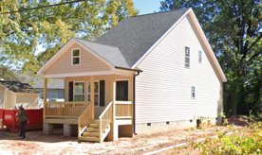  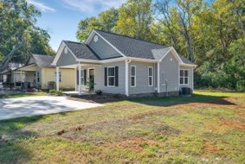

**647 E. Black Street**

David advised that the house is coming along.

* Porch roof built and framed in
* Vinyl siding next step
* Projected finish date by end of August
* For sale property

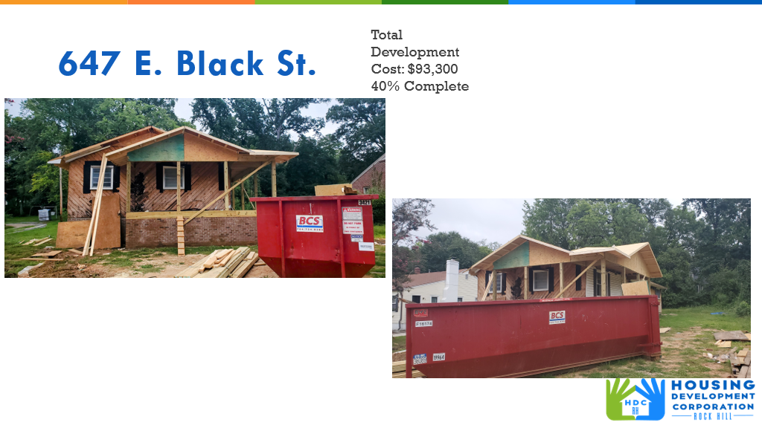

**First Time Homebuyers** – Corinne advised on July FTHB

Client Intake - 36

Students who received certificates – 5

Closings with assistance – 1

Counseling sessions – 12

# enrolled in next in-person class - 27

Next class: October 12, 2024

CDBG 24/25 Funding - $50,070

**FIX**

**Rehab Projects- CDBG – Southside Home Improvement Program (SHIP)**

|  |  |  |
| --- | --- | --- |
| **Stage** | **Amount of Units** | **SHIP** |
| **Pre-Work** | **0** | * Maximum $5000 |
| **Bidding** | **0** | * Exterior only |
| **In Construction** | **0** | * Roofs, HVACs, Porch, Decks, Handicap accessible ramps |
| **Completed** | **0** | * Ward 1 & 5 |

**Rehab Projects- – CDBG – Owner Occupied Rehab - Rehab-World Changers**

|  |  |
| --- | --- |
| **Stage** | **Amount of Units** |
| **Pre-Work** | **5** |
| **Bidding** | **0** |
| **In Construction** | **0** |
| **Completed** | **0** |

**Rehab Projects – HTF- Critical Home Repair & Home Repair**

|  |  |
| --- | --- |
| **Stage** | **Amount of Units** |
| **Pre-Work** | **2** |
| **Bidding** | **0** |
| **In Construction** | **0** |
| **Completed** | **0** |

**Rehab Projects**

CDBG 23/24 CDBG 24/25

OOR - $2,306.30 OOR - $101,930

Volunteer Projects - $0 Volunteer Projects-$35,945.15

SHIP - $164.44 SHIP - $50,000

|  |  |
| --- | --- |
| **Starting amount** | **71** |
| **Inactive *did not respond to mailer\*** | **22** |
| **Over Income** | **3** |
| **Homeowner completed work** | **2** |
| **House Sold** | **1** |
| **Requested Removal** | **2** |
| **In Progress** | **5** |
| **Completed** | **16** |
| **ELIGIBLE HOUSEHOLDS ON WAITLIST** | **21** |

**Grants Update**

* Received
  + Family Trust Federal Credit Union
    - Community Partnership Foundation Applied for $5000 for furniture for 405 W. Main St.

**Old Business**

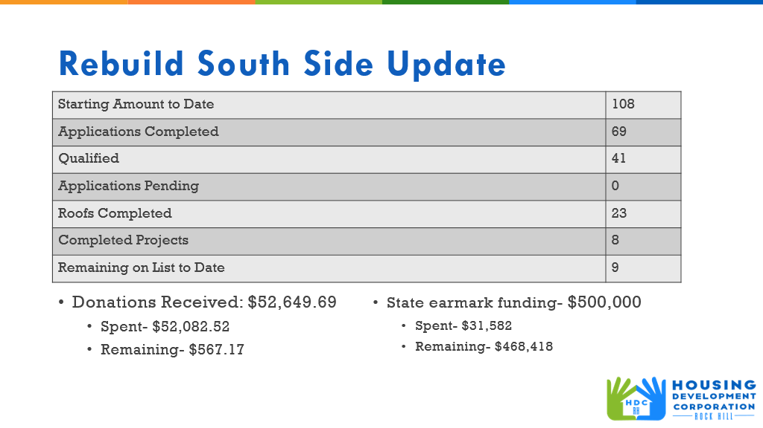

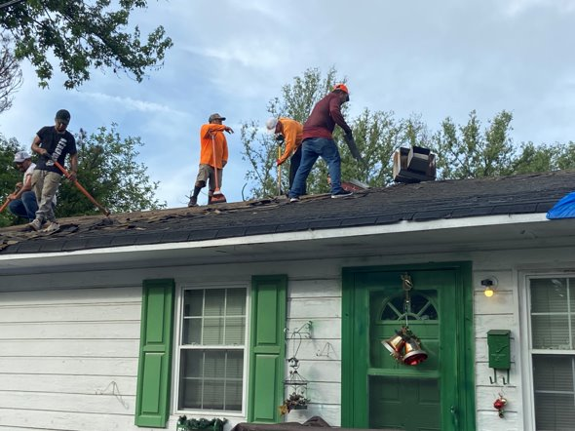

**New Business**

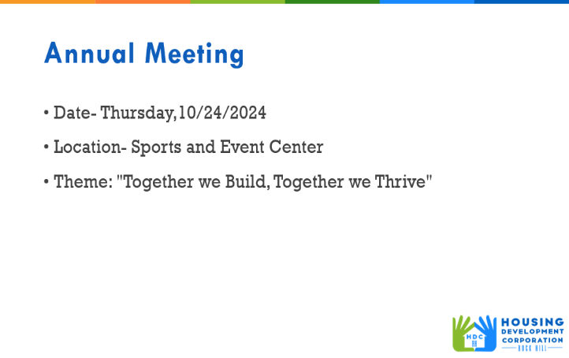

**Adjourn**

With no further business, a motion was made, seconded, and unanimously approved to adjourn.

The meeting was adjourned at 9:26 a.m.

Upcoming Events/Meetings: HDCRH Board Meeting, 8:30 a.m., September 12, 2024.

Submitted by: _____________________  
 Beverly Buchanan, Secretary  
 Date: August 8, 2024

______________________  
Chairman/Vice Chairman  
Date: