Housing Development Corporation of Rock Hill Board Meeting

Thursday, May 9, 2024

A Board Meeting was held Thursday, May 9, at 8:30 a.m. at City Hall, Room 373.

Members present: Walter Hardin, Will Jordan, Mary Reid, Phyllis Fickling, Naomi Carpenter, Sharon Hines, Tom Roper, Sandra Oborokumo, David LeGrande, Warren Baxter, Perry Sutton,

Members absent: Brent Faulkenberry, Anne Lambert

Staff Present: Corinne Sferrazza, Ryan Powell, Beverly Buchanan, Sarah Bechtold, Danielle Sanders, Miguel Rullan, Jordan Hamrick, David Martin

Call to Order: Phyllis Fickling called the meeting to order at 8:33 a.m.

Minutes of the April 11, meeting was reviewed. Walter Hardin asked for a motion that the minutes be approved as presented. Sandra Oborokumo made a motion to approve. The motion was seconded. Unanimous approval.

**Staff Reports**

**A. Financials**

Financial information was shared with Board members. Financial information can be e-mailed, or a hard copy can be mailed to Board Members if requested. Account balance information for the South State Community Checking Account (Sunset Park Houses) is $45,671.69. The Wells Fargo Account (HDC rentals) balance is $32,546.01. The TD Bank (Cottages) balance is $50,657.50. The NSP Rental Properties balance is $24,860.28. The TD General account is the main account with the most activity that includes utility and rental assistance transactions, deposits for assistance and proceeds for home sales, the balance is $234,921.44. Total Unrestricted Funding as of 4.30.2024: $156,818.42.

|  |  |
| --- | --- |
| **Finances** | |
| **Total Funds as of 4.30.2024** | **$598,918.67** |
| Restricted for Rental Properties | $153,735.48 |
| Restricted Grant Funds | $1,625 |
| Restricted/Held Funds for Projects | $198,844.92 |
| **Total unrestricted funds as of 4.30.24** | **$244,713.27** |

**KEEP - Homeless Prevention Assistance**

Rental

* 9 households assisted
* $19,864.93 spent

Mortgage

* 0 household assisted
* $0 spent

Utilities

* 27 households assisted
* $8,937.54 spent

**Funding Sources Remaining**

**Emergency Food and Shelter Program–EFSP – 80% AMI**

Provides rent, utility, and mortgage assistance

Total funding: $52,352.50

Remaining: $12,735.92

**Rapid Rehousing Update**

Funding available: $14,926.20

RRH Counseling sessions: 12

Benefits counseling sessions: 3

Miguel advised that the Rapid Rehousing Program is going well, and clients are participating in their counseling sessions, monthly meetings as well as the IDA program.

**Individual Development Account Program**

Number of Accounts opened: 7 (2 remaining participant slots)

Funding remaining: $46,600 ($39,600 UWYC + $7000 Family Trust)

**Rental Properties**

Danielle advised on the following rental properties during the month of April

|  |  |  |  |
| --- | --- | --- | --- |
| Gross income: $20,776 | Net income: $9.520.64 | Total properties: 31 | Total persons served: 61 (2 vacancies) |

420 Gettys – Family approved to move in on June 1st.

918 Carolina – Officially on the market for rent

Rental waitlist will open on Monday, May13th.

There were rental properties affected by the storm

**BUY**

New Construction

Ryan advised on the following projects

* + 115 Allen - two story – 3BR, 2 BT
  + 225 Baker – 2BR, 1 BT
  + Will go out for bid around mid-June
  + For sale

115 Allen St. 225 Baker St.

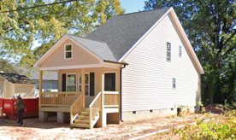  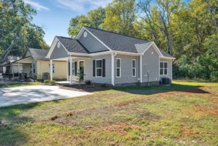

**647 E. Black Street**

David advised that the house has been officially moved

* Currently working on piers and brick work
* For sale property

Total Development cost: $93,300

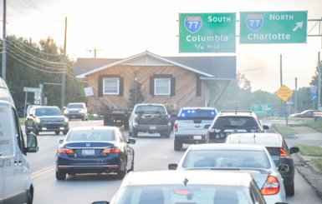 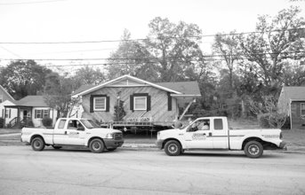 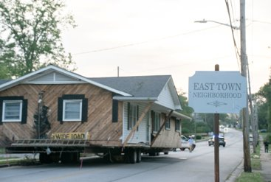

**First Time Homebuyers** –Jordan Hamrick advised on April FTHB

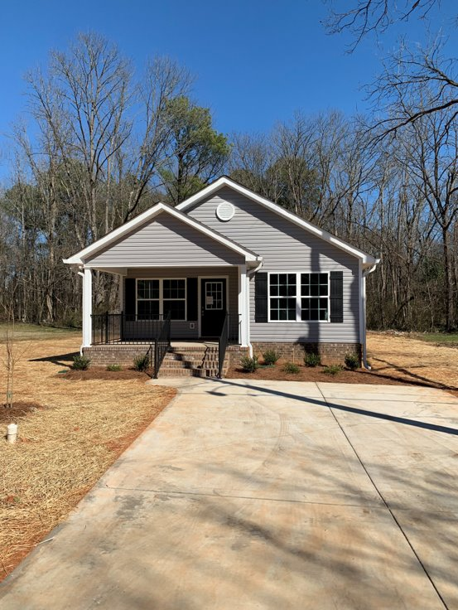

267 Lomax Closed April 10, 2024

Client Intake - Students - 18

Students who received certificates – 16

Closings with assistance – 1

Counseling sessions – 15

# enrolled in next in-person class - 10

CDBG 23/24 Funding - $43,070

Next Class – June 1, 2024

**Client Stories**

David shared two client stories regarding recent rehab projects

**FIX**

**Rehab Projects- CDBG – Southside Home Improvement Program (SHIP)**

|  |  |  |
| --- | --- | --- |
| **Stage** | **Amount of Units** | **SHIP** |
| **Pre-Work** | **1** | * Maximum $5000 |
| **Bidding** | **0** | * Exterior only |
| **In Construction** | **0** | * Roofs, HVACs, Porch, Decks, Handicap accessible ramps |
| **Completed** | **7** | * Ward 1 & 5 |

**Rehab Projects- – CDBG – Owner Occupied Rehab - Rehab-World Changers**

|  |  |
| --- | --- |
| **Stage** | **Amount of Units** |
| **Pre-Work** | **11** |
| **Bidding** | **0** |
| **In Construction** | **0** |
| **Completed** | **0** |

**Rehab Projects – HTF- Critical Home Repair & Home Repair**

|  |  |
| --- | --- |
| **Stage** | **Amount of Units** |
| **Pre-Work** | **3** |
| **Bidding** | **0** |
| **In Construction** | **0** |
| **Completed** | **0** |

**Rehab Projects**

CDBG 23/24

OOR - $4,236.30

Volunteer Projects - $40,000

SHIP - $10,164

|  |  |
| --- | --- |
| **Starting amount** | **71** |
| **Inactive *did not respond to mailer\*** | **22** |
| **Over Income** | **3** |
| **Homeowner completed work** | **2** |
| **House Sold** | **1** |
| **Requested Removal** | **2** |
| **In Progress** | **13** |
| **Completed** | **3** |
| **ELIGIBLE HOUSEHOLDS ON WAITLIST** | **26** |

**Summer Missions Volunteer Project**

**World Changers** – Approximately 250 Volunteers consisting of students from all over the country: Paint, porch repair, siding (no roofs) -June 17-21, 2024.

**Salkehatchie-** State levelthrough United Methodist group – June 22-28, 2024

**Grants Update**

* Applied awaiting notice
  + Family Trust Federal Credit Union
    - Community Partnership Foundation Applied for $5000 for furniture for 405 W. Main St.
  + Received
    - EFSP Phase 41
      * Rent ($37,352.50) and Utility Assistance ($15,000)
  + Applied for
    - * ESG (Rapid Rehousing, instead of homeless prevention assistance

**Old Business**

**Heir’s Property**

Jordan gave an update on the Center for Heir’s property educational seminar, which was held on Saturday, May 4, 2024, at the City Operations Center from 9am-12pm.

**New Business**

|  |
| --- |
| **ReBuild South Side**   * Roofs, siding, windows to houses that were affected by the hailstorm * Currently 46 on the list * Leveraging City Departments, donations, and other funds * Straight Talk – Walter and Corinne May 9th |

Corinne gave an overview of the ReBuild South Side Program, and considerable discussion followed.

Happy Birthday to Sandra Oborokumo

**Adjourn**

With no further business, a motion was made, seconded, and unanimously approved to adjourn.

The meeting was adjourned at 9:47 a.m.

Upcoming Events/Meetings: HDCRH Board Meeting, 8:30 a.m., June 13, 2024.

Submitted by: _____________________  
 Beverly Buchanan, Secretary  
 Date: May 20, 2024

______________________  
Chairman/Vice Chairman  
Date: