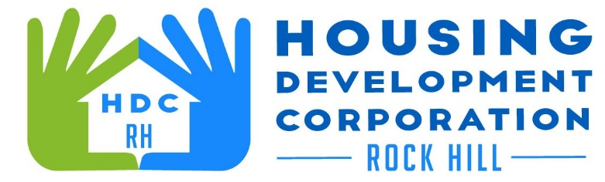

HDCRH MEETING

**December 9, 2021**

8:30 a.m.

Microsoft Teams Meeting

1. Call to Order
2. Approval of November 11, 2021 meeting minutes.

3) Staff Reports

1. Financials and Development Division Reports

1. Special Report
   1. Staff Updates
   2. Client Stories
2. New Business
3. Miscellaneous Business
4. Adjourn

Next Meeting: 8:30 a.m., January 13, 2022

***Mission Statement:*** *The mission of the Housing Development Corporation of Rock Hill is to provide and improve housing opportunities for low-to moderate-income residents.*

***Vision:*** *Inform. Educate. Empower. By providing homeownership education and assistance; rehabilitation assistance to owner-occupied homes; increasing affordable housing options; and offering foreclosure prevention counseling.*