Housing Development Corporation of Rock Hill Board Meeting

Thursday, December 8, 2022

A Board Meeting was held Thursday, December 8, at 8:30 a.m. at City Hall, Room 373.

Members present: Anne Lambert, David LeGrande, Phyllis Fickling, Kathy Pender, Perry Sutton, Will Jordan, Derrick Lindsay, Naomi Carpenter, Sandra Oborokumo, Sharon Hines,

Members absent: Walter Hardin, Mary Reid, Tom Roper, Nakia McGraw, Patricia McClurkin Sibley,

Staff Present: Jennifer McAdams, Corinne Sferrazza, Jordan Hamrick, Ed Causebrook, Ryan Powell, Danielle Sanders, Sarah Bechtold, Ariah Massey

Guest: Harley Hubbard

Call to Order: Anne Lambert called the meeting to order at 8:34 a.m. and thanked everyone for attending.

Minutes of the November 10, meeting was reviewed. Anne Lambert asked for a motion that the minutes be approved as presented. Motions were made for the minutes, seconded, and unanimously approved.

**Staff Reports**

**A. Financials**

Financial information was shared with Board members. Financial information can be e-mailed, or a hard copy can be mailed to Board Members if requested. Account balance information for the South State Community Checking Account (Sunset Park Houses) is $201,345.73. The Wells Fargo Account (HDC rentals) balance is $54,658.54. The TD Bank (Cottages) balance is $35,341.51 The NSP Rental Properties balance is $26,108.71. The TD General account is the main account with the most activity that includes utility and rental assistance transactions, deposits for assistance and proceeds for home sales, the balance is $170,103.80.

**Development Division Report**BUY

**New Construction**

Southside Properties – Planning Stage

Will be for sale units

1454 Crawford Rd. – 3 Bedroom 2 Bath

233 Baker St. – 2 Bedroom 1 Bath

Currently waiting for surveys to be complete

**SMG will build the houses**

**First Time Homebuyers** –

Jordan Hamrick advised that in November there were 18 students.

Students who received certificates – 4

Closings with assistance – 1

Counseling sessions – 10

Opted for In-person – 4

Opted for Remote learning – 6

4th buyer to be approved by December 22.

FTHB class on Saturday at Operations Center – currently 22 people signed up

**FIX**

**Rehab Projects- CDBG**

|  |  |
| --- | --- |
| **Stage** | **Amount of Units** |
| **Pre-Work** | **2** |
| **Bidding** | **2** |
| **In Construction** | **0** |
| **Complete** | **0** |

**Rehab Projects – HTF**

|  |  |
| --- | --- |
| **Stage** | **Amount of Units** |
| **Pre-Work** | **0** |
| **Bidding** | **0** |
| **In Construction** | **0** |
| **Complete** | **0** |

Housing Repair program contractor pricing is out to bid

HTF bids are due back first of the year

Currently identifying HTF qualifying projects

**Corinne reported:**

CDBG Funding Remaining - $115, 004.57

Eligible households on the waitlist: 104

Will take a pause from CDBG funding because World Changers are coming

Planning for World Changers and Salkehatchie summer of 2023

World Changers has 265 volunteers signed up

About 25 homes have been assigned

Phyllis asked about minority businesses bidding on HTF projects and how we reach out to them

**KEEP**

**Homeless Prevention Assistance**

Sarah advised that during the month of November the following households were served.

Rental – 5 households assisted - $8,713 spent

Mortgage- 1 household assisted - $1,832.34 spent

Utilities – 8 households assisted - $4,538.36 spent

Emergency Solutions Grant

Provides rental assistance, rent deposits, utility assistance, and utility deposits (30% AMI)

$49,806.26

Community Development Block Grant – Coronavirus (CDBG-CV)

Mortgage assistance – $0 left in funding

Rental Assistance - $4,000 left in funding

EFSP (Emergency Food and Shelter Program) –

Provides rent, utility, and mortgage assistance

Total funding: $245,627 (waiting for)

Utility Assistance For Working Families

United Way funded program

Provides utility assistance for working families in York County - $4,858.26

**Rental Properties**

Danielle Sanders advised on the following rental properties during the month of November

|  |  |  |  |
| --- | --- | --- | --- |
| Gross income: $6,738.28 | Net income: $-1,527.72 | Total properties: 30 | Total persons served: 62 |

**\*There was also a $19,098 insurance payment for all rentals\***

All 6 SRDP houses are leased

**Counseling Sessions**

Counseling sessions for October

Benefits sessions: 2 Foreclosure sessions: 0 Rapid Rehousing sessions: 5

**New Business**

**Federal Home Loan Bank of Atlanta**

**Corinne advised that HDC is interested in applying for funding through the Federal Home Loan Bank of Atlanta’s Community Investment Services Affordable Housing Program. This would be in partnership with Family Trust. We need to have board approval to execute a Sponsor Access Agreement.**

**After discussion, Will Jordan made motion to approve the Sponsor Access Agreement as presented, the motion was seconded by David LeGrande, and unanimously approved.**

**General discussion topics**

* 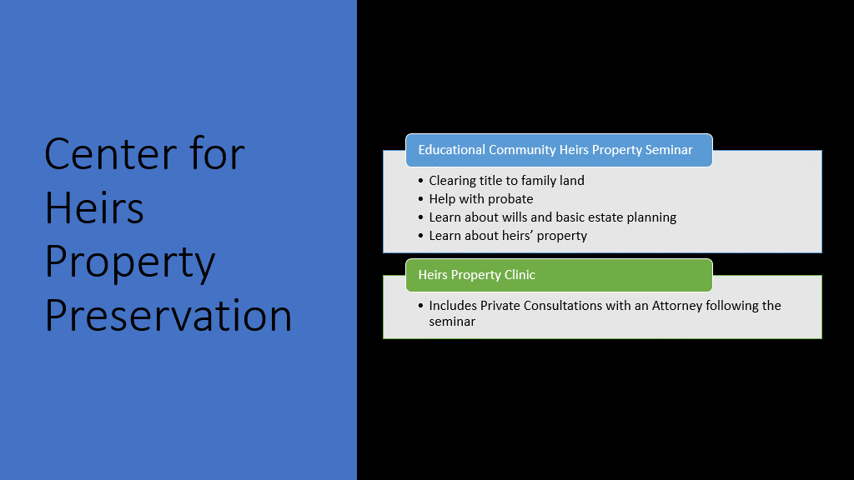

**Looking toward 2023**

* Board Development
* Meetings with each board member
* Reviewing bylaws and board expectations
* Continued tracking of efforts to achieve strategic plan goals

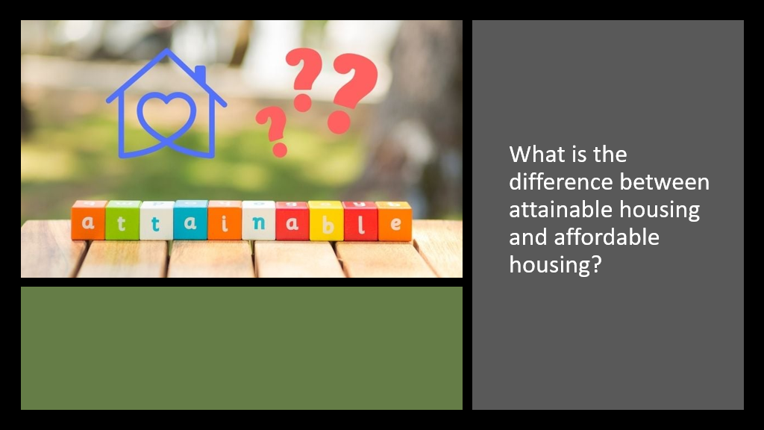

With no further business, motion was made, seconded, and unanimously approved to adjourn the meeting.

Meeting adjourned at 9:20 a.m.

Upcoming Events/Meetings: HDCRH Board Meeting, 8:30 a.m., January 12, 2022.

Submitted by: _______________________  
 Beverly Buchanan, Secretary  
 Date: December 16, 2022

______________________  
Chairman/Vice Chairman  
Date: