Housing Development Corporation of Rock Hill Board Meeting

Thursday, September 8, 2022

A Board Meeting was held Thursday, September 8, at 8:30 a.m. at City Hall, Room 373.

Members present: Walter Hardin, Anne Lambert, David LeGrande, Mary Reid, Sandra Oborokumo, Phyllis Fickling, Perry Sutton

Members absent: Sharon Hines, Will Jordan, Tom Roper, Nakia McGraw, Patricia McClurkin Sibley, Kathy Pender, Naomi Carpenter

Staff Present: Corinne Sferrazza, Jordan Hamrick, Beverly Buchanan, Ed Causebrook, Danielle Sanders, Sarah Bechtold, Miguel Rullan, Ariah Massey, Melissa Carlyle

Call to Order: Walter Hardin called the meeting to order at 8:32 a.m. and thanked everyone for attending.

Minutes of the August 11 meeting was reviewed. Walter Hardin asked for a motion that the minutes be approved as presented. Motions were made for the minutes, seconded, and unanimously approved.

**Staff Reports**

**A. Financials**

Financial information was shared with Board members. Financial information can be e-mailed, or a hard copy can be mailed to Board Members if requested. Account balance information for the South State Community Checking Account (Sunset Park Houses) is $204,776.35. The Wells Fargo Account (HDC rentals) balance is $55,972.76. The TD Bank (Cottages) balance is $36,783.20. The NSP Rental Properties balance is $32,173.08. The TD General account is the main account with the most activity that includes utility and rental assistance transactions, deposits for assistance and proceeds for home sales, the balance is $284,685.76.

**Development Division Report**BUY

**New Construction**

Southside Properties – Planning Stage

Will be for sale units

Ed Causebrook advised on lots for construction

1454 Crawford Rd. – 3 Bedroom 2 Bath

233 Baker St. – 2 Bedroom 1 Bath

**First Time Homebuyers** –

Jordan Hamrick advised that in August there were 27 students.

Students who received certificates – 10

Closings with assistance – 1

Counseling sessions – 10

Opted for In-person – 9

Opted for Remote learning - 18

**FIX**

Ed reported on the owner-occupied rehab projects

**Rehab Projects- CDBG**

|  |  |
| --- | --- |
| **Stage** | **Amount of Units** |
| **Pre-Work** | **5** |
| **Bidding** | **1** |
| **In Construction** | **1** |
| **Complete** | **1** |

**Rehab Projects – HTF**

|  |  |
| --- | --- |
| **Stage** | **Amount of Units** |
| **Pre-Work** | **1** |
| **Bidding** | **0** |
| **In Construction** | **0** |
| **Complete** | **0** |

**Corinne reported:**

CDBG Funding Remaining - $127,040

Eligible households on the waitlist: 105

**KEEP**

**Homeless Prevention Assistance**

Sarah advised that during the month of August the following households were served.

Rental – 1 household assisted - $2,600 spent

Mortgage- 0 household assisted - $0 spent

Utilities – 4 households assisted - $3,421 spent

ESG (Emergency Solutions Grant) – Coronavirus Phase II (ESG-CVII)

Provides rental assistance, rent deposits, utility assistance, and utility deposits (50% AMI)

$480,924.24 spent total, $3,357 remaining

Community Development Block Grant – Coronavirus (CDBG-CV)

Mortgage assistance – $0 left in funding

Rental Assistance - $4,000 left in funding

EFSP (Emergency Food and Shelter Program) –

$250,000 has been awarded by United Way, to be used for rental, utility, and mortgage

Funds have not been distributed yet

Utility Assistance For Working Families

United Way funded program

Provides utility assistance for working families in York County - $8000

**Rent**

**Rental Properties**

Danielle Sanders advised on the following rental properties during the month of August

|  |  |  |  |
| --- | --- | --- | --- |
| Gross income: $14,741 | Net income: $-19,294.80 | Total properties: 30 | Total persons served: 54 |

**Counseling Sessions**

Miguel reported on counseling sessions for August

Benefits sessions: 3 Foreclosure sessions: 0 Rapid Rehousing sessions: 8

**Intern Update**:

* Corinne introduced the EUD interns; Ariah Massey and Melissa Carlyle

**New Business**

**Grant opportunity update**

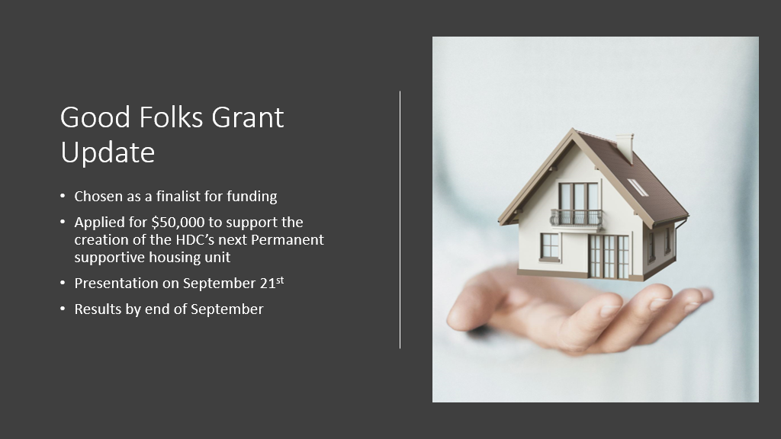

**Annual Meeting Update**

* Annual Meeting October 13, 11:30-1:00
* Manchester Meadows
* Theme “Homeless to Housed”
* Invitations will be going out soon
* Fundraiser to promote support for permanent supportive housing

**Other**

**After discussion regarding Will Jordan, David LeGrande made a motion to grant Will Jordan a six month leave of absence, with ability to be on speaker phone if a quorum is needed, the motion was seconded and unanimously approved.**

With no further business, motion was made, seconded, and unanimously approved to adjourn the meeting.

Meeting adjourned at 9:07 a.m.

Upcoming Events/Meetings: HDCRH Annual Meeting, 11:00 am, October 13,2022.

Submitted by: _______________________  
 Beverly Buchanan, Secretary  
 Date: September 9, 2022

______________________  
Chairman/Vice Chairman  
Date: