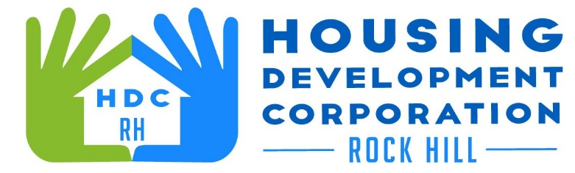

HDCRH MEETING

**May 13, 2021**

8:30 a.m.

via Zoom Meetings

1. Call to Order
2. Approval of April 13, 2020 minutes.

3) Staff Reports (included in packet)

1. Financials and Development Division Reports
2. Staff stories

1. Old Business
   1. Vet Benefit (Hero House) update
2. New Business
   1. Annual Meeting
3. Miscellaneous Business
   1. Subcommittees
4. Adjourn

Next Meeting: 8:30 a.m., June 10, 2021

***Mission Statement:*** *The mission of the Housing Development Corporation of Rock Hill is to provide and improve housing opportunities for low-to moderate-income residents.*

***Vision:*** *Inform. Educate. Empower. By providing homeownership education and assistance; rehabilitation assistance to owner-occupied homes; increasing affordable housing options; and offering foreclosure prevention counseling.*