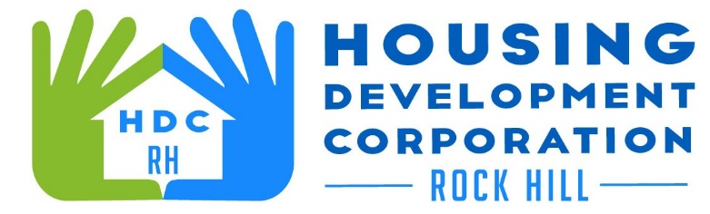

HDCRH MEETING

**July 13, 2023**

8:30 a.m.

City Hall Room 373

1. Call to Order
2. Approval of June 8, 2023, meeting minutes.

3) Staff Reports

1. Financials and Development Division Reports

1. Old Business
   1. By-Laws Ad Hoc Committee Update
2. New Business
   1. Annual Meeting discussion
3. Adjourn

Next Meeting: **8:30 am., August 10, 2023**

***Mission Statement:*** *The mission of the Housing Development Corporation of Rock Hill is to provide and improve housing opportunities for low-to moderate-income residents.*

***Vision:*** *Inform. Educate. Empower. By providing homeownership education and assistance; rehabilitation assistance to owner-occupied homes; increasing affordable housing options; and offering foreclosure prevention counseling.*