Housing Development Corporation of Rock Hill Board Meeting

Thursday, May 12, 2022

A Board Meeting was held Thursday, May 12, at 8:30 a.m. at City Hall, Room 373.

Members present: Anne Lambert, Will Jordan, David LeGrande, Sandra Oborokumo, Phyllis Fickling, Naomi Carpenter, Sharon Hines, Patricia McClurkin Sibley, Nakia McGraw, Mary Reid, Kathy Pender

Members absent: Walter Hardin, Tom Roper, Nakia McGraw

Staff On Call: Corinne Sferrazza, Jennifer McAdams, Jordan Hamrick, Beverly Buchanan, Ryan Powell, Sarah Bechtold, Danielle Sanders, Miguel Rullan

Guest: Harley Hubbard

Call to Order: Anne Lambert called the meeting to order at 8:30 a.m. and thanked everyone for attending.

Minutes of the April 7, Anne Lambert asked for a motion that the minutes be approved as presented. Motions were made for the minutes, seconded, and unanimously approved.

**Staff Reports**

Financials  
Financial information was shared with Board members. Financial information can be e-mailed, or a hard copy can be mailed to Board Members if requested. Account balance information for the South State Community Checking Account (Sunset Park Houses) is $277,664.49. The Wells Fargo Account (HDC rentals) balance is $46,244.33. The TD Bank (Cottages) balance is $35,287.42. The NSP Rental Properties balance is $47,299.88. The TD General account is the main account with the most activity that includes utility and rental assistance transactions, deposits for assistance and proceeds for home sales, the balance is $267,560.60.

Development Division Report  
BUY

**New Construction**

New construction is on hold.

**First Time Homebuyers** –

Jordan Hamrick advised that in April there were 25 students.

Students that received certificates – 10

Closings with assistance – 0

Counseling sessions – 13

June 11, 2022 – First Time HomeBuyers workshop at Operations Center 8:30-12:30

**FIX**

Ryan Powell reported on the rehab projects

**Rehab Projects- CDBG**

|  |  |
| --- | --- |
| **Stage** | **Amount of Units** |
| **Pre-Work** | **2** |
| **Bidding** | **4** |
| **In Construction** | **2** |
| **Complete** | **0** |

**Rehab Projects – HTF**

|  |  |
| --- | --- |
| **Stage** | **Amount of Units** |
| **Pre-Work** | **5** |
| **Bidding** | **0** |
| **In Construction** | **0** |
| **Complete** | **1** |

**Corinne reported:**

CDBG Funding Remaining - $169,831.73

Eligible households on the waitlist: 116

100 letters were mailed to the individuals that were no longer eligible in terms of the eligible activities list. There were 4 responses from people that wanted clarification; 4 letters returned due to person no longer living in the home.

We are now operating from the eligible activities list.

Ryan advised that conversations have started with local church groups, and city youth council for some volunteer projects. There will be more information to report at the next meeting.

**KEEP**

**Homeless Prevention Assistance**

Sarah Bechtold advised that during the month of April the following households were served.

Rental – 4 households assisted - $16,272.99 spent

Mortgage- 1 household assisted - $1,971.63 spent

Utilities – 5 households assisted - $3,157.68 spent

ESG (Emergency Solutions Grant) – Coronavirus Phase II (ESG-CVII)

Provides rental assistance, rent deposits, utility assistance, and utility deposits (50% AMI)

$454,440,40 spent total, $22,035.16 remaining

Community Development Block Grant – Coronavirus (CDBG-CV)

Mortgage assistance – $0 left in funding

Rental Assistance - $29,313.86 left in funding

EFSP (Emergency Food and Shelter Program) –

$250,000 has been awarded by United Way, to be used for rental, utility, and mortgage

Funds have not been distributed yet

Utility Assistance For Working Families

United Way funded program

Provides utility assistance for working families in York County - $8000

**Rent**

**Rental Properties**

Danielle Sanders advised on the following rental properties during the month of April

|  |  |  |  |
| --- | --- | --- | --- |
| Gross income: $14,441.54 | Net income: $8,571.14 | Total properties: 30 | Total persons served: 56 |

**Sunset Park SRDP**

6 affordable rental units – 30%, 60% and 80% AMI -1 mobility unit, 1 sensory unit

* 3 Tenants officially moved into units -
  + 460 Fewell – Occupied
  + 753 Carolina - Occupied
  + 360 Scoggins – Occupied
* 371 Baker – Occupied

353 Baker – Occupied

813 Harrison –Have tenant approved, waiting on CO

* 859 Finley View – Workforce housing – 120% AMI – Occupied as of January 20th
* 307 Workman – Occupied

Two commercial properties will be coming online in April- Homestead Agreement properties owned by the City of Rock Hill. HDC has agreed to manage and collect half the rent.

**Counseling Sessions**

Miguel Rullan advised on counseling sessions for April.

Benefits sessions: 4 Foreclosure sessions: 0 Rapid Rehousing sessions: 8

**Special Report**

Corinne gave update on Village at Osceola – Catawba Terrace Neighborhood

Type- Rental New Construction

Number of units – 28 (Townhouses, Duplex, Single family homes)

2 Mobility 1 Sensory

SRDP Award - $8,187,753

Status- working through SC Housing Comments

**Client Stories**

Jordan Hamrick shared a client story with the board

**New Business**

**Permanent Supportive Housing**

Corinne gave an overview of what Permanent Supportive Housing is and how it will be help in offering affordable housing to help with homelessness.

HDC is willing to offer 310 Maple St., as an affordable unit for individuals that are homeless forever.

Individual – will pay 30% of the rent

Service providers (Emergency shelters) will pay rest of rent subsidy

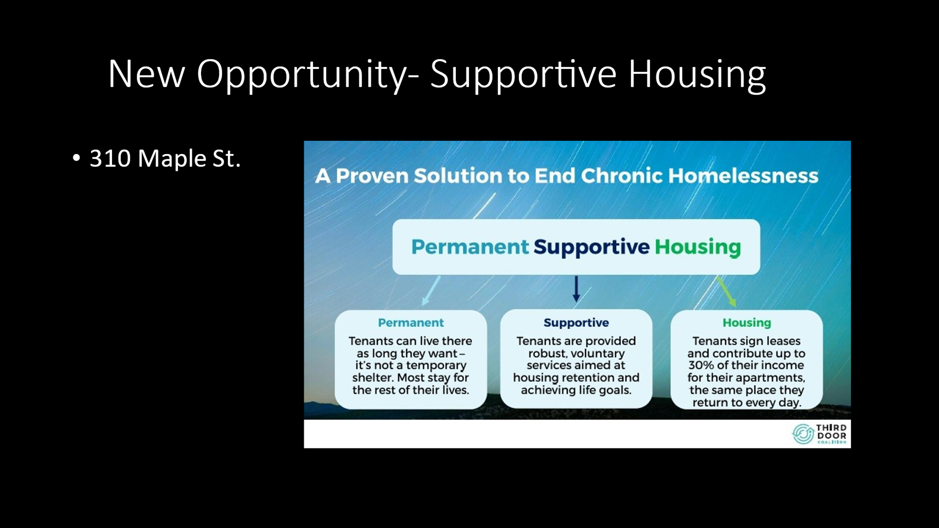

**Board Development Discussion**

Corinne advised that HDC Board members, Walter Hardin, Anne Lambert, and Naomi Carpenter met with the HDC staff to explore Board Development ideas. 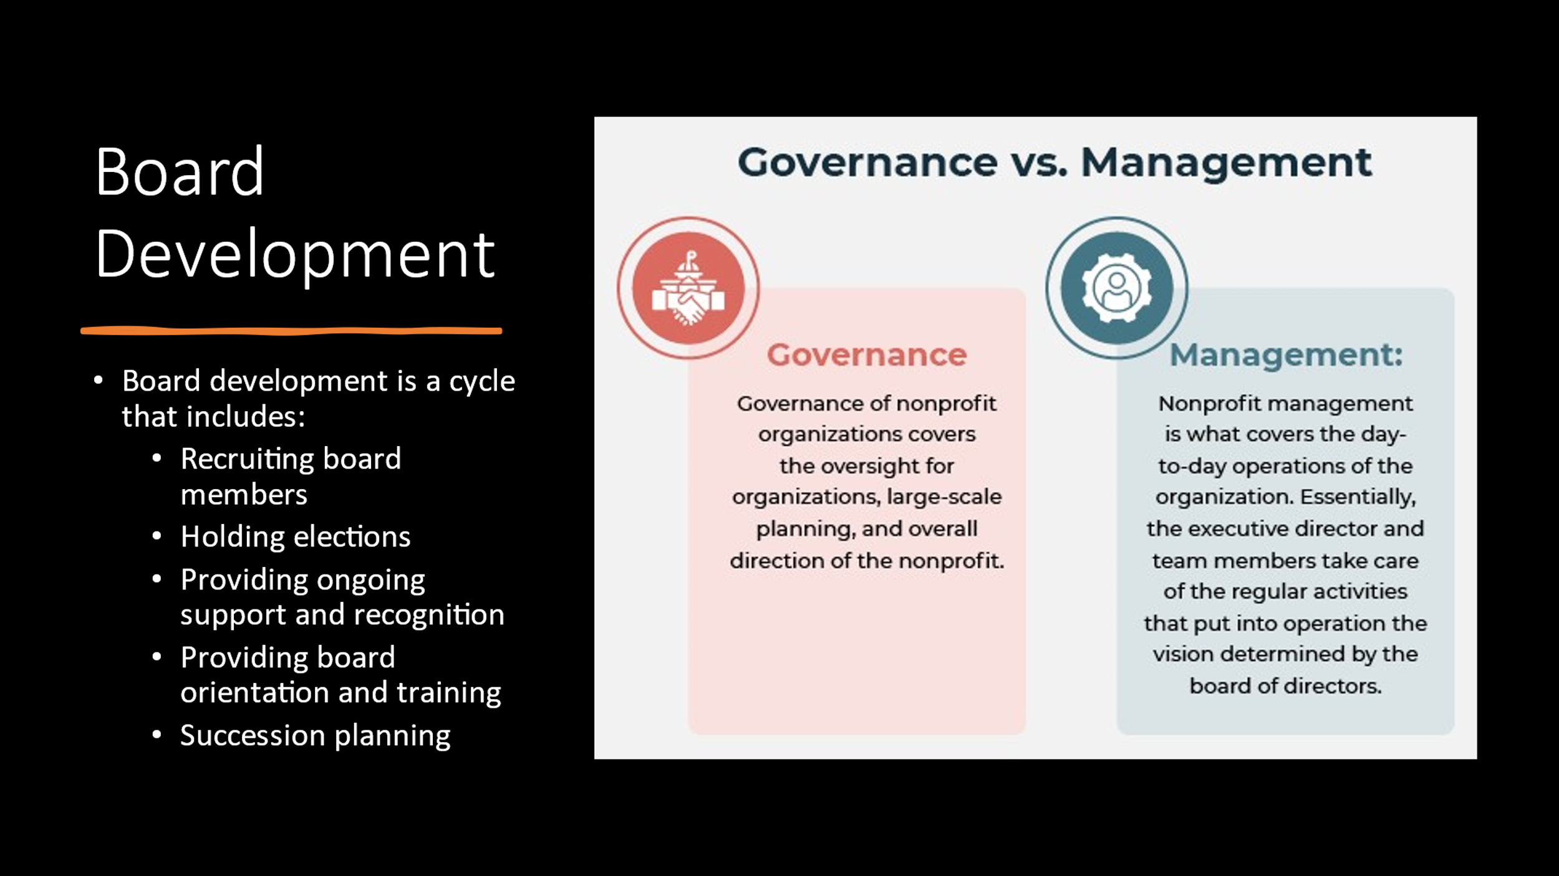

Corinne asked that if anyone has any questions or ideas regarding Board Development, please contact her.

**Strategic Plan Follow-Up**

* Continue to review the draft

With no further business, motion was made, seconded, and unanimously approved to adjourn the meeting.

Meeting adjourned at 9:19 a.m.

Upcoming Events/Meetings: HDCRH Board Meeting, 8:30 a.m. June 9, 2022.

Submitted by: _______________________  
 Beverly Buchanan, Secretary  
 Date: May 17, 2022

______________________  
Chairman/Vice Chairman  
Date: