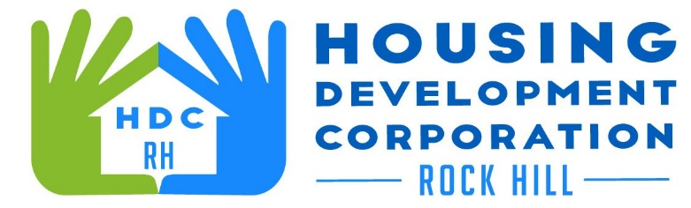

HDCRH MEETING

**September 9, 2021**

8:30 a.m.

Zoom Meeting

1. Call to Order
2. Approval of August 24, 2021 meeting minutes.

3) Staff Reports (included in packet)

1. Financials and Development Division Reports
2. Staff stories

1. Old Business

a. Consider Homestead rental agreement

1. New Business
   1. Consider application for board membership
2. Miscellaneous Business
3. Adjourn

Next Meeting: 8:30 a.m., October 14, 2021

***Mission Statement:*** *The mission of the Housing Development Corporation of Rock Hill is to provide and improve housing opportunities for low-to moderate-income residents.*

***Vision:*** *Inform. Educate. Empower. By providing homeownership education and assistance; rehabilitation assistance to owner-occupied homes; increasing affordable housing options; and offering foreclosure prevention counseling.*