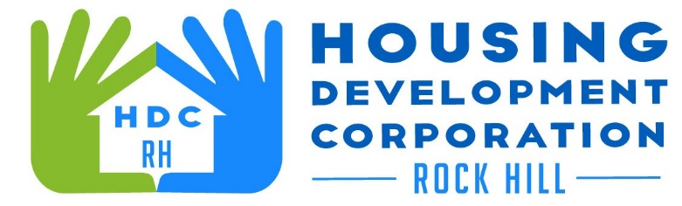

HDCRH MEETING

**June 9, 2022**

8:30 a.m.

City Hall Room 373

1. Call to Order
2. Approval of May 12, 2022, meeting minutes.

3) Staff Reports

1. Financials and Development Division Reports
2. Supportive Housing Update

1. New Business
   1. Strategic Plan approval
2. Adjourn

Next Meeting: **8:30 a.m., July 14, 2022**

***Mission Statement:*** *The mission of the Housing Development Corporation of Rock Hill is to provide and improve housing opportunities for low-to moderate-income residents.*

***Vision:*** *Inform. Educate. Empower. By providing homeownership education and assistance; rehabilitation assistance to owner-occupied homes; increasing affordable housing options; and offering foreclosure prevention counseling.*